Time Drive Gear Train Components
Meets ASE Task: (A9-B-11) Inspect and time drive gear train components.

Name _______________________________ Date ___________ Time on Task __________

Make/Model/Year _________________ VIN ________________ Evaluation: 4 3 2 1

_____ 1. Check service information for the specified procedure to follow when timing drive
gear train components. What is the specified procedure? ______________________
_________________________________________________________________
_________________________________________________________________
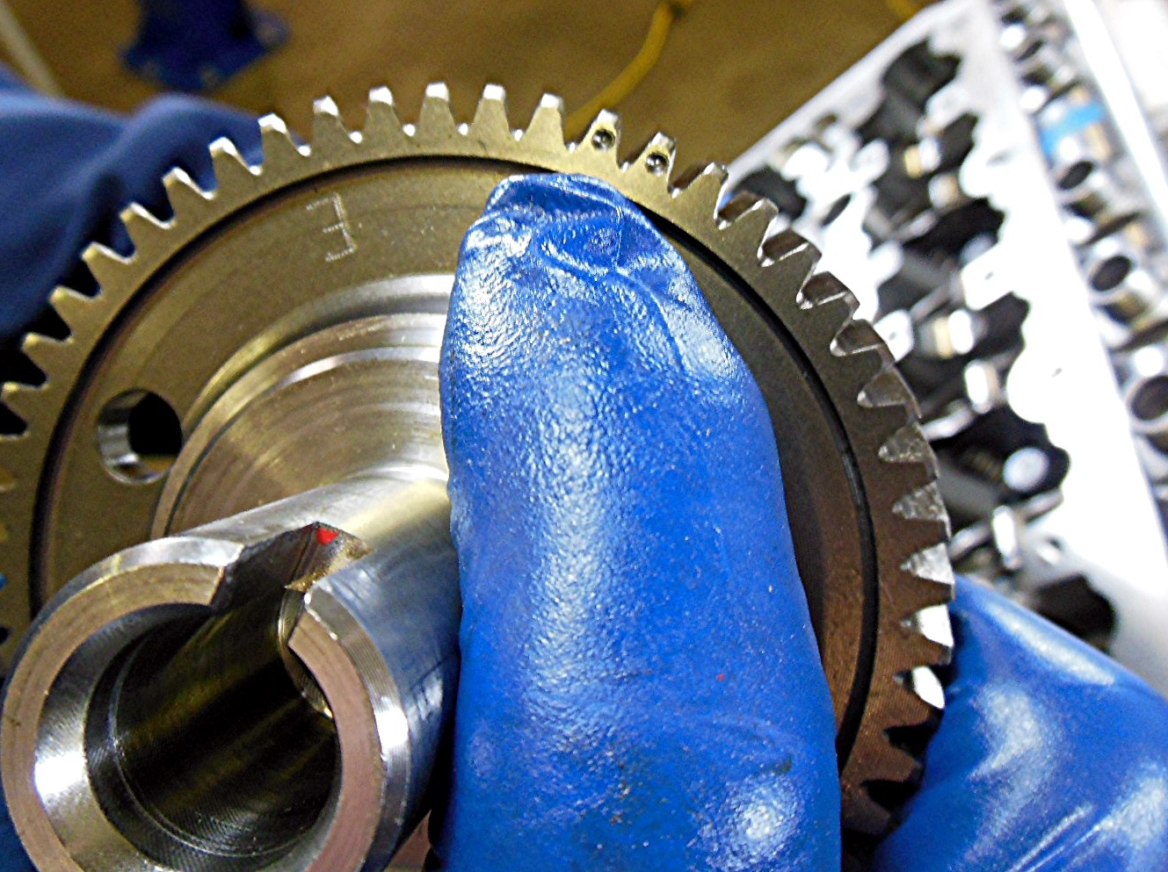

_____ 2. Some diesel engines time the high-pressure pump drive gear. What is the
specified procedure for the engine being serviced? _________________________
_______________________________________________________________



