Inspect, Measure, and Repair/Replace Oil Pump
Meets ASE Task: (A9-D-2) Inspect, measure, repair/replace the oil pump, housing, drives, pipes and screens.

Name _______________________________ Date ___________ Time on Task __________

Make/Model/Year _________________ VIN ________________ Evaluation: 4 3 2 1

_____ 1. Check service information for the specified specifications and procedures to follow
when inspecting and measuring the oil pump. Describe the specified procedures.
_________________________________________________________________
_________________________________________________________________
_________________________________________________________________
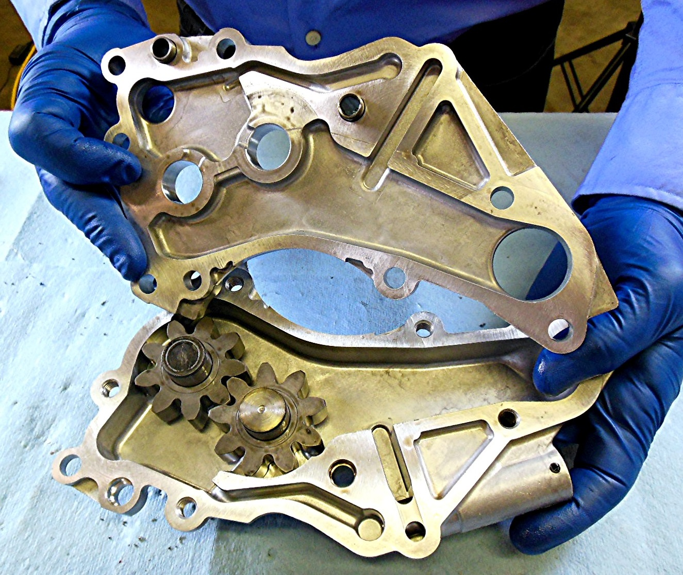

_____ 2. Based on the inspection and measurement, what is the needed action? ____________
_________________________________________________________________
_________________________________________________________________
_________________________________________________________________

