Inspect, Repair/Replace Oil Pressure Regulator

Meets ASE Task: (A9-D-3) Inspect, repair/replace the oil pressure regulator assembly.

Name _______________________________ Date ___________ Time on Task __________

Make/Model/Year _________________ VIN ________________ Evaluation: 4 3 2 1

_____ 1. Check service information for the specified procedures and measurements when
inspecting the oil pump pressure regulator. Describe the specified procedures.
__________________________________________________________________
__________________________________________________________________
__________________________________________________________________
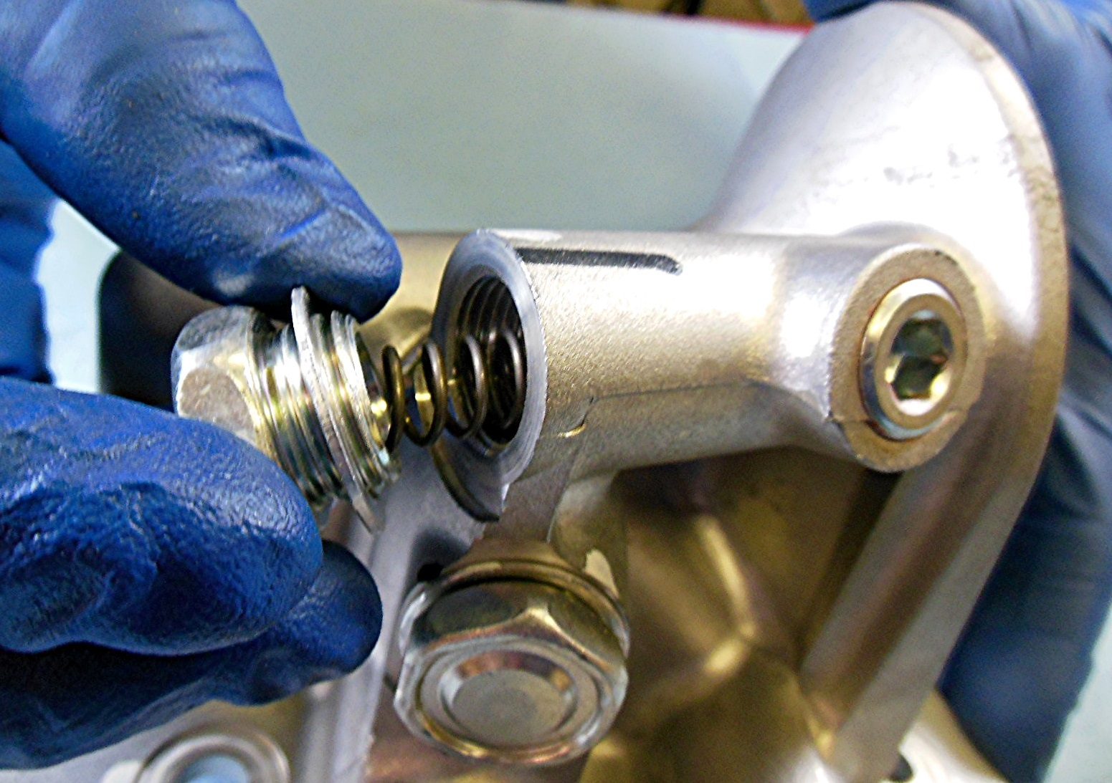

_____ 2. Based on the inspection, what is the needed action? ___________________________
__________________________________________________________________
__________________________________________________________________
__________________________________________________________________

