Accessory Drive Belts
Meets ASE Task: (A9-D-7) Inspect and reinstall/replace pulleys, tensioner, and drive belts; adjust drive belts and check alignment.

Name _______________________________ Date ___________ Time on Task __________

Make/Model/Year _________________ VIN ________________ Evaluation: 4 3 2 1

_____ 1. Check service information for the specified procedures to follow when replacing the
accessory drive belt(s) and tensioner. Describe the specified procedure. _______
__________________________________________________________________
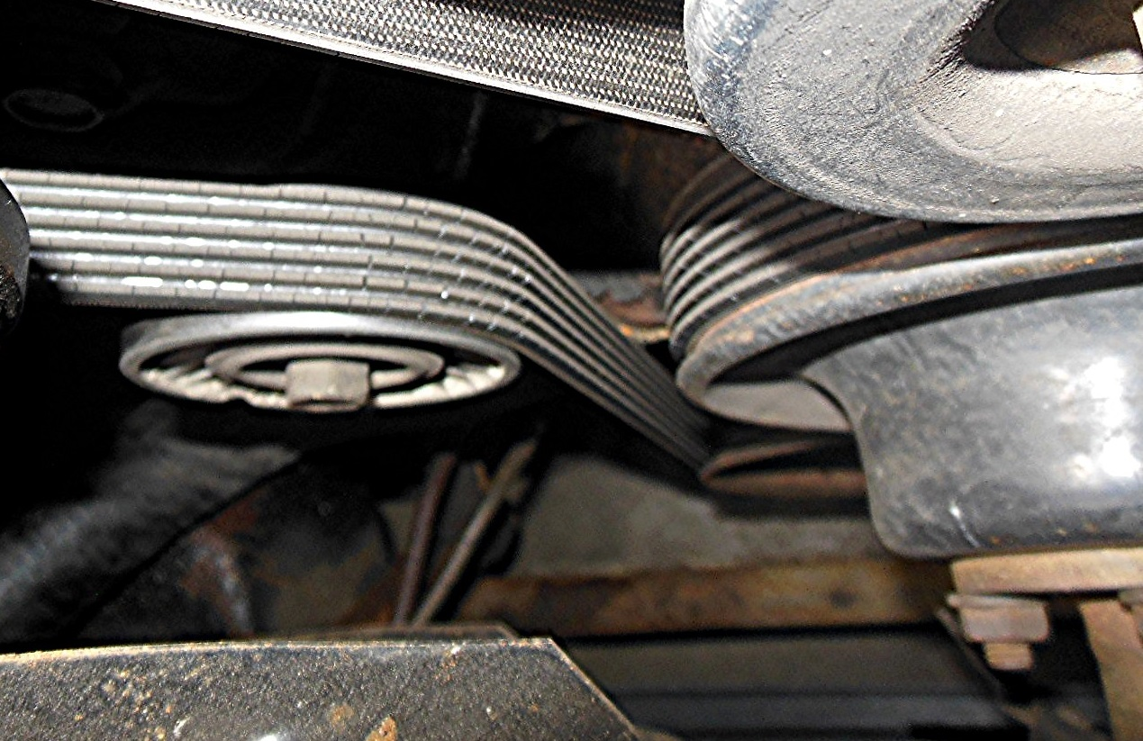
__________________________________________________________________
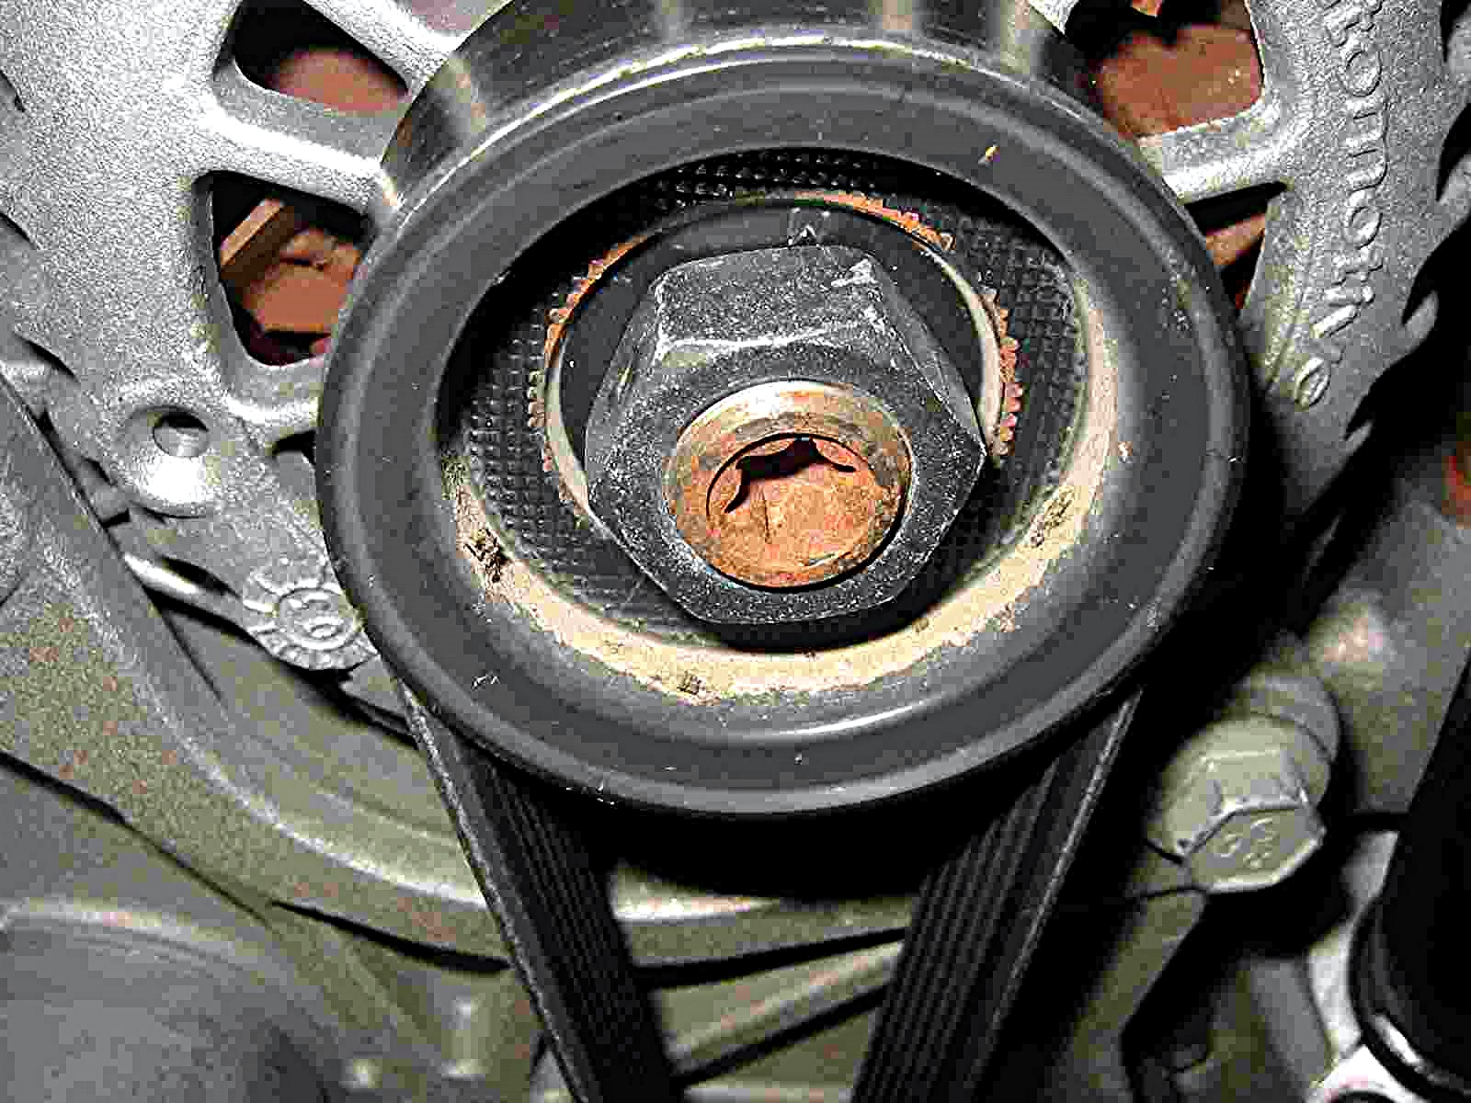
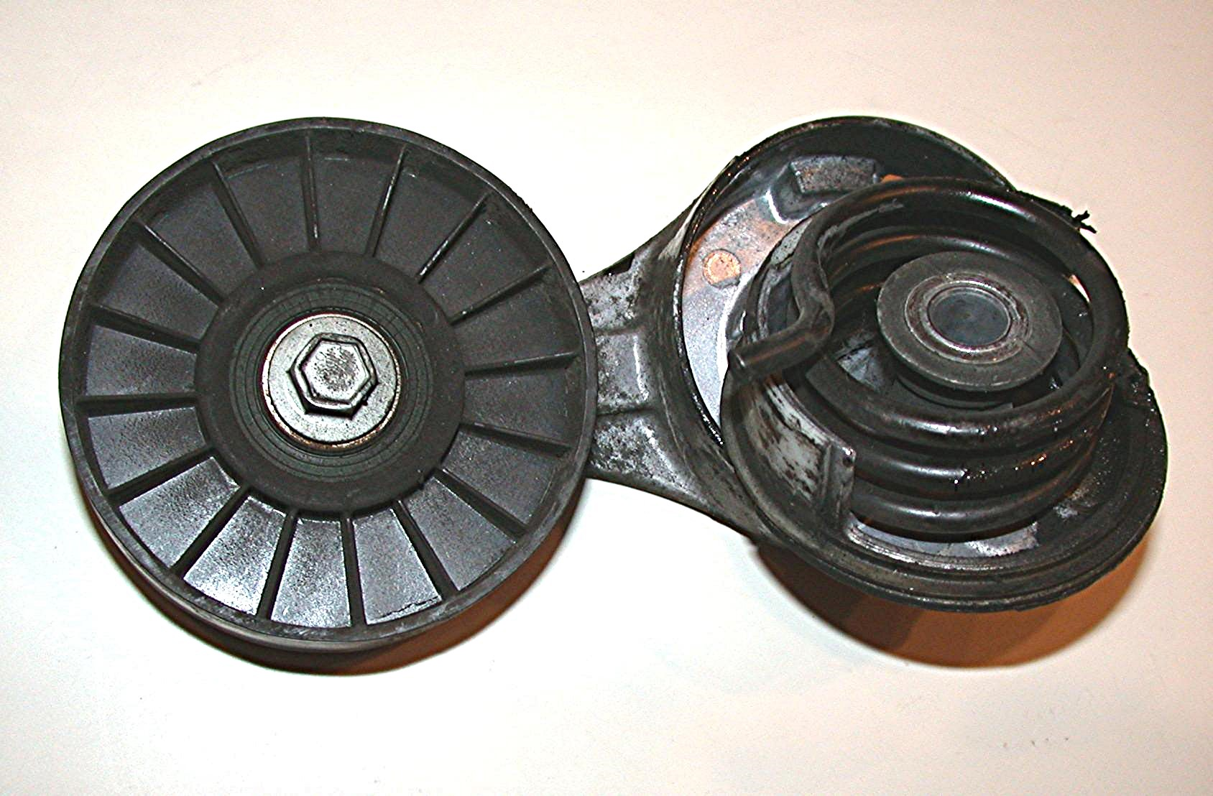

_____ 2. Based on the inspection, what was the needed action? __________________________
__________________________________________________________________
__________________________________________________________________

