Verify Coolant Temperature
Meets ASE Task: (A9-D-8) Verify coolant temperature; check operation of temperature and level sensors, switches and temperature gauge.

Name _______________________________ Date ___________ Time on Task __________

Make/Model/Year _________________ VIN ________________ Evaluation: 4 3 2 1

_____ 1. Check service information for the specified procedure to perform to verify coolant
temperature. Check all that apply.
_____ Check engine coolant temperature (ECT) temperature using a scan tool.
_____ Check coolant temperature using an infrared pyrometer.
_____ Compare dash temperature gauge readings to actual measurement.
_____ Other (specify) ______________________________________________
___________________________________________________________
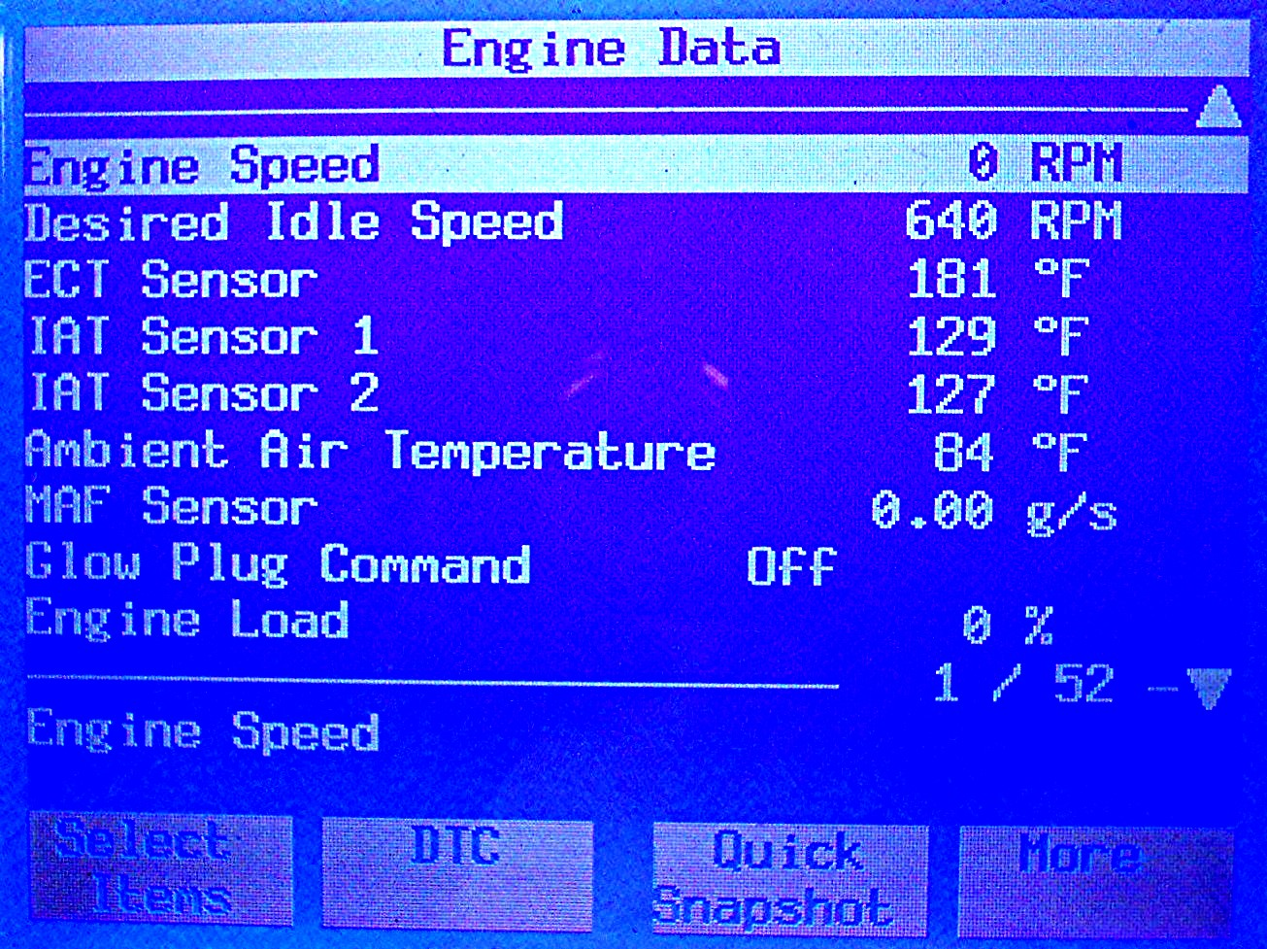
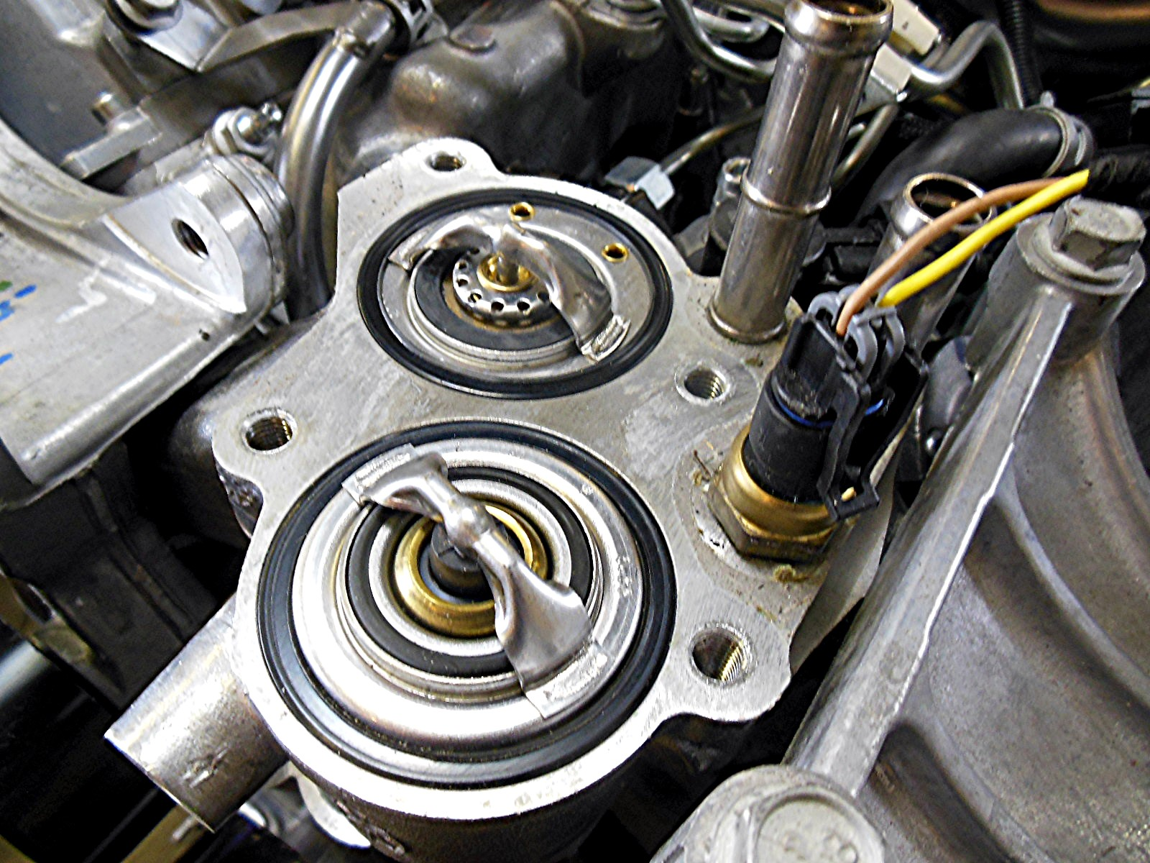
_____ 2. Scan tool temperature = ____________ Pyrometer temperature = _______________
_____ 3. Based on the inspection and testing, what is the needed action? __________________
__________________________________________________________________
__________________________________________________________________

