Inspect and Replace the Thermostat(s)
Meets ASE Task: (A9-D-9) Inspect and replace thermostat(s), by-pass(es), housing(s), and seal(s).

Name _______________________________ Date ___________ Time on Task __________

Make/Model/Year _________________ VIN ________________ Evaluation: 4 3 2 1

_____ 1. Check service information to determine what specific instructions are to be followed
when replacing the thermostat(s). Describe the specified procedures. _________
__________________________________________________________________ __________________________________________________________________
__________________________________________________________________
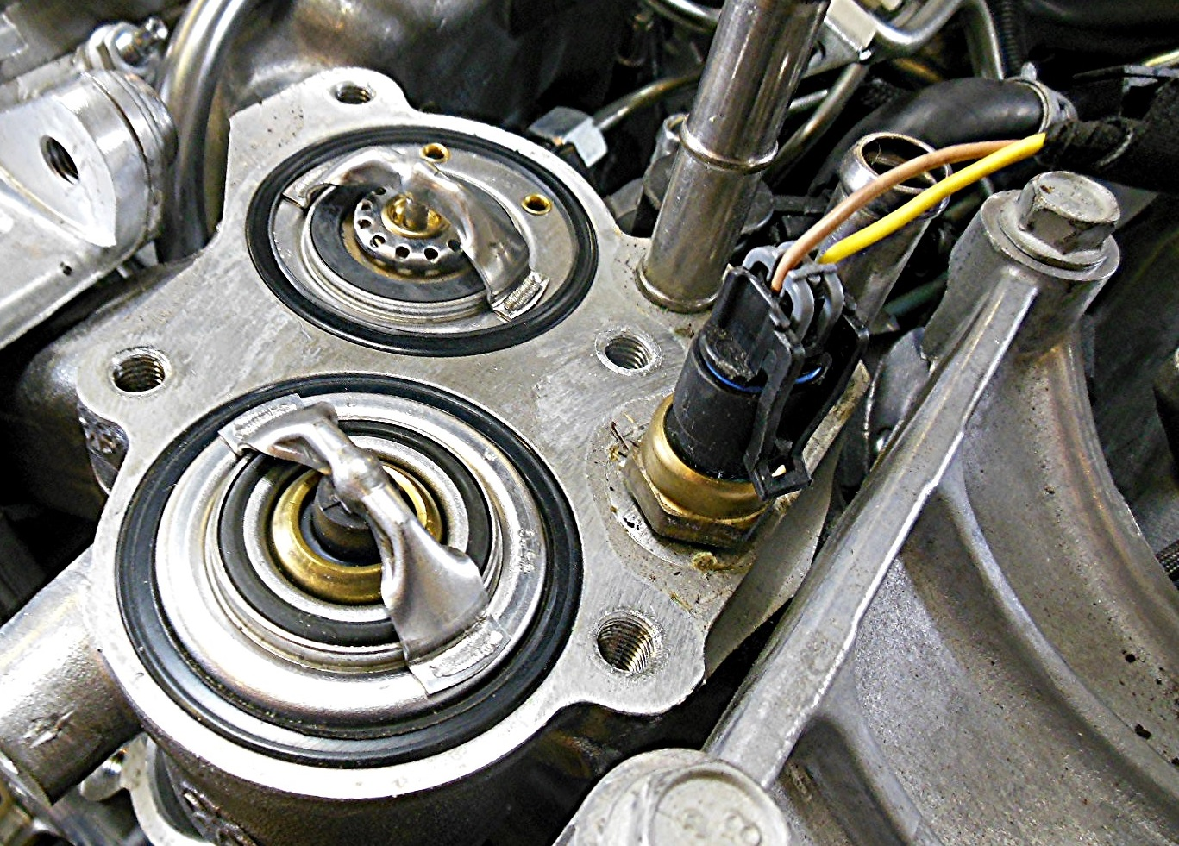

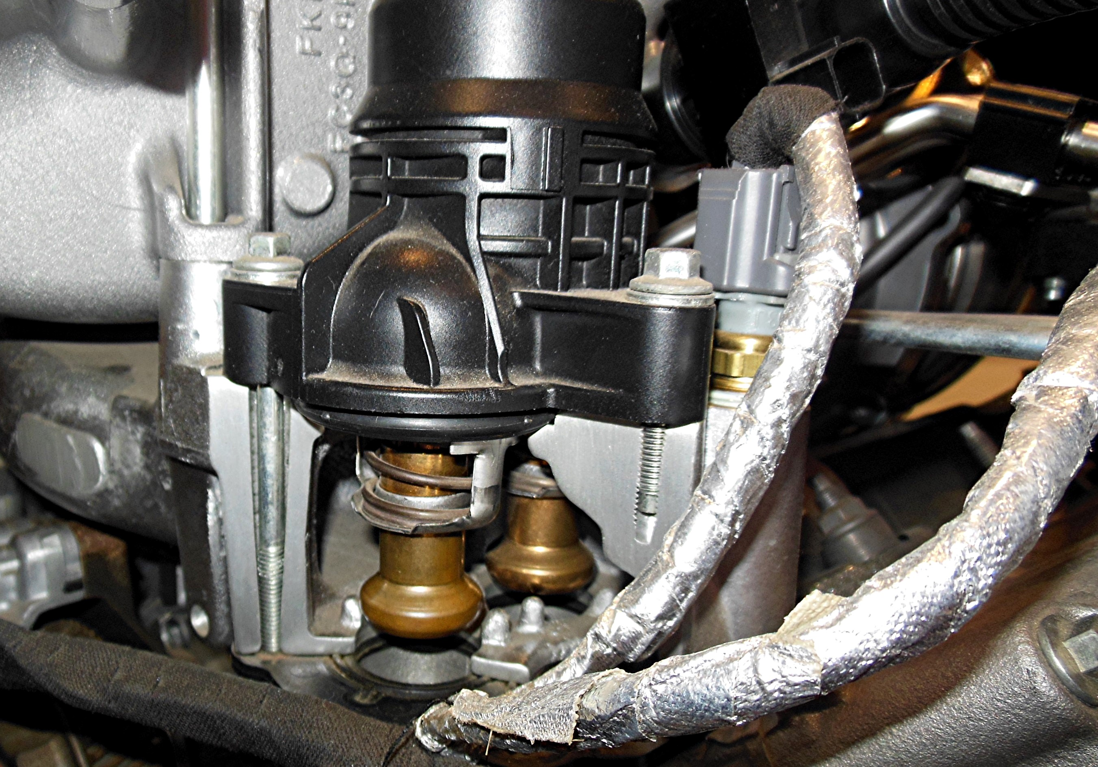

_____ 2. Based on the recommended procedures and the inspection, what service was
performed? ________________________________________________________
__________________________________________________________________
__________________________________________________________________

