Flush and Refill the Cooling System

Meets ASE Task: (A9-D-10) Flush and refill the cooling system; bleed the air from the system.

Name _______________________________ Date ___________ Time on Task __________

Make/Model/Year _________________ VIN ________________ Evaluation: 4 3 2 1

_____ 1. Check service information for the specified procedure to follow when refilling the
cooling system.
A. What is the specified procedure? ____________________________________
____________________________________________________________
B. What is the specified coolant? ______________________________________
C. What is the capacity in quarts/liters of the cooling system? _______________
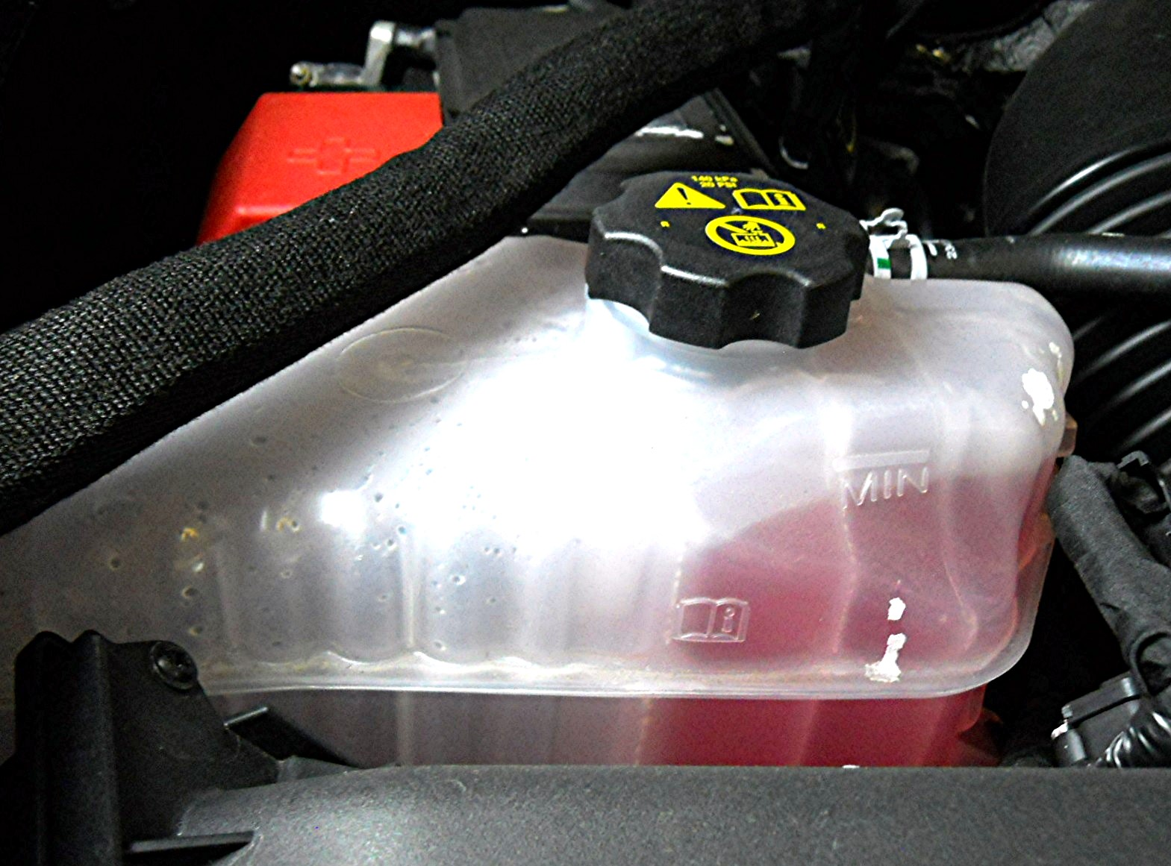

_____ 2. Describe the procedure used to flush and refill the cooling system. _______________
__________________________________________________________________
__________________________________________________________________
_____ 3. Describe the procedure used to bleed the air from the cooling system. _____________
__________________________________________________________________
__________________________________________________________________

