Inspect the Cooling System and Pressure Test
Meets ASE Task: (A9-D-12) Inspect the cooling system components and pressure test; determine needed repairs.

Name _______________________________ Date ___________ Time on Task __________

Make/Model/Year _________________ VIN ________________ Evaluation: 4 3 2 1

_____ 1. Check service information for the specified procedures to follow when inspecting and
testing the cooling system. Describe the specified procedures. _______________
__________________________________________________________________
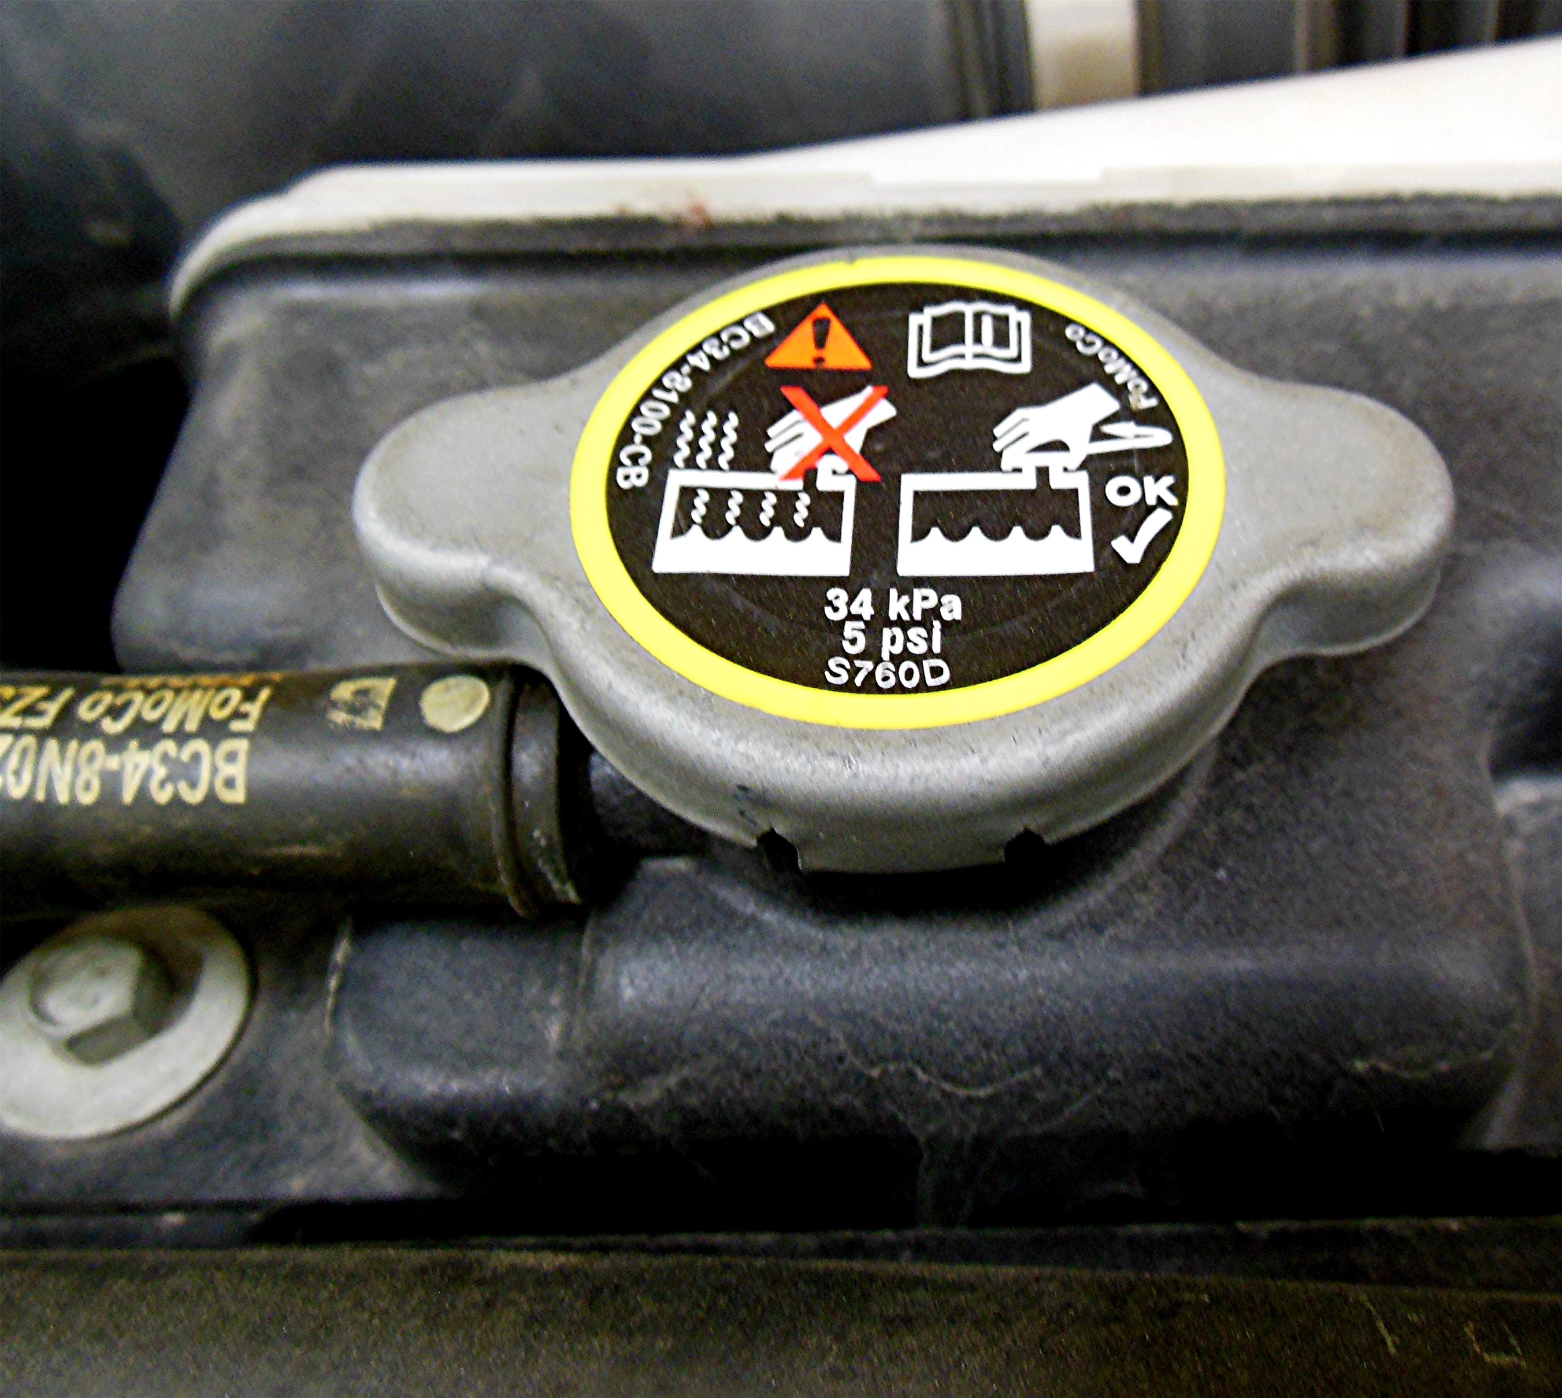
__________________________________________________________________
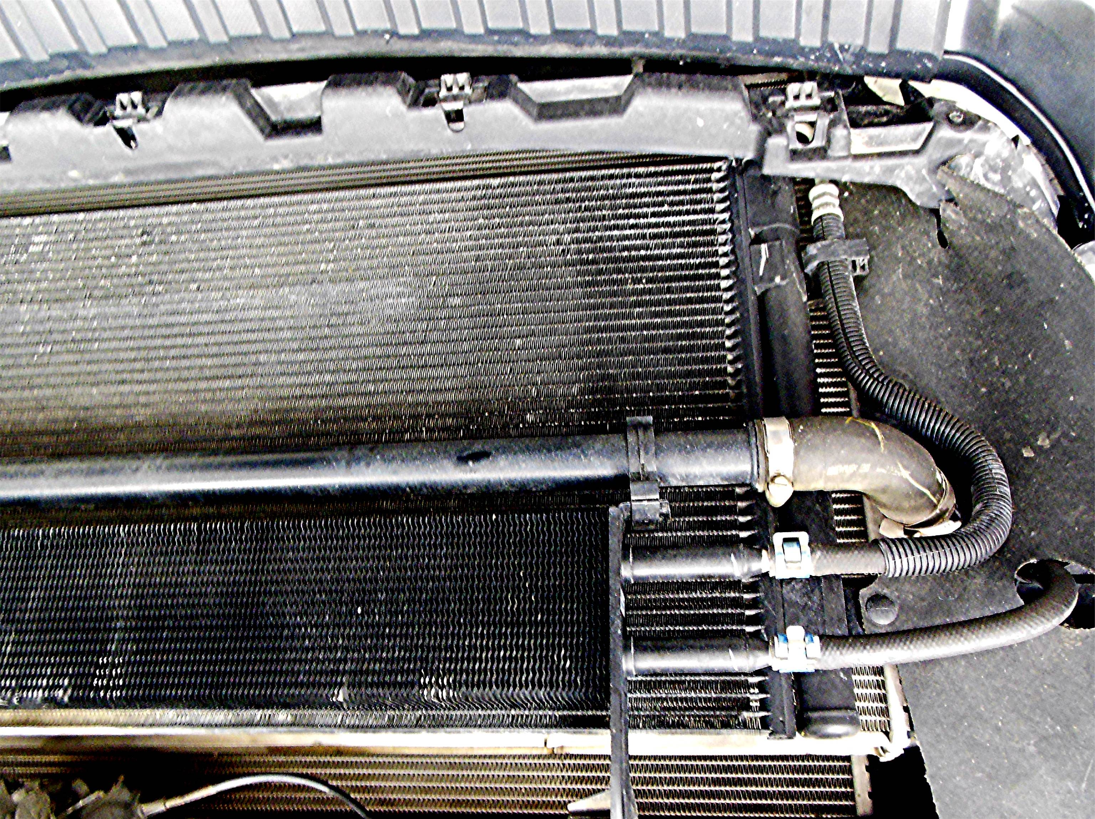

_____ 2. What is the specified procedure to be used when checking the cooling system? _____
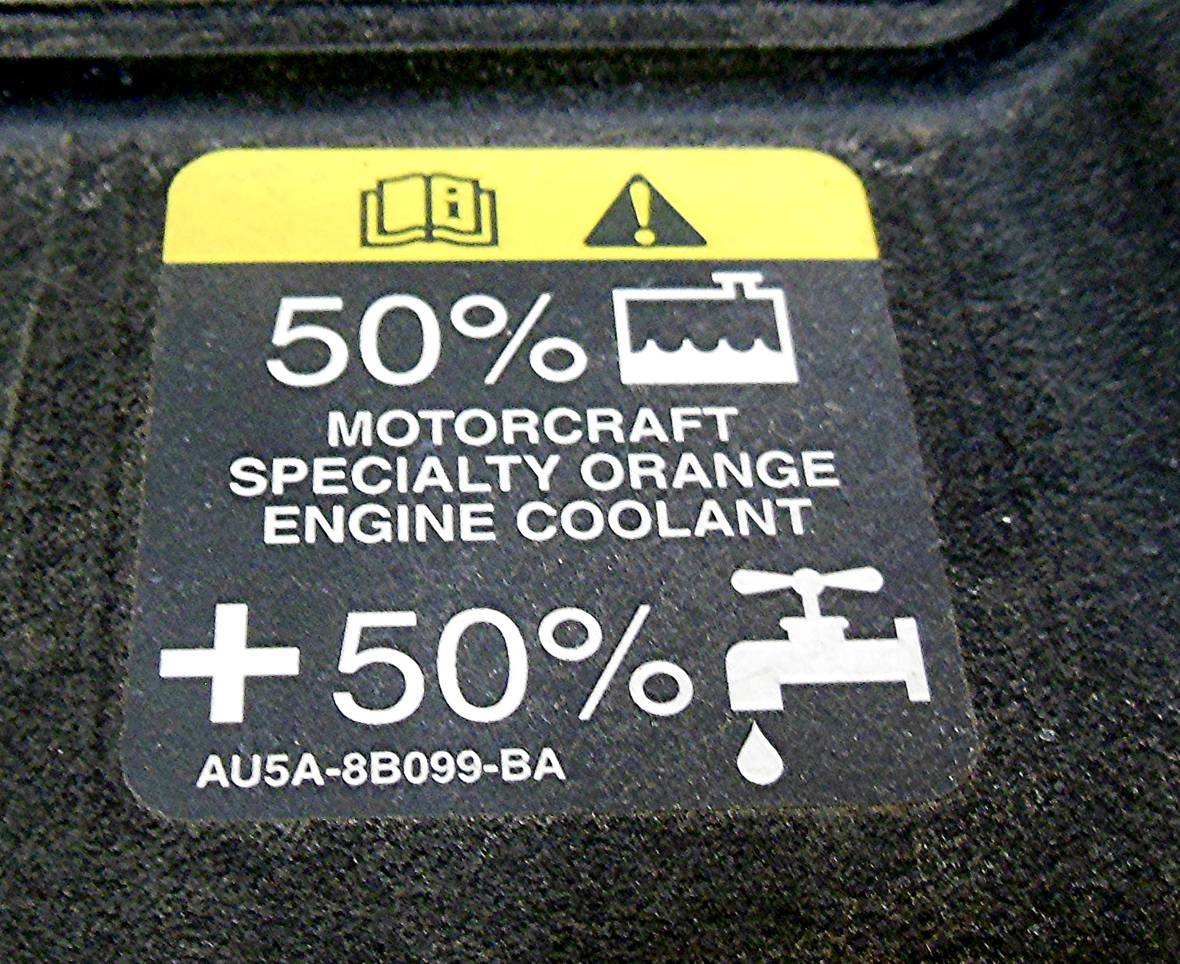
_________________________________________________________________

_____ 3. Describe the results of the pressure test.
Leak(s) found? ____Yes ____No
Pressure cap okay? ____Yes ____No

_____ 4. Based on the test and the inspection, what are the needed repairs? ________________
__________________________________________________________________
__________________________________________________________________

