Inspect and Repair/Replace the Cooling Fan

Meets ASE Task: (A9-D-13) Inspect and repair the cooling fan and related components.

Name _______________________________ Date ___________ Time on Task __________

Make/Model/Year _________________ VIN ________________ Evaluation: 4 3 2 1

_____ 1. Check service information for the specified procedure to follow when inspecting and
replacing the cooling fan. Describe the specified procedure. ________________
_________________________________________________________________
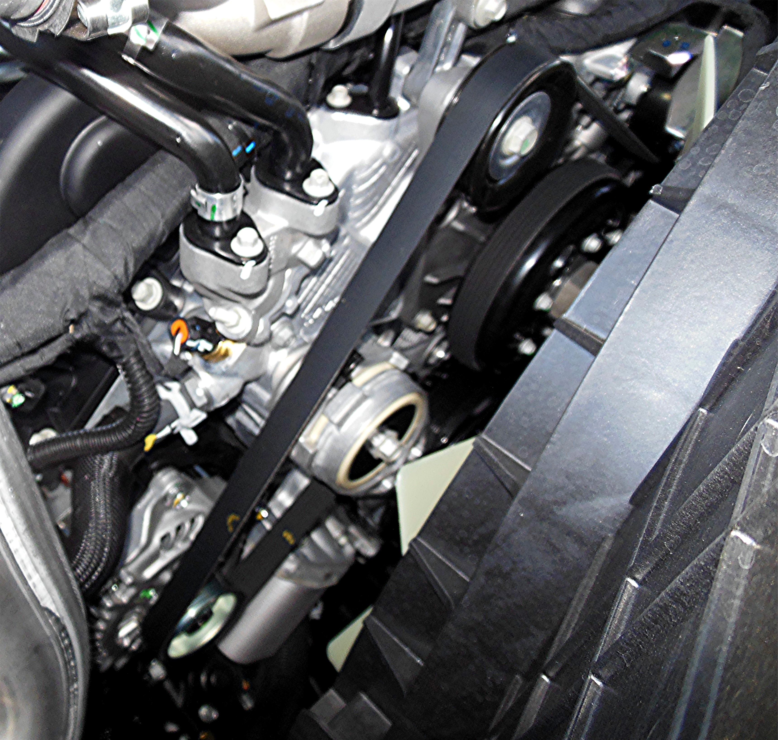
_________________________________________________________________
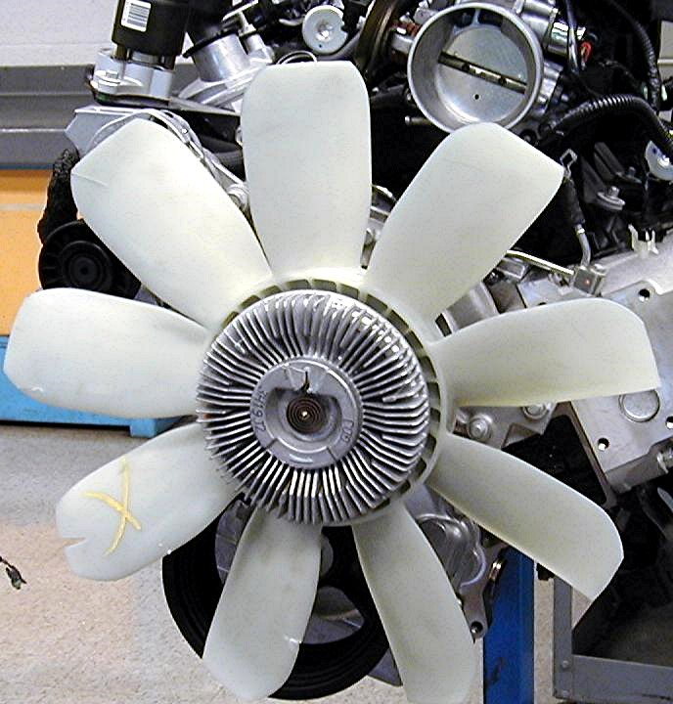
_____ 2. Inspect the following and describe the results:
Cooling fan ________________________________________________________
Fan hub ___________________________________________________________
Fan clutch _________________________________________________________
Fan controls _______________________________________________________
Fan shroud ________________________________________________________

