Engine Leak Inspection

Meets ASE Task: (A9-A-6) Inspect engine for leaks; determine the needed repairs.

Name _______________________________ Date ___________ Time on Task __________

Make/Model/Year _________________ VIN ________________ Evaluation: 4 3 2 1

_____ 1. Perform a thorough inspection of the engine for fuel, coolant, exhaust, or other leaks.
Describe the result of this inspection. ___________________________________
__________________________________________________________________
__________________________________________________________________
__________________________________________________________________

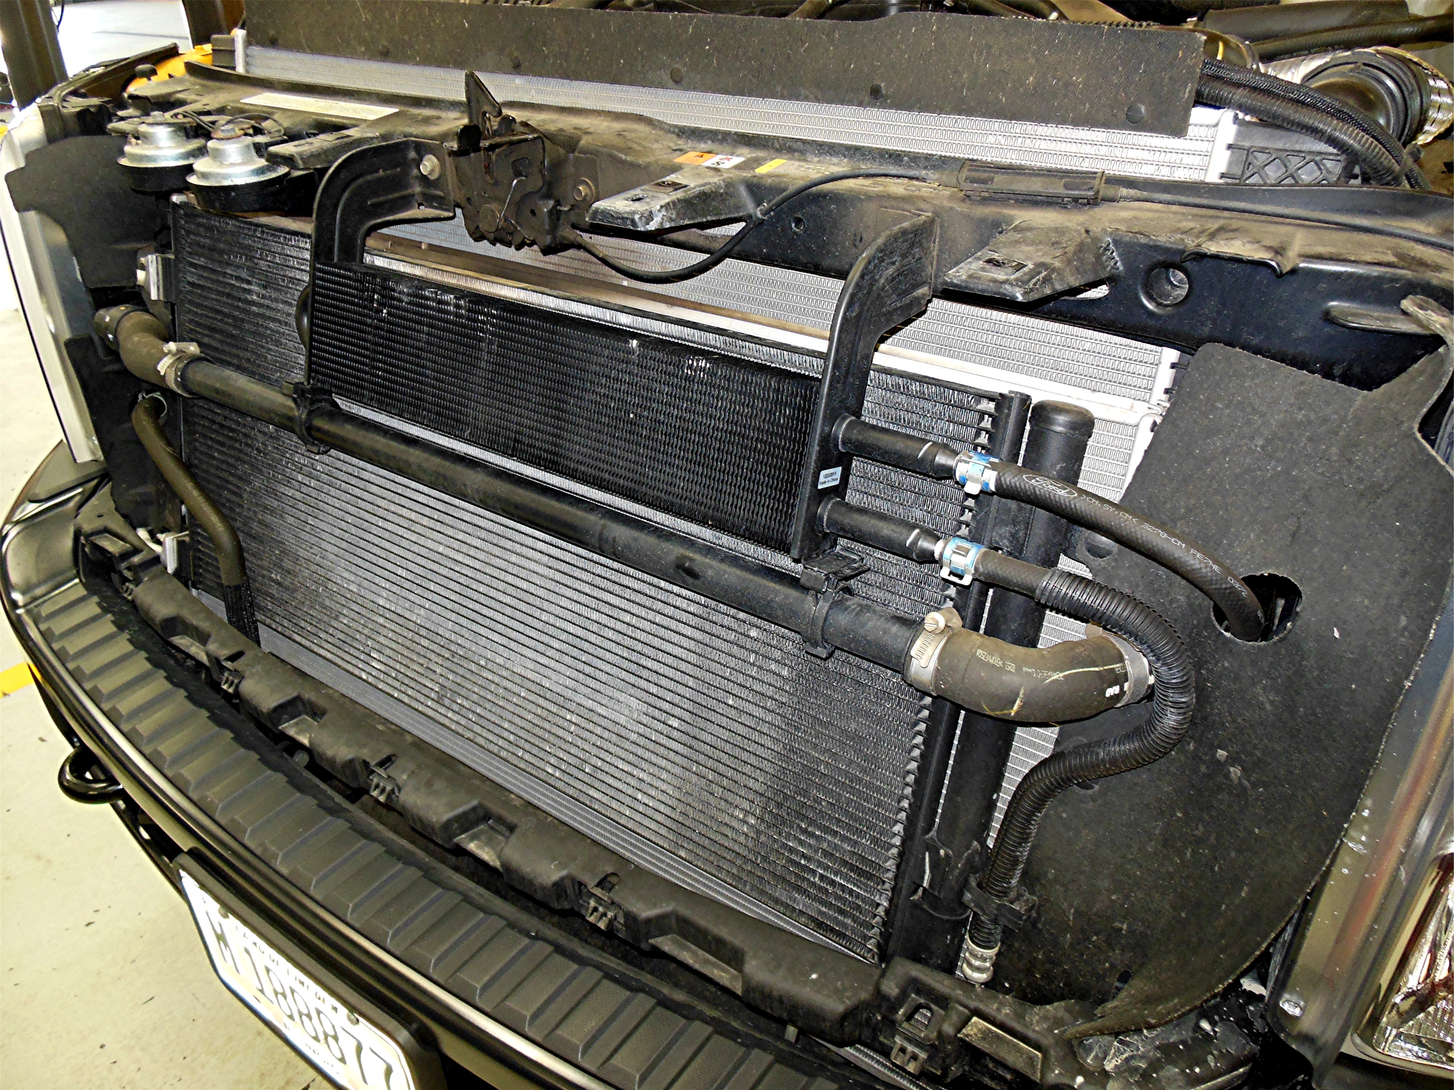

_____ 2. Based on the results of the thorough visual inspection, what are the needed service
repairs? __________________________________________________________
_________________________________________________________________
_________________________________________________________________
_________________________________________________________________

