Engine Block Inspection
Meets ASE Task: (A9-C-2) Disassemble, clean, and inspect the engine block.

Name _______________________________ Date ___________ Time on Task __________

Make/Model/Year _________________ VIN ________________ Evaluation: 4 3 2 1

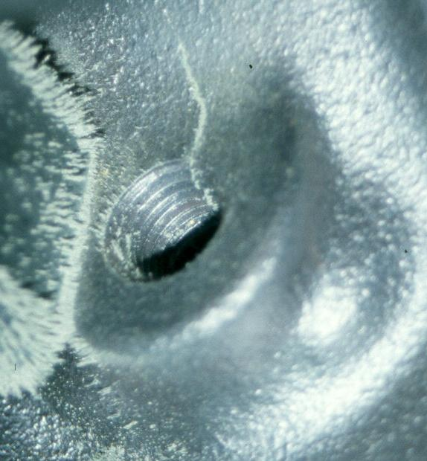
_____ 1. Visually check the engine block for cracks.

OK ____ NOT OK ____

Describe fault(s) _____________________________
___________________________________________
___________________________________________
___________________________________________

_____ 2. Inspect block passages (coolant and oil) for condition.

OK ____ NOT OK ____ Describe fault(s) _____________________________
________________________________________________

_____ 3. Inspect core and gallery plugs condition for signs of leakage.

OK ____ NOT OK ____ describe fault(s) _____________________________
________________________________________________
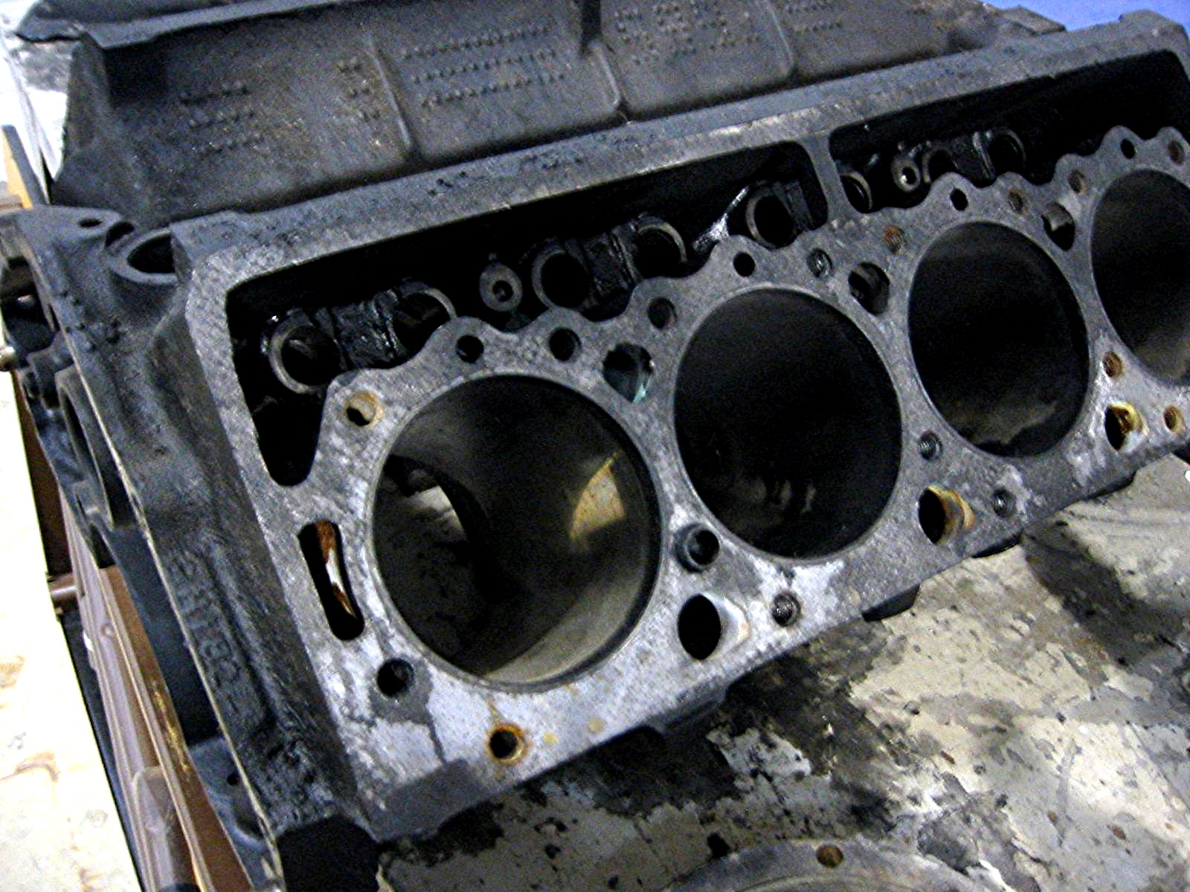
_____ 4. Check surface for warpage:

A. Specification for maximum
allowable warpage = __________

B. Measured amount of
warpage = __________

_____ 5. What is the needed action? ____________________________________________

________________________________________________________________

