Diesel Engine Operation Diagnosis

Meets ASE Task: (A9-A-13) Diagnose rough engine operation; determine the needed actions.

Name _______________________________ Date ___________ Time on Task __________

Make/Model/Year _________________ VIN ________________ Evaluation: 4 3 2 1

_____ 1. Check the operation for the following and check all that apply.
____ Surging ____ Rough on
____ Misfiring ____ Low power
____ Slow deceleration (slowing down) ____ Shut-down problem
____ Slow acceleration (speeding up)
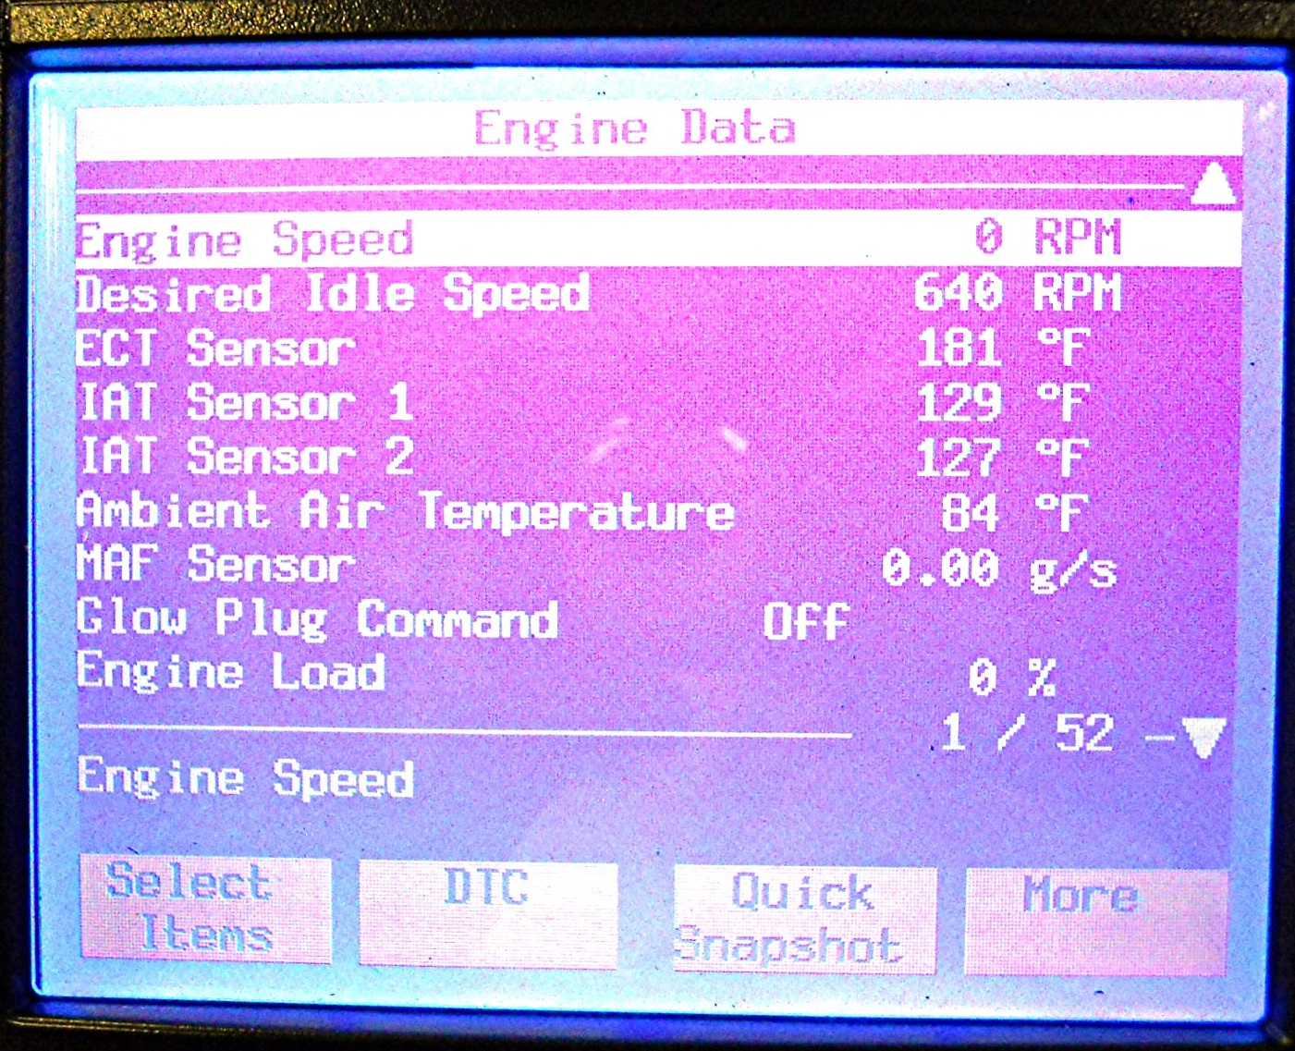

_____ 2. Check the PCM for any stored diagnostic trouble codes and list any found.
_________________________________________________________________
_________________________________________________________________
_____ 3. Check scan tool data for possible causes of engine operating faults. ______________
_________________________________________________________________
_________________________________________________________________
_____ 4. Based on the inspection and diagnosis, what is the needed action? _______________
_________________________________________________________________
_________________________________________________________________

