Engine Cranking and Starting Diagnosis
Meets ASE Task: (A9-A-16) Diagnose engine cranking and starting; determine the needed actions.

Name _______________________________ Date ___________ Time on Task __________

Make/Model/Year _________________ VIN ________________ Evaluation: 4 3 2 1

_____ 1. Check service information for the specified tests and procedures to follow when
diagnosing cranking and/or starting problems. Describe the specified procedure.
__________________________________________________________________
__________________________________________________________________
__________________________________________________________________
_____ 2. Using a scan tool, check for proper input and output signals and commands that are
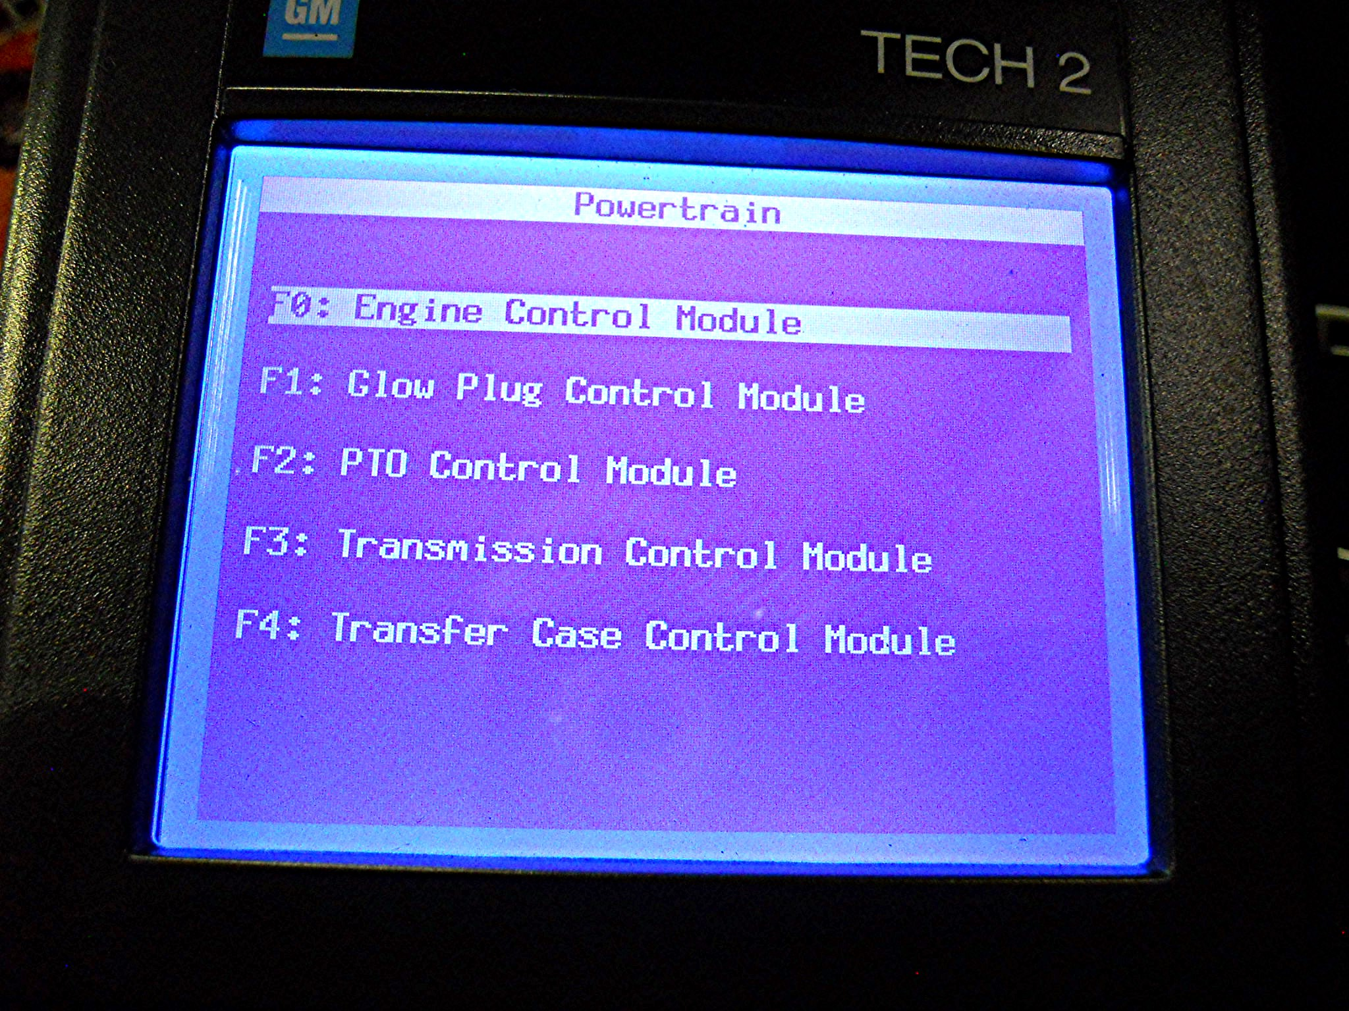
related to engine starting. Describe any faults or concerns found. ____________
__________________________________________________________________
__________________________________________________________________

_____ 3. Based on the inspection and diagnosis, what is/are the action(s)? ________________
__________________________________________________________________
__________________________________________________________________

