Diesel Engine Charging System Diagnosis
Meets ASE Task: (A9-A-18) Diagnose engine problems associated with the charging system; determine the needed action.

Name _______________________________ Date ___________ Time on Task __________

Make/Model/Year _________________ VIN ________________ Evaluation: 4 3 2 1

_____ 1. Check service information for the specified tests and procedures to follow when
diagnosing a charging system-related problem. Describe the specified procedure.
__________________________________________________________________
__________________________________________________________________
_____ 2. Is the alternator equipped with an overrunning alternator pulley (OAP) or overrunning
alternator dampener (OAD)? _____ Yes ____ No
If yes, is the pulley working as designed? _____ Yes ____ No
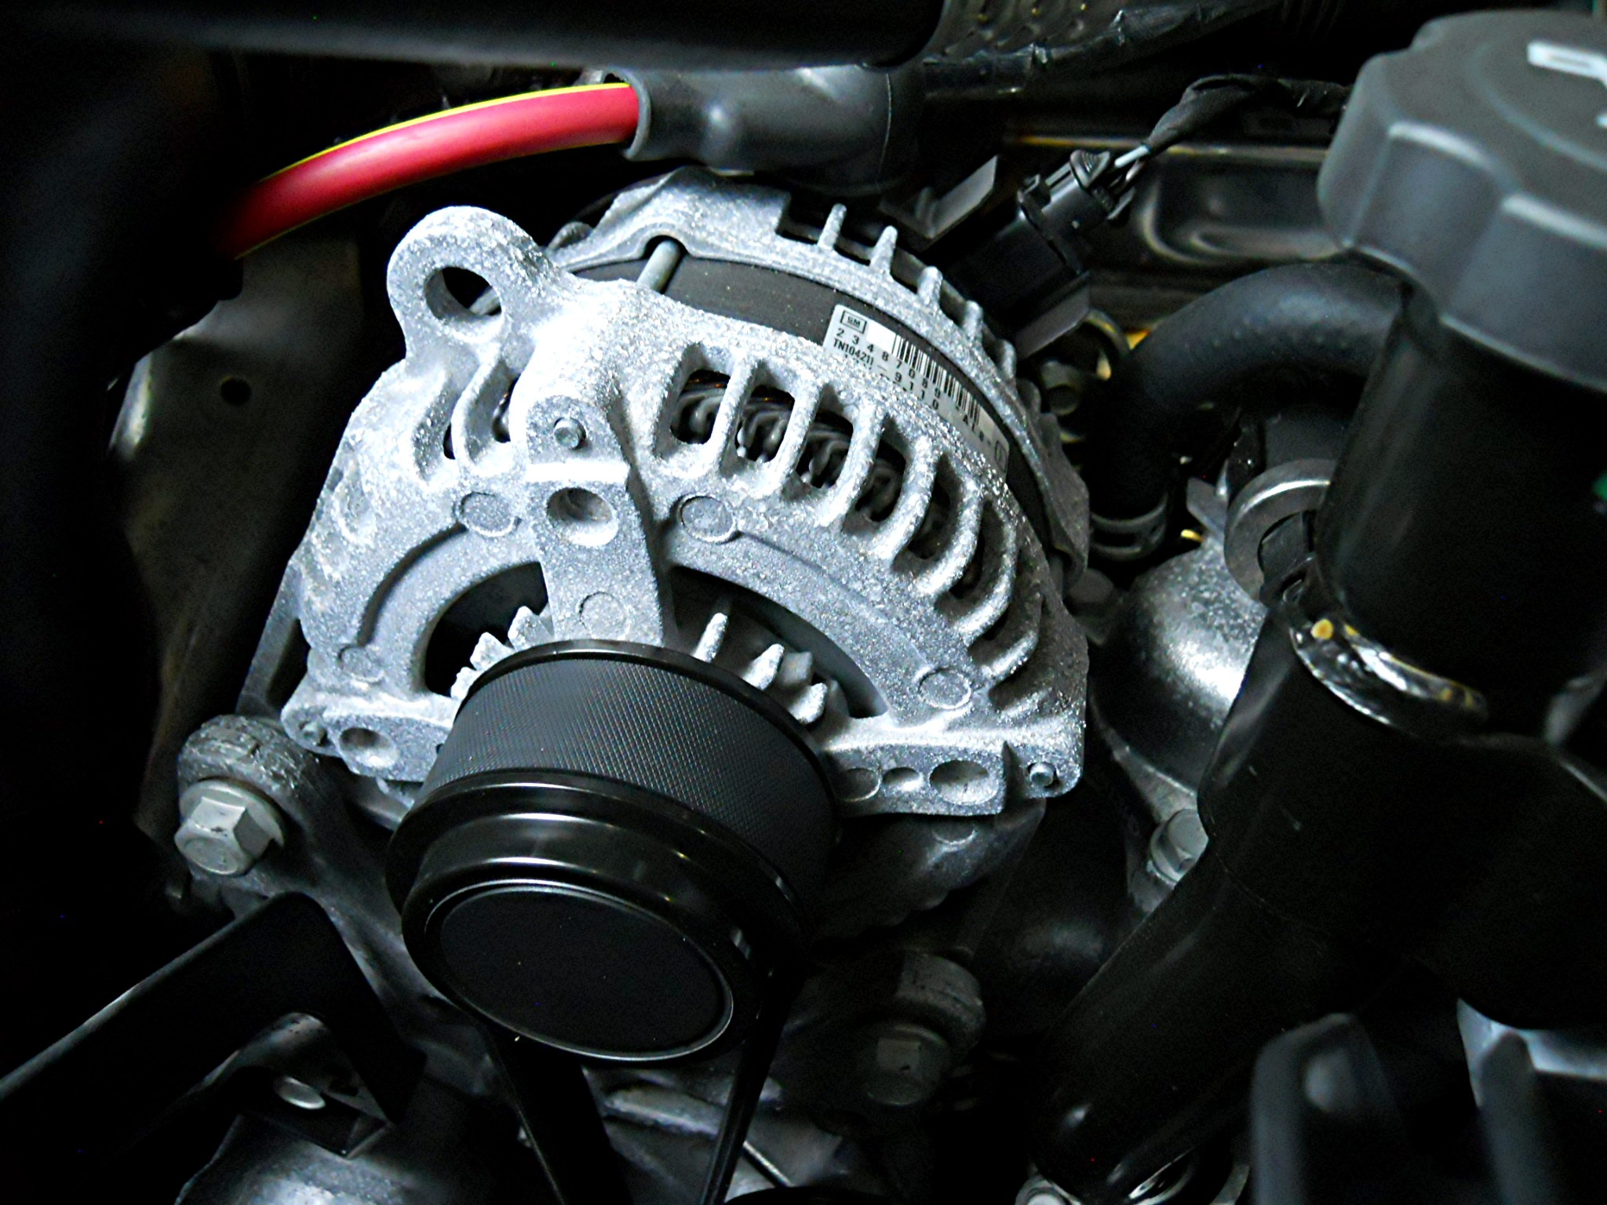

_____ 3. Test the alternator output and compare it to the factory specification.
Alternator output specification = __________________
Measured Output = ___________________
____ OK ____ NOT OK
_____ 4. Based on the test results, what action is needed? ______________________________
_________________________________________________________________

