Inspect Engine Cylinder Walls
Meets ASE Task: (A9-C-3) Inspect and measure cylinder walls.

Name _______________________________ Date ___________ Time on Task __________

Make/Model/Year _________________ VIN ________________ Evaluation: 4 3 2 1

_____ 1. Check service information for the specified procedure to follow when inspecting and
measuring cylinder walls.
What is the specified procedure? _______________________________________
__________________________________________________________________
__________________________________________________________________
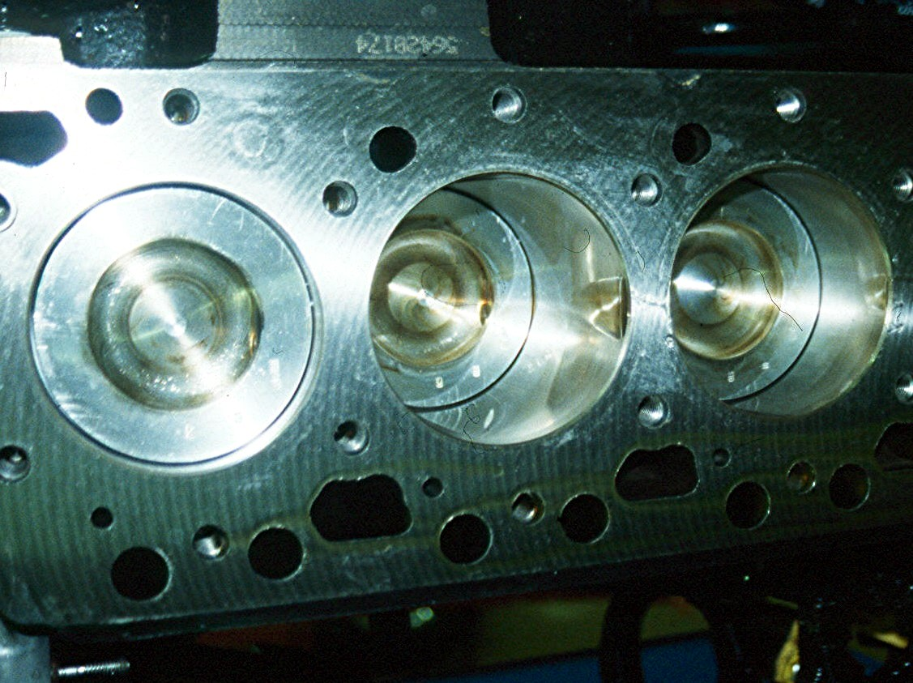
_____ 2. What is the specified cylinder wear measurement?

- Specification = ____________

- Measured = _______________

_____ 3. Based on the inspection and measurement, what is the needed service?

__________________________________________________________________
__________________________________________________________________
__________________________________________________________________

