Inspect Threaded Holes, bolts, and Studs
Meets ASE Task: (A9-B-2) Inspect threaded holes, studs, and bolts for serviceability; service/replace as needed.

Name _______________________________ Date ___________ Time on Task __________

Make/Model/Year _________________ VIN ________________ Evaluation: 4 3 2 1

_____ 1. Check service information for the specified procedure to follow when inspecting
threaded fasteners. What is the specified procedure? __________________________
_________________________________________________________________
_________________________________________________________________
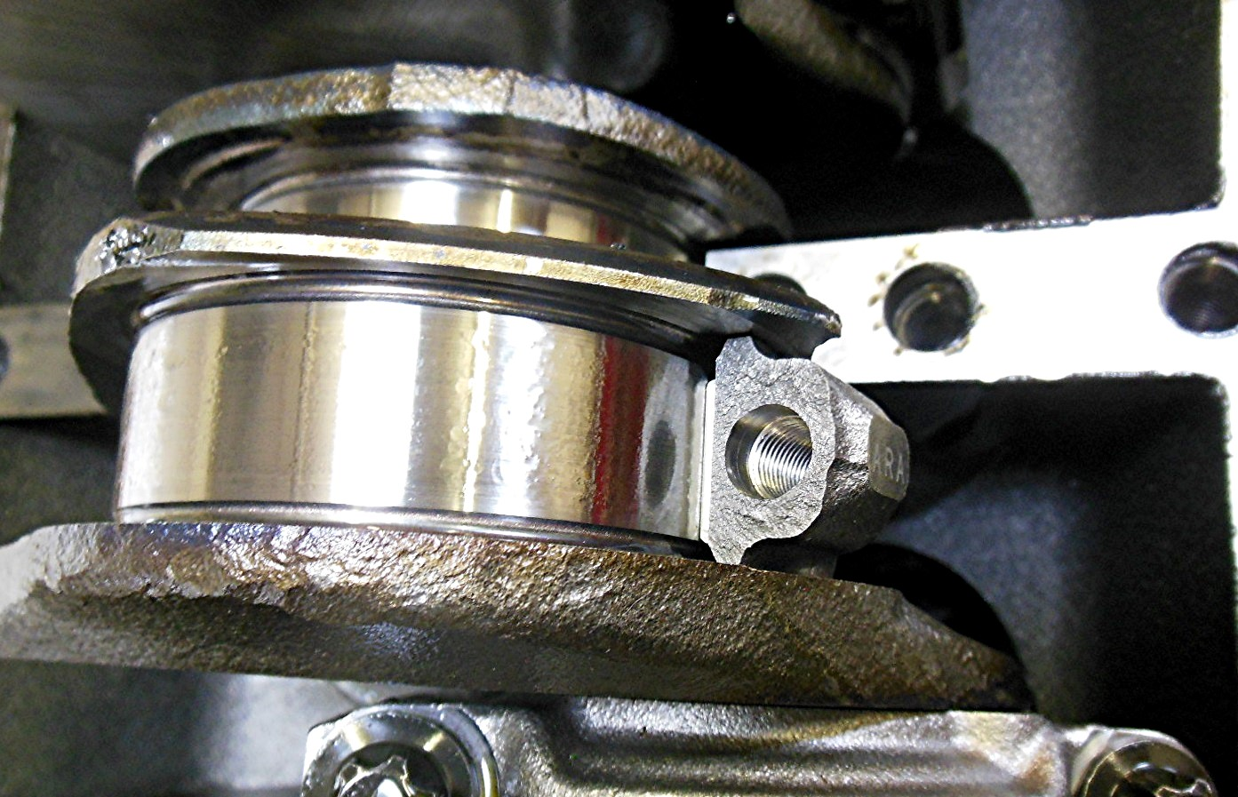

_____ 2. What service was needed to clean the threaded holes? _________________________
_________________________________________________________________
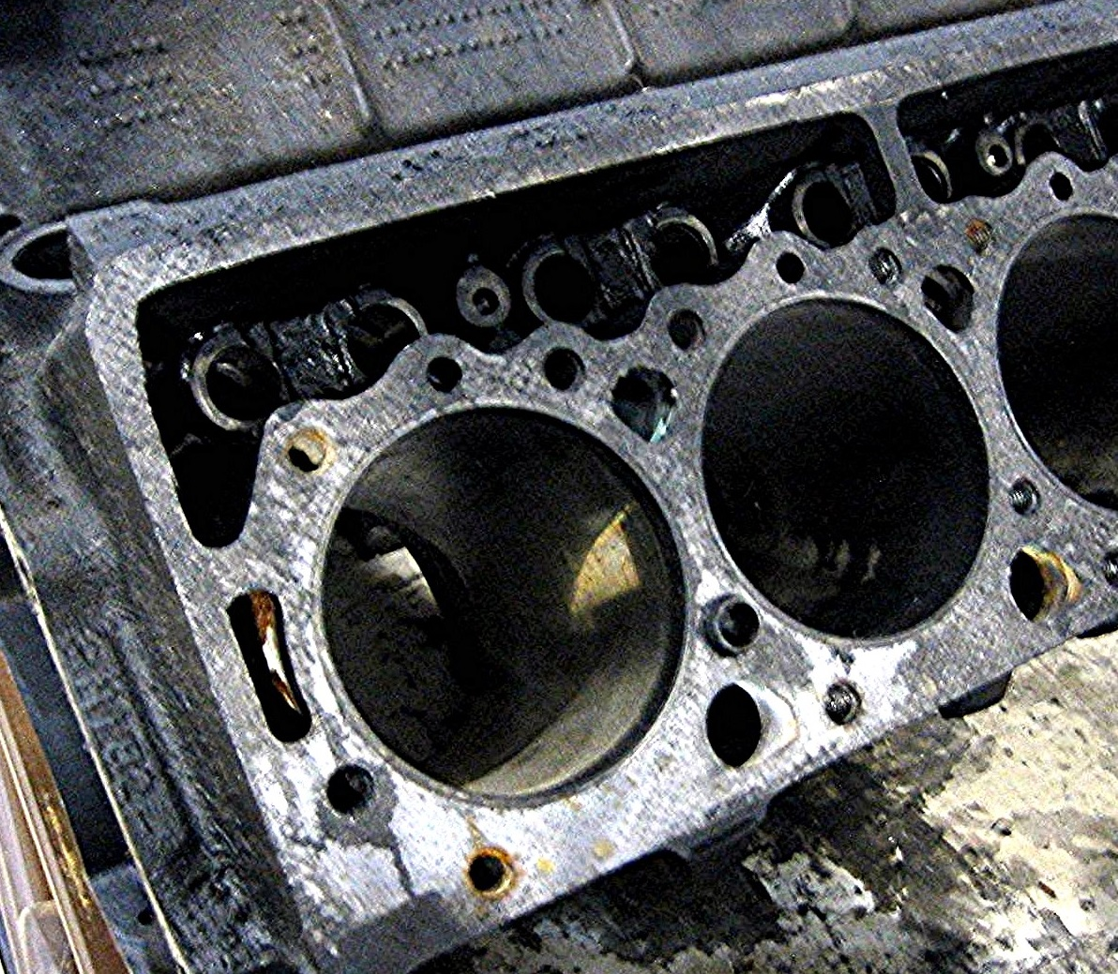
_____ 3. What was the result of the inspection?
_____ All of the threaded fasteners can be reused.
_____ Most of the threaded fasteners can be reused
_____ None of the fasteners can be reused.
_____ 4. Based on the inspection, what is the needed action?
__________________________________________
__________________________________________
__________________________________________

