Inspect Valves and Valve Guides
Meets ASE Task: (A9-B-4) Inspect valves, guides, seats, springs, retainers, rotators, locks, and seals; determine needed service.

Name _______________________________ Date ___________ Time on Task __________

Make/Model/Year _________________ VIN ________________ Evaluation: 4 3 2 1

_____ 1. Check service information for the specifications and inspection procedures for valves
and valve-related components. What are the specifications and specified procedures?
__________________________________________________________________
__________________________________________________________________
__________________________________________________________________
_____ 2. Describe the condition of the following:
- Valves _____________________________________
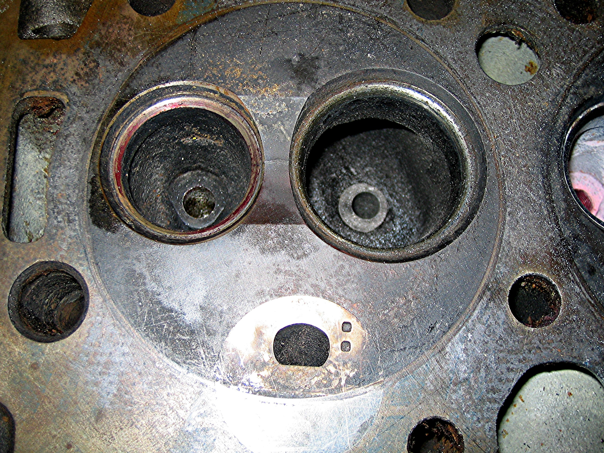
- Seats _______________________________________

- Springs _____________________________________________________
- Retainer ____________________________________________________
- Rotators ____________________________________________________
- Locks ______________________________________________________
- Seals _______________________________________________________
_____ 3. Based on the inspection, what is the needed service? __________________________
__________________________________________________________________

