Inspect Injectors and Glow Plug Sleeves
Meets ASE Task: (A9-B-5) Inspect and service injectors and glow plug sleeves and seals.

Name _______________________________ Date ___________ Time on Task __________

Make/Model/Year _________________ VIN ________________ Evaluation: 4 3 2 1

_____ 1. Check service information for the specified inspection procedures and specifications
for the glow plug and injector sleeve service. What are the specified procedures and
specifications? _______________________________________________________
________________________________________________________________
________________________________________________________________
_____ 2. Remove and inspect the fuel injector. Perform specified inspection and measurement
according to factory specifications. _______________________________________
_________________________________________________________________
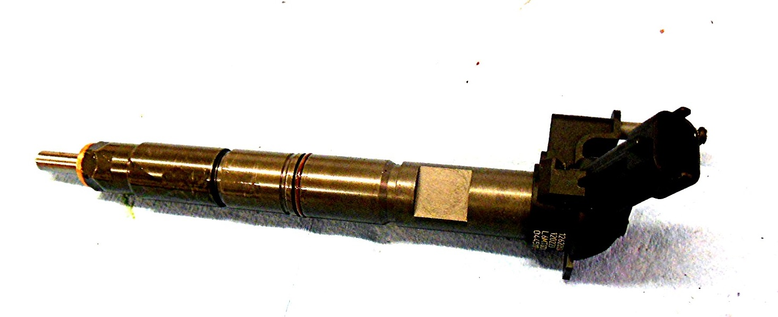

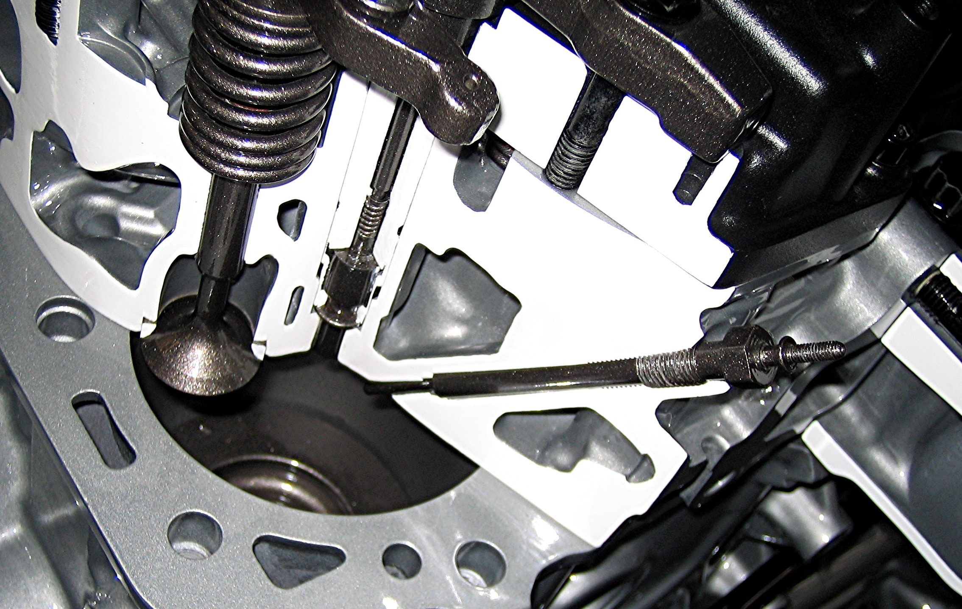
_____ 3. Remove and inspect the glow plug
and perform specific inspection.

_____ 4. What other inspections and measurements are
specified by the vehicle manufacturer?
Describe inspection results. ______________________________________________
_________________________________________________________________
_________________________________________________________________

