Inspect Crankshaft Vibration Damper

Meets ASE Task: (A9-C-14) Inspect crankshaft damper; determine needed repairs.

Name _______________________________ Date ___________ Time on Task __________

Make/Model/Year _________________ VIN ________________ Evaluation: 4 3 2 1

_____ 1. Check service information for the specified procedure to follow when inspecting the
crankshaft damper. Describe the specified procedure. _____________________
_________________________________________________________________
_________________________________________________________________
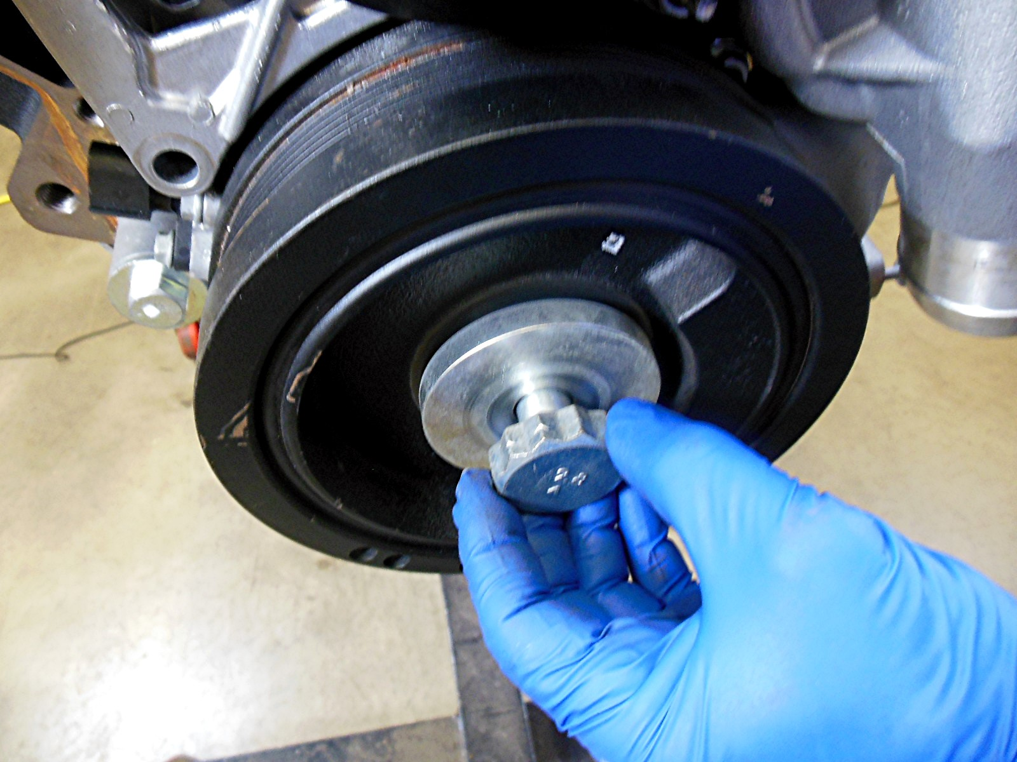

_____ 2. Based on the inspection, what is the needed repair? ____________________________
__________________________________________________________________
__________________________________________________________________

