Inspect Flywheel/Flexplate

Meets ASE Task: (A9-C-15) Inspect the flywheel/flexplate; determine the needed repairs.

Name _______________________________ Date ___________ Time on Task __________

Make/Model/Year _________________ VIN ________________ Evaluation: 4 3 2 1

_____ 1. Check service information for the specified procedure and specification when
checking the flywheel/flexplate. Describe the specified procedure and
specifications, including:
Surface finish specification = _________________________________________
___________________________________________________________
Wear limit specification = ____________________________________________
___________________________________________________________
Wear limit measurement = ___________________________________________
___________________________________________________________
Runout specification = _______________________________________________
___________________________________________________________
Runout measurement = ______________________________________________
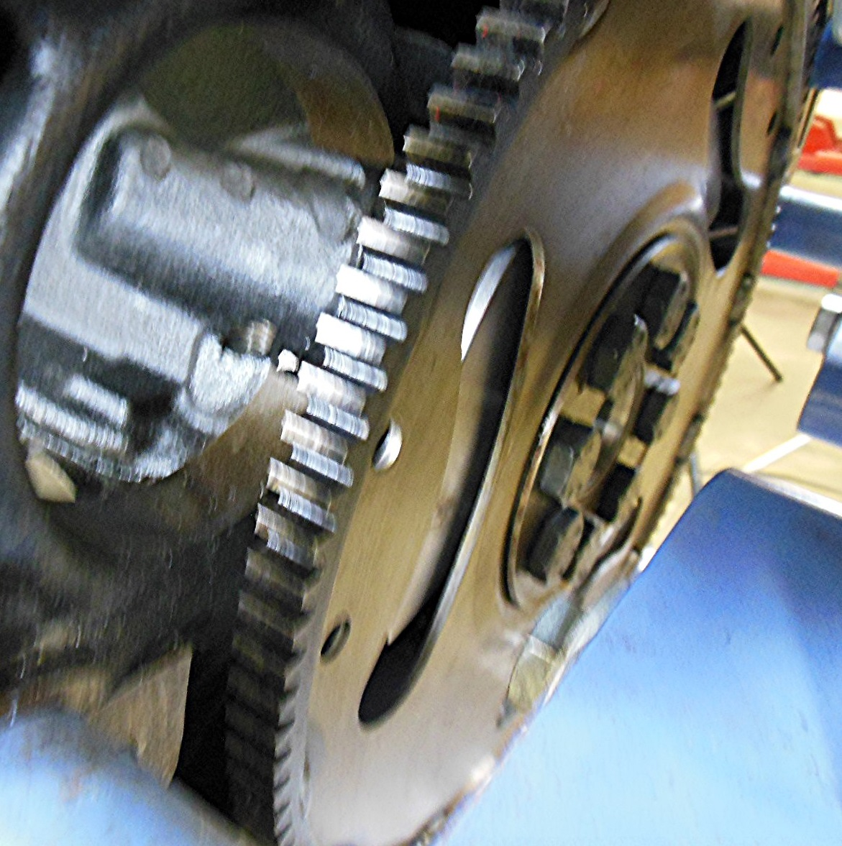
___________________________________________________________

_____ 2. Based on the results of the inspection, what is the needed repair? ________________
_________________________________________________________________ _________________________________________________________________

