Service the Air Cleaner System
Meets ASE Task: (A9-E-1) Inspect and service/replace air induction piping, air cleaner and element; determine the needed action.

Name _______________________________ Date ___________ Time on Task __________

Make/Model/Year _________________ VIN ________________ Evaluation: 4 3 2 1

_____ 1. Check service information for the specified procedures to follow when inspecting the
air induction and air cleaner systems. Describe the specified procedures. _______
__________________________________________________________________
__________________________________________________________________
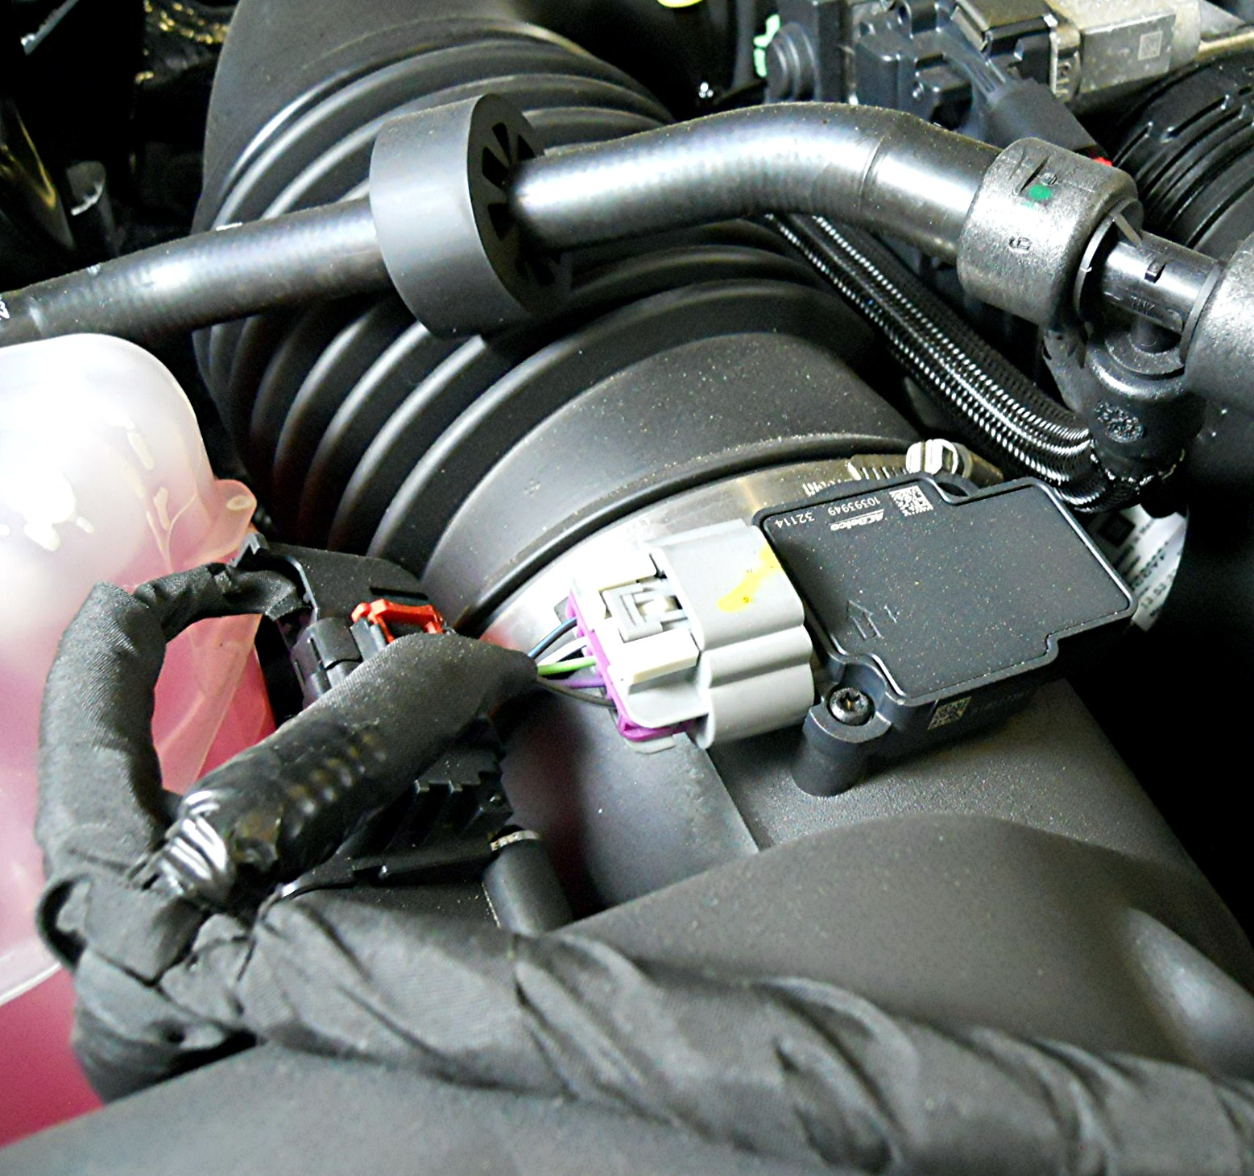
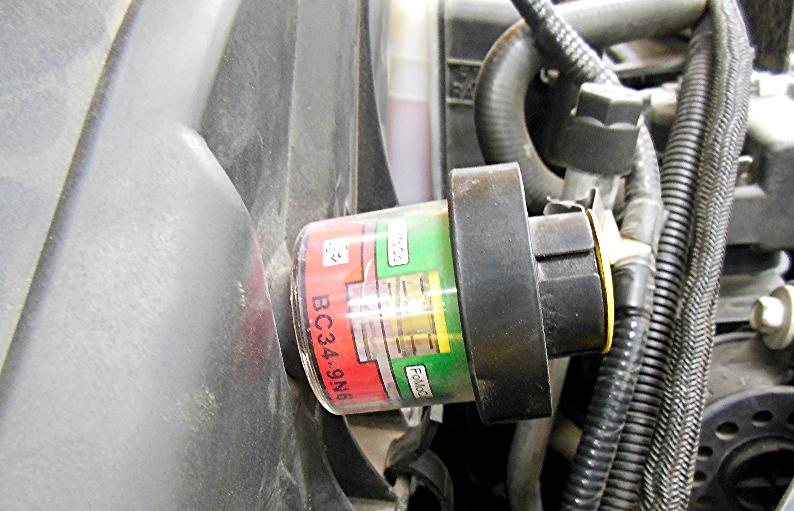

_____ 2. Check all that apply.
_____ Uses cold air induction
_____ Uses an air filter monitor, indicating when the air filter should be replaced.
_____ Uses a MAF sensor.
_____ 3. Based on the inspection, what is the needed action? ___________________________
_________________________________________________________________
_________________________________________________________________

