Intake Manifold Pressure Test
Meets ASE Task: (A9-E-2) Perform an intake manifold pressure test; test, inspect charge air cooling and determine the needed action.

Name _______________________________ Date ___________ Time on Task __________

Make/Model/Year _________________ VIN ________________ Evaluation: 4 3 2 1

_____ 1. Check service information for the specified procedures to follow to perform an intake
manifold pressure test. Describe the specified procedures. __________________
__________________________________________________________________
__________________________________________________________________
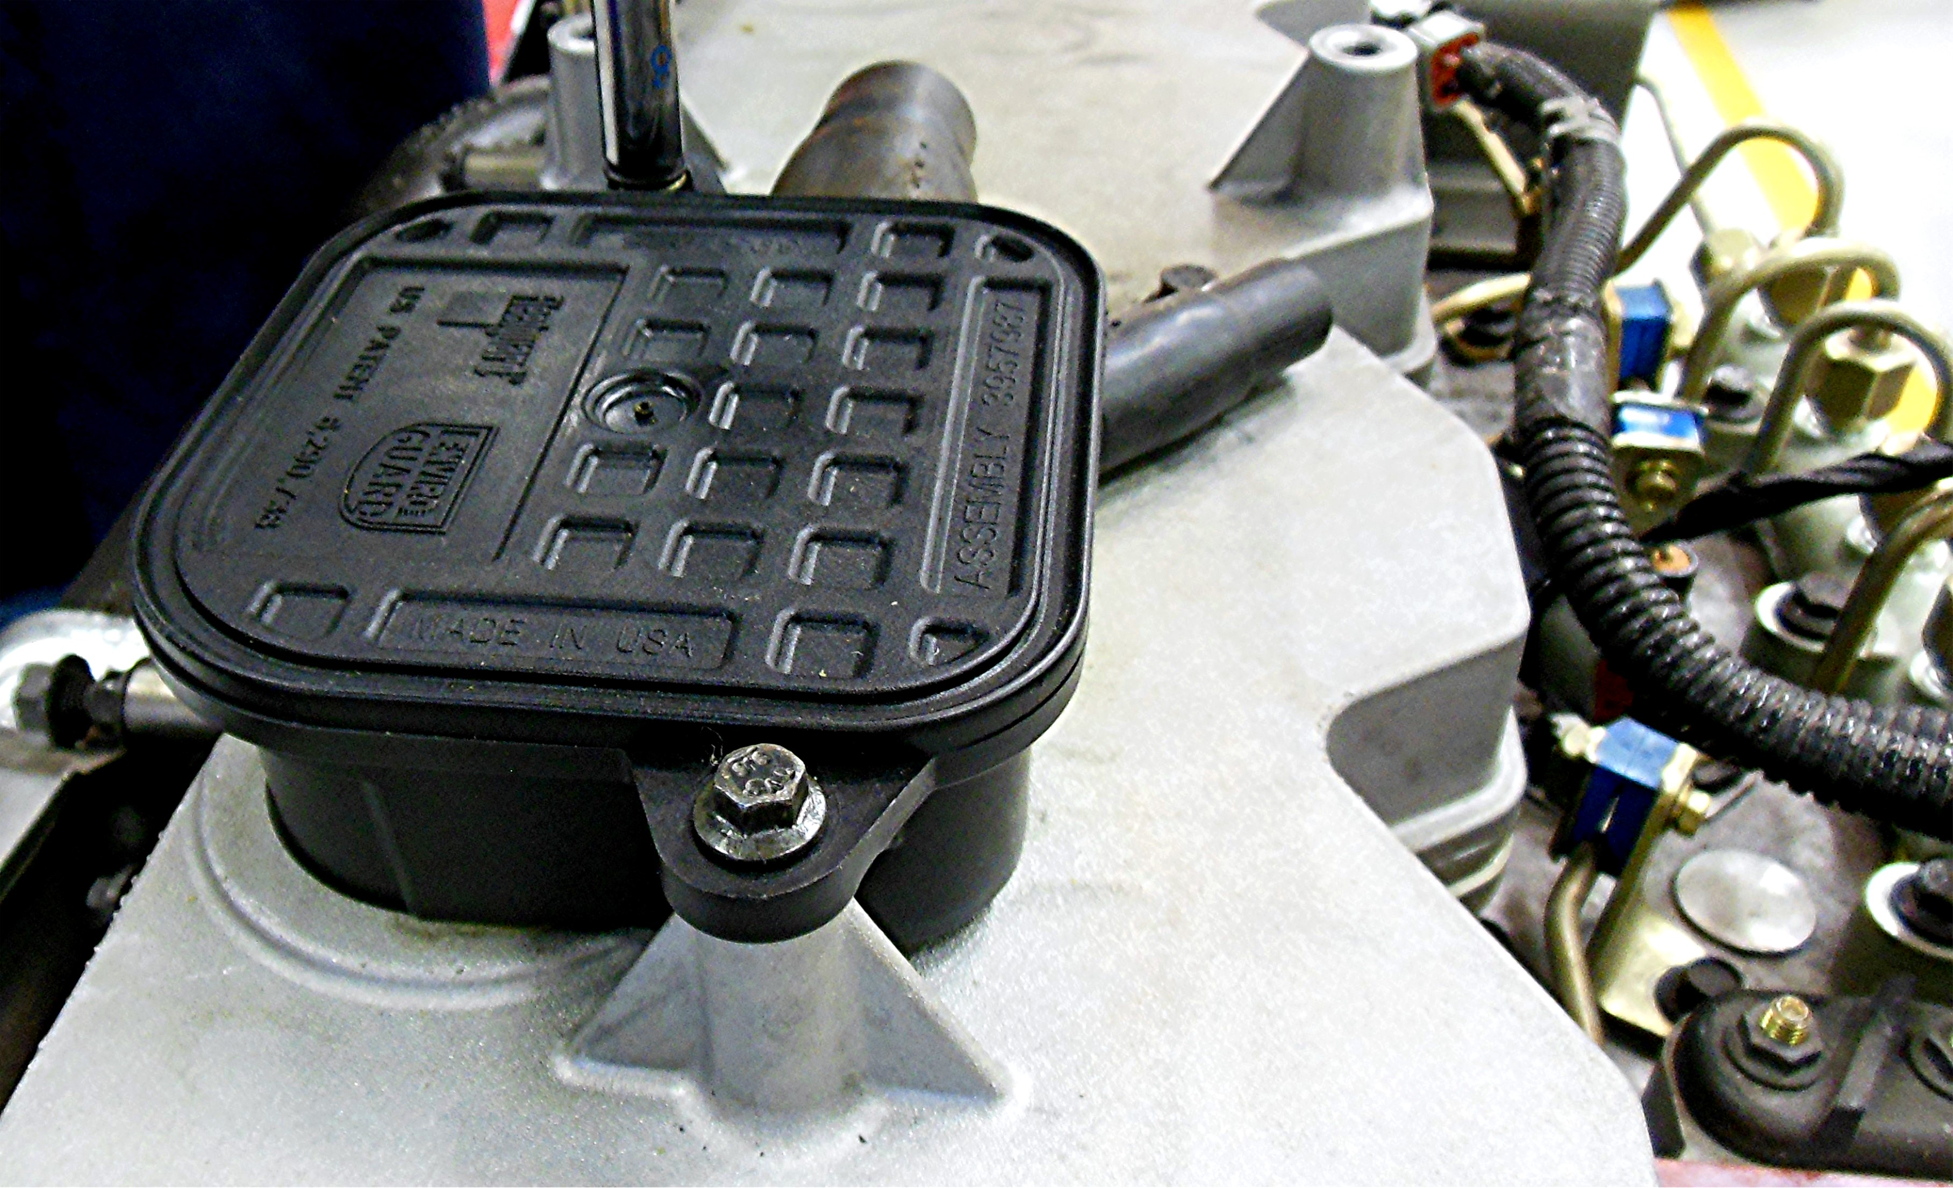

_____ 2. Inspect the air charge cooler. Describe the location and condition. _______________
__________________________________________________________________
__________________________________________________________________
_____ 3. Based on the tests and inspections, what is the needed action? ___________________
__________________________________________________________________
__________________________________________________________________

