Inspect Crankcase Ventilation System
Meets ASE Task: (A9-E-11) Inspect, test, and replace crankcase ventilation system components, including sensors, filters, valves, and piping.

Name _______________________________ Date ___________ Time on Task __________

Make/Model/Year _________________ VIN ________________ Evaluation: 4 3 2 1

_____ 1. Check service information for the specified procedure to follow when inspecting and
testing the following components. Describe the specified procedures.
Crankcase pressure sensor ____________________________________________
____________________________________________________________
Crankcase filter ____________________________________________________
___________________________________________________________
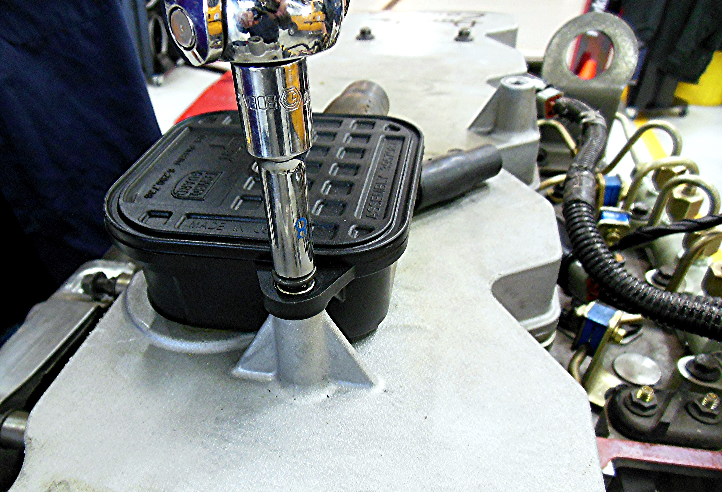

Crankcase ventilation piping and valves _________________________________
____________________________________________________________

