Fuel Inspection
Meets ASE Task: (A9-A-11) Check fuel for commination, quantity, quality, and consumption; determine the needed action.

Name _______________________________ Date ___________ Time on Task __________

Make/Model/Year _________________ VIN ________________ Evaluation: 4 3 2 1

_____ 1. Check service information for the specified procedure to follow to get a fuel sample.
What is the specified procedure? ______________________________________
_________________________________________________________________
_________________________________________________________________
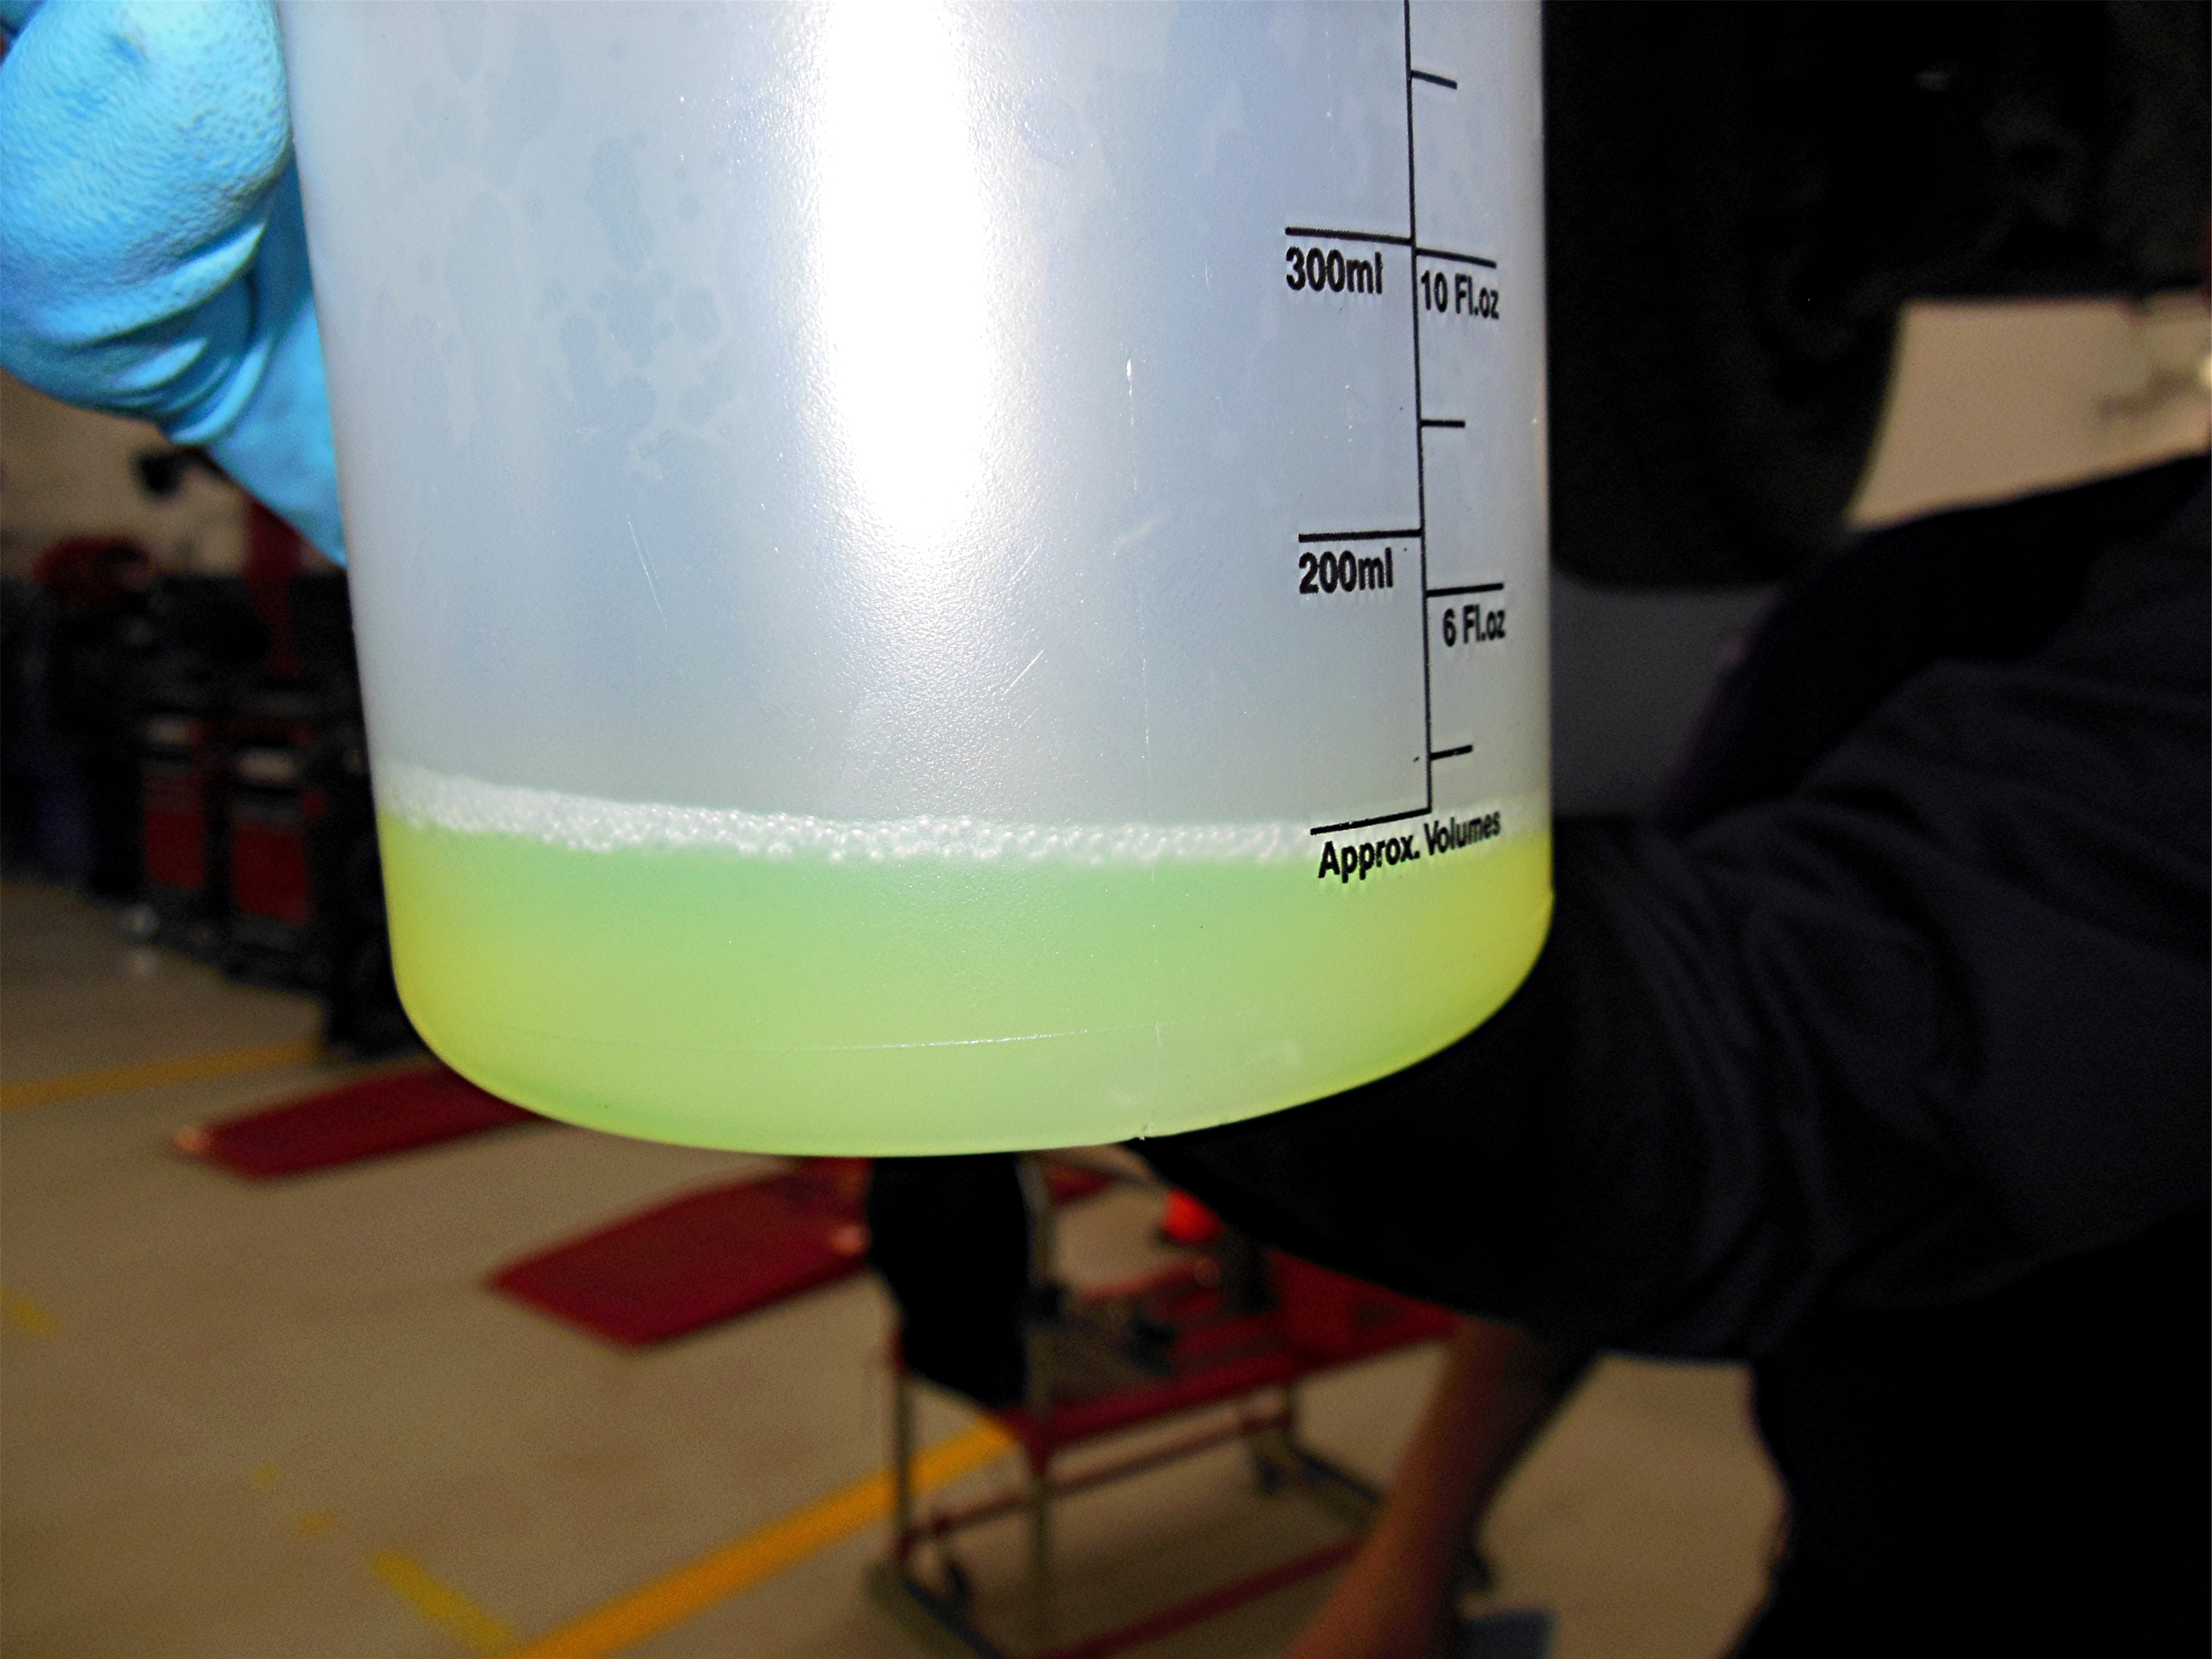

_____ 2. Based on the fuel sample evaluation, what is the needed action? _________________
__________________________________________________________________
__________________________________________________________________

