Inspect Fuel System Components
Meets ASE Task: (A9-F-1) Inspect, clean, test, and repair/replace fuel system tanks, vents, caps, mounts, valve, supply and return lines.

Name _______________________________ Date ___________ Time on Task __________

Make/Model/Year _________________ VIN ________________ Evaluation: 4 3 2 1

_____ 1. Check service information for the specified procedure to follow when inspecting,
cleaning, and testing the following diesel fuel system components. Describe the
specific procedures for each of the following:
Fuel cap __________________________________________________________
___________________________________________________________
___________________________________________________________
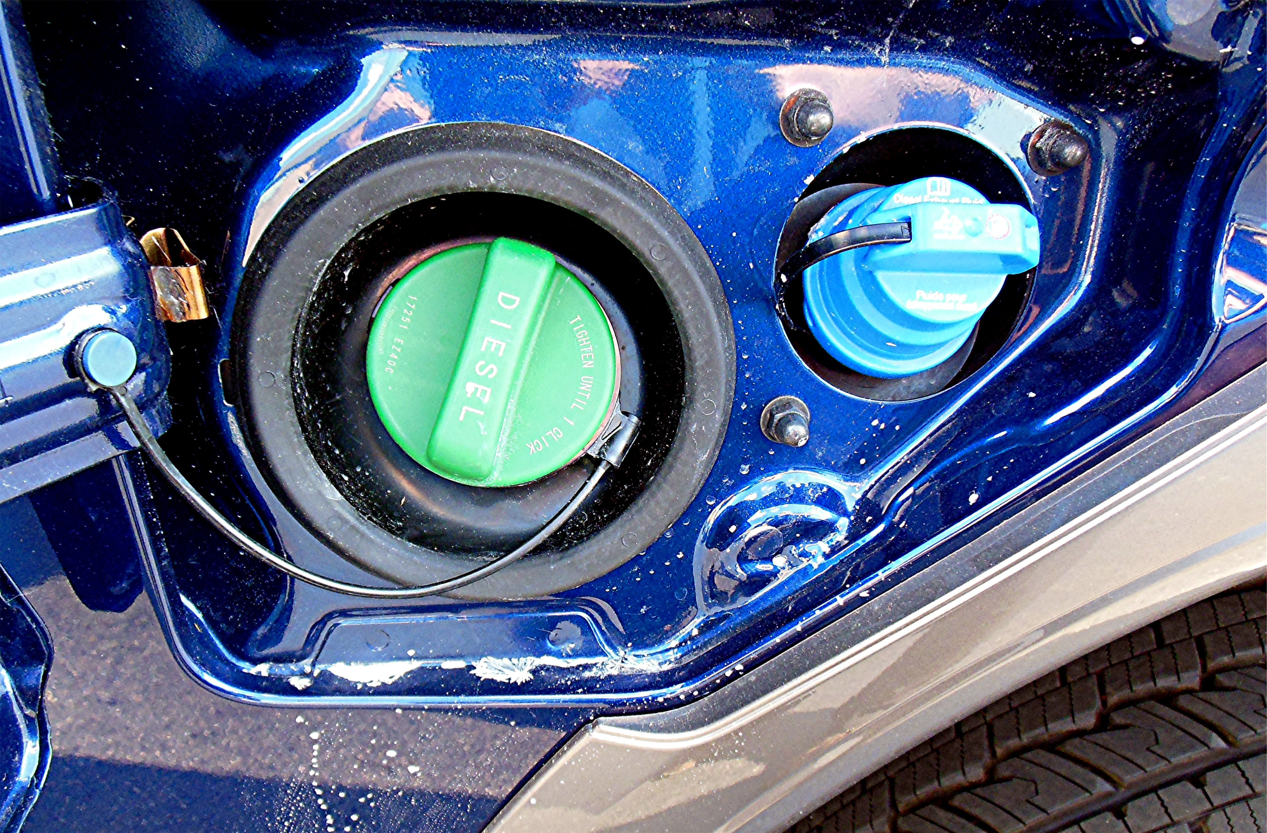

Fuel tank(s) _______________________________________________________
___________________________________________________________
___________________________________________________________
Fuel valves and lines ________________________________________________
___________________________________________________________
___________________________________________________________

