Diesel Fuel Pump Filters and Heaters
Meets ASE Task: (A9-F-2) Inspect, clean, test, and repair/replace fuel transfer/supply pump, sensors, strainers, fuel/water separators, filters, heaters, coolers, and related components.

Name _______________________________ Date ___________ Time on Task __________

Make/Model/Year _________________ VIN ________________ Evaluation: 4 3 2 1

_____ 1. Check service information for the specified procedure to follow when performing an
inspection or replacement of the following components. Describe the specified
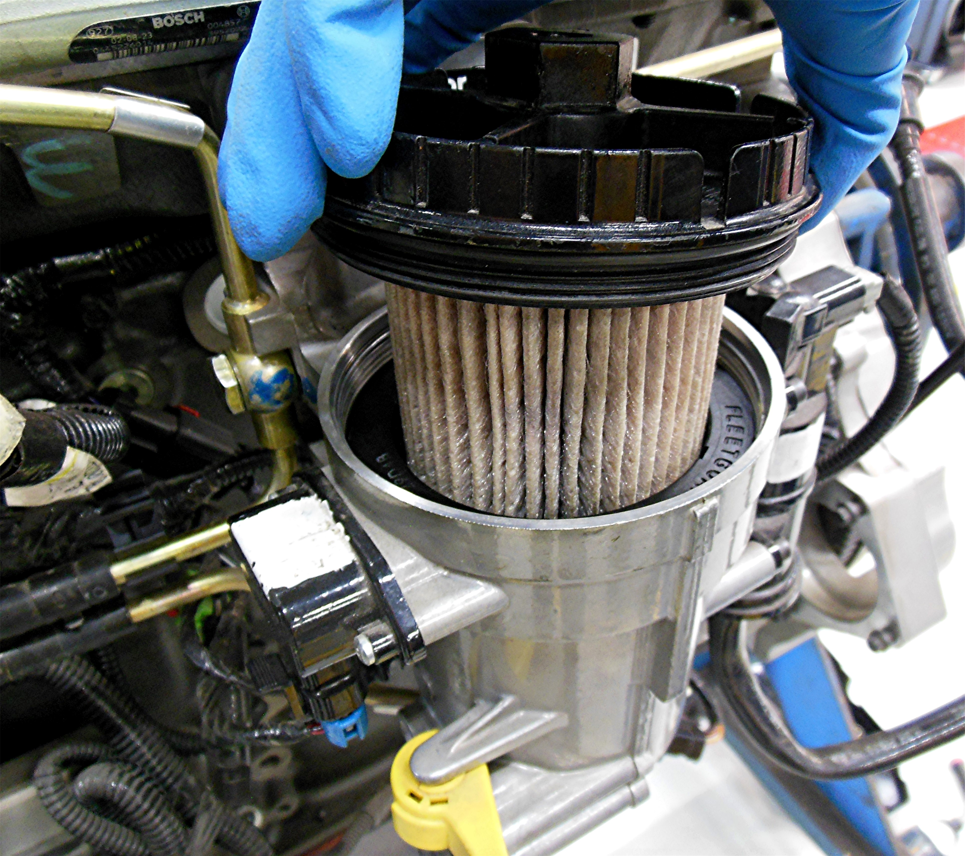
procedures.

Fuel filter _________________________________
___________________________________
___________________________________
___________________________________
___________________________________

Supply (transfer) pump ______________________________________________
___________________________________________________________
Fuel/water separator ________________________________________________
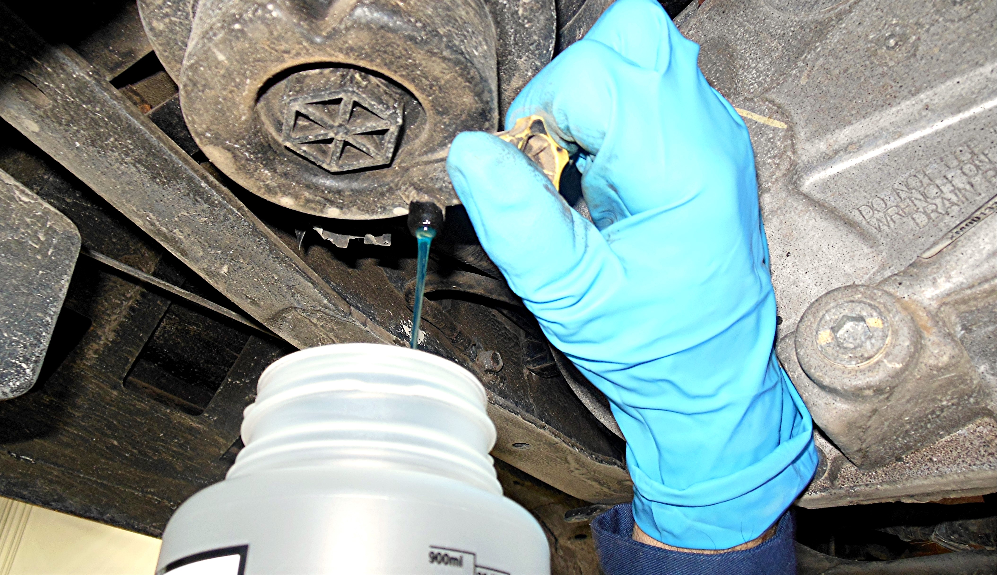
___________________________________________________________

Fuel heater/cooler _________________________________________________
__________________________________________________________

