Inspect High-Pressure Fuel Lines
Meets ASE Task: (A9-F-5) Inspect and reinstall/replace high-pressure injection lines, fittings, transfer tubes, seals and mounting hardware.

Name _______________________________ Date ___________ Time on Task __________

Make/Model/Year _________________ VIN ________________ Evaluation: 4 3 2 1

_____ 1. Check service information for the specified procedure to follow when inspecting and
replacing high-pressure injection lines. Describe the specified procedure.
_________________________________________________________________
_________________________________________________________________
_________________________________________________________________
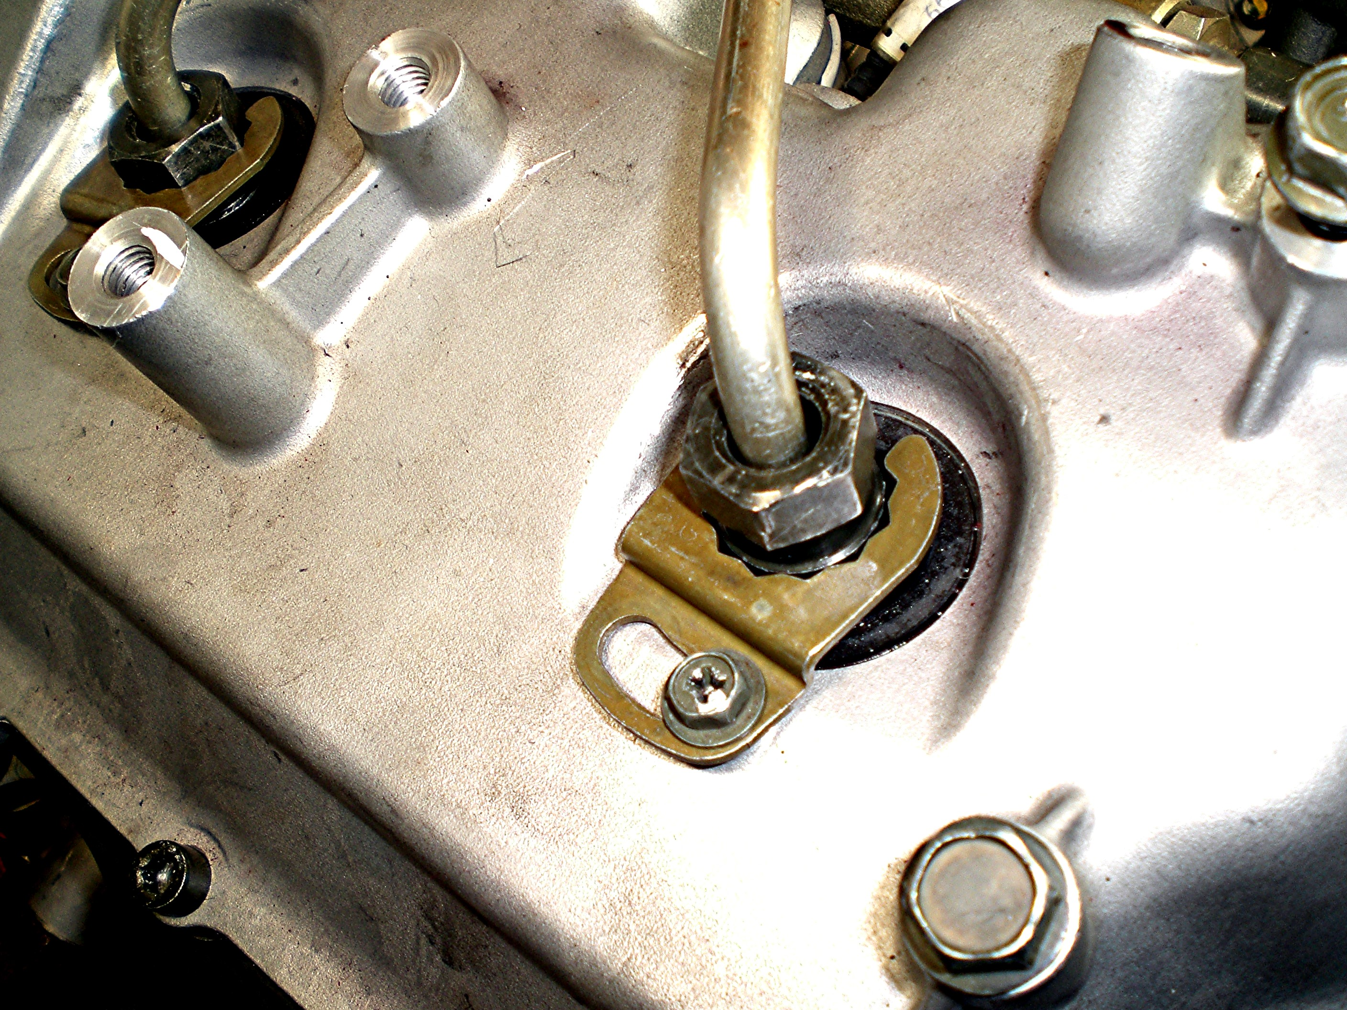

_____ 2. Check service information for the specified procedure to follow when inspecting and
replacing the transfer tubes. Describe the specified procedure. _______________
__________________________________________________________________



