Replace Electronic Unit Injectors
Meets ASE Task: (A9-F-10) Perform on-engine inspection and tests; replace electronic unit injector components and electronic controls.

Name _______________________________ Date ___________ Time on Task __________

Make/Model/Year _________________ VIN ________________ Evaluation: 4 3 2 1

_____ 1. Check service information for the specified procedure to follow when inspecting and
testing electronic unit injector components. Describe the specified procedure.
__________________________________________________________________
__________________________________________________________________
__________________________________________________________________
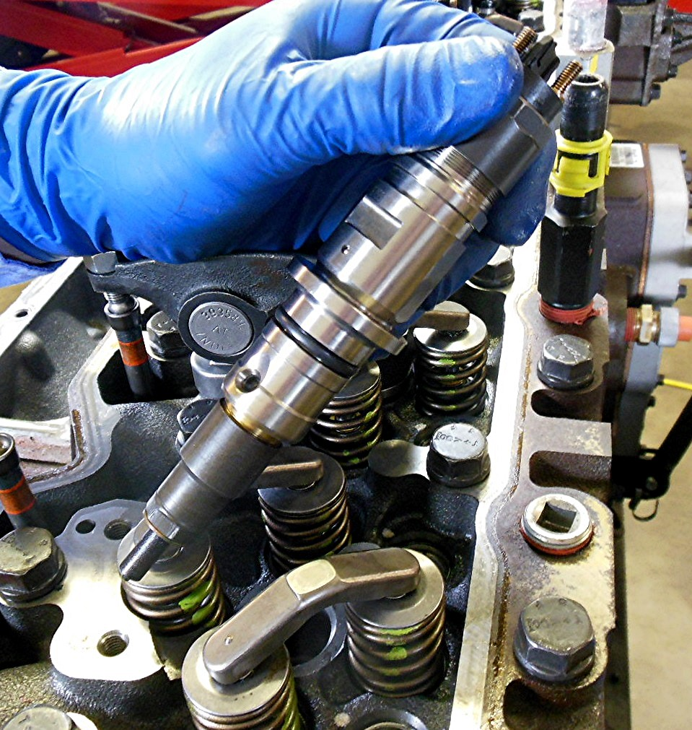

_____ 2. Check service information for the specified procedure that needs to be performed
when replacing electronic unit injectors. Describe the specified procedure.
__________________________________________________________________
__________________________________________________________________
__________________________________________________________________

