Service the Crankshaft and Journals
Meets ASE Task: (A9-C-6) Clean and inspect the crankshaft journals; determine needed service.

Name _______________________________ Date ___________ Time on Task __________

Make/Model/Year _________________ VIN ________________ Evaluation: 4 3 2 1

_____ 1. Check service information for the specified procedure and measurements when
inspecting the crankshaft. What is the specified procedure? ____________________
__________________________________________________________________
__________________________________________________________________
_____ 2. Clean and inspect the crankshaft and journals for surface finish, cracks, and damage.
_____ OK _____ NOT OK
If not OK, what is the needed service? __________________________________
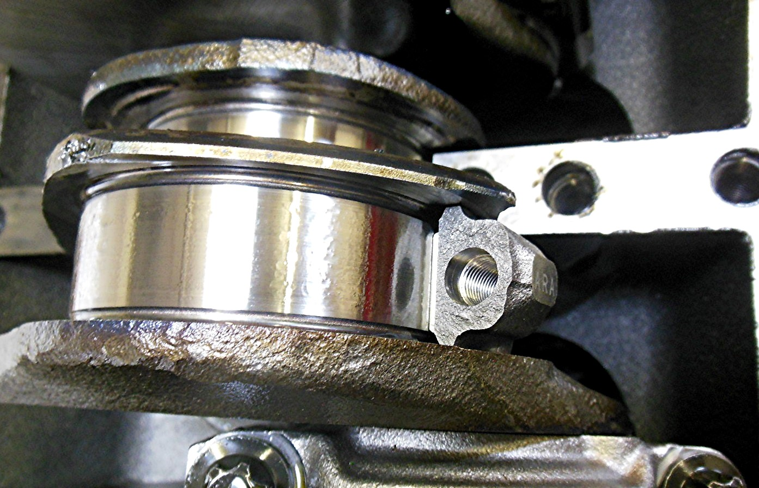

_____ 3. Measure the crankshaft journals and compare to specifications.
Main bearing journal specification = __________
Main bearing journal measurement = __________
_____ OK _____ NOT OK

Rod bearing journal specification = __________
Rod bearing journal measurement = __________
_____ OK _____ NOT OK

