Exhaust Back Pressure Test
Meets ASE Task: (A9-E-5) Perform exhaust back pressure and temperature tests; determine needed action.

Name _______________________________ Date ___________ Time on Task __________

Make/Model/Year _________________ VIN ________________ Evaluation: 4 3 2 1

_____ 1. Check service information for the specified procedure to follow when performing an
exhaust back pressure test, including:
Tools/equipment needed (describe): ____________________________________
_________________________________________________________________
Location where measurement is to be read: ______________________________
_________________________________________________________________
Specification for back pressure: _______________________________________
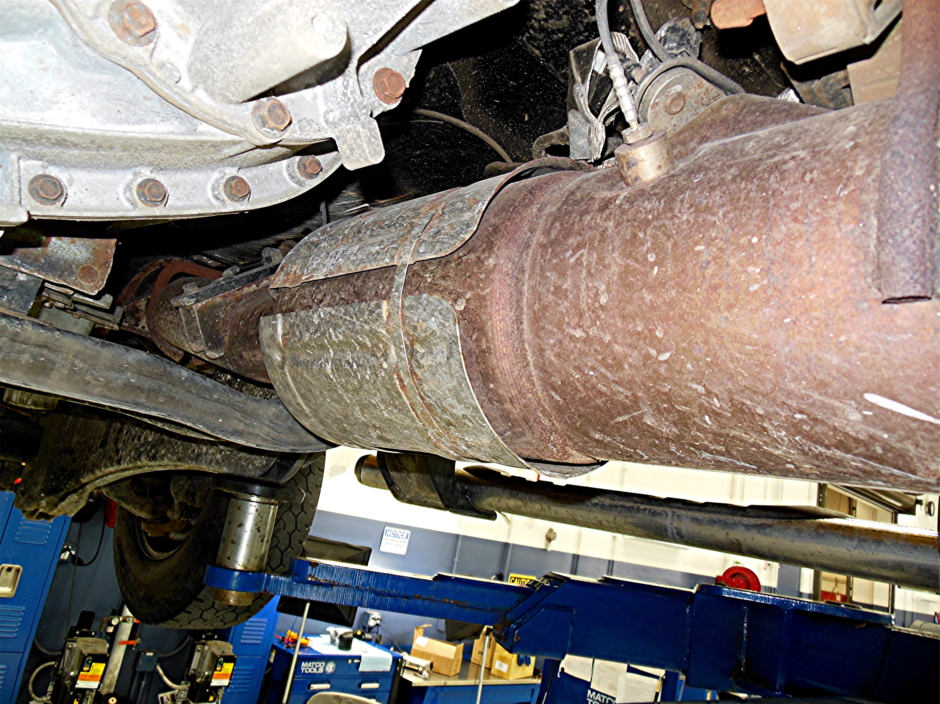

_____ 2. What were the test results? _________________________________________
____OK ____NOT OK
_____ 3. Perform temperature tests. Describe the results. _____________________________
________________________________________________________________
_____ 4. Based on the tests, what is the needed action? _______________________________
_________________________________________________________________

