Exhaust System Inspection
Meets ASE Task: (A9-E-6) Inspect and repair/replace exhaust manifold(s), gaskets, piping, mufflers and mounting hardware.

Name _______________________________ Date ___________ Time on Task __________

Make/Model/Year _________________ VIN ________________ Evaluation: 4 3 2 1

_____ 1. Check service information for the specified procedure to follow when inspecting and
replacing the exhaust manifold. Describe the specified procedure. ____________
__________________________________________________________________
__________________________________________________________________
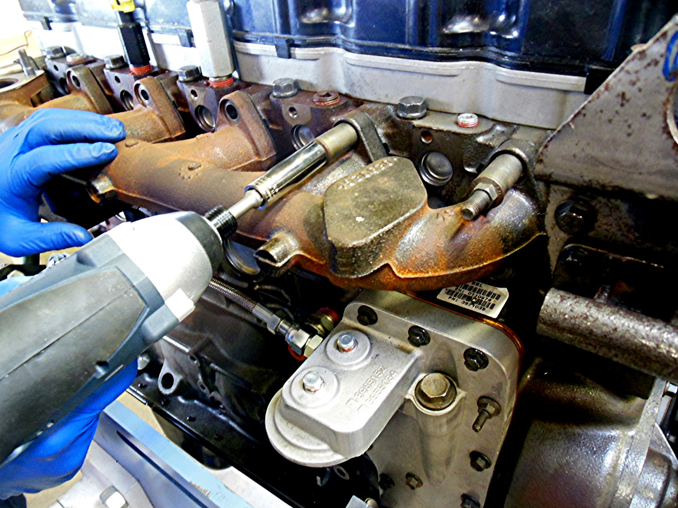

_____ 2. Perform an inspection of the exhaust system and describe its condition, including:
Gaskets _________________________________________________________
Piping __________________________________________________________
Muffler _________________________________________________________
Mounting hardware _______________________________________________
