Inspect Exhaust Aftertreatment Components
Meets ASE Task: (A9-E-8) Inspect, test, and replace exhaust aftertreatment system components and controls.

Name _______________________________ Date ___________ Time on Task __________

Make/Model/Year _________________ VIN ________________ Evaluation: 4 3 2 1

_____ 1. Check service information for the specified procedure to follow when inspecting,
testing, and replacing the diesel oxidation catalyst (DOC). Describe the specified
procedure. _________________________________________________________
__________________________________________________________________
__________________________________________________________________
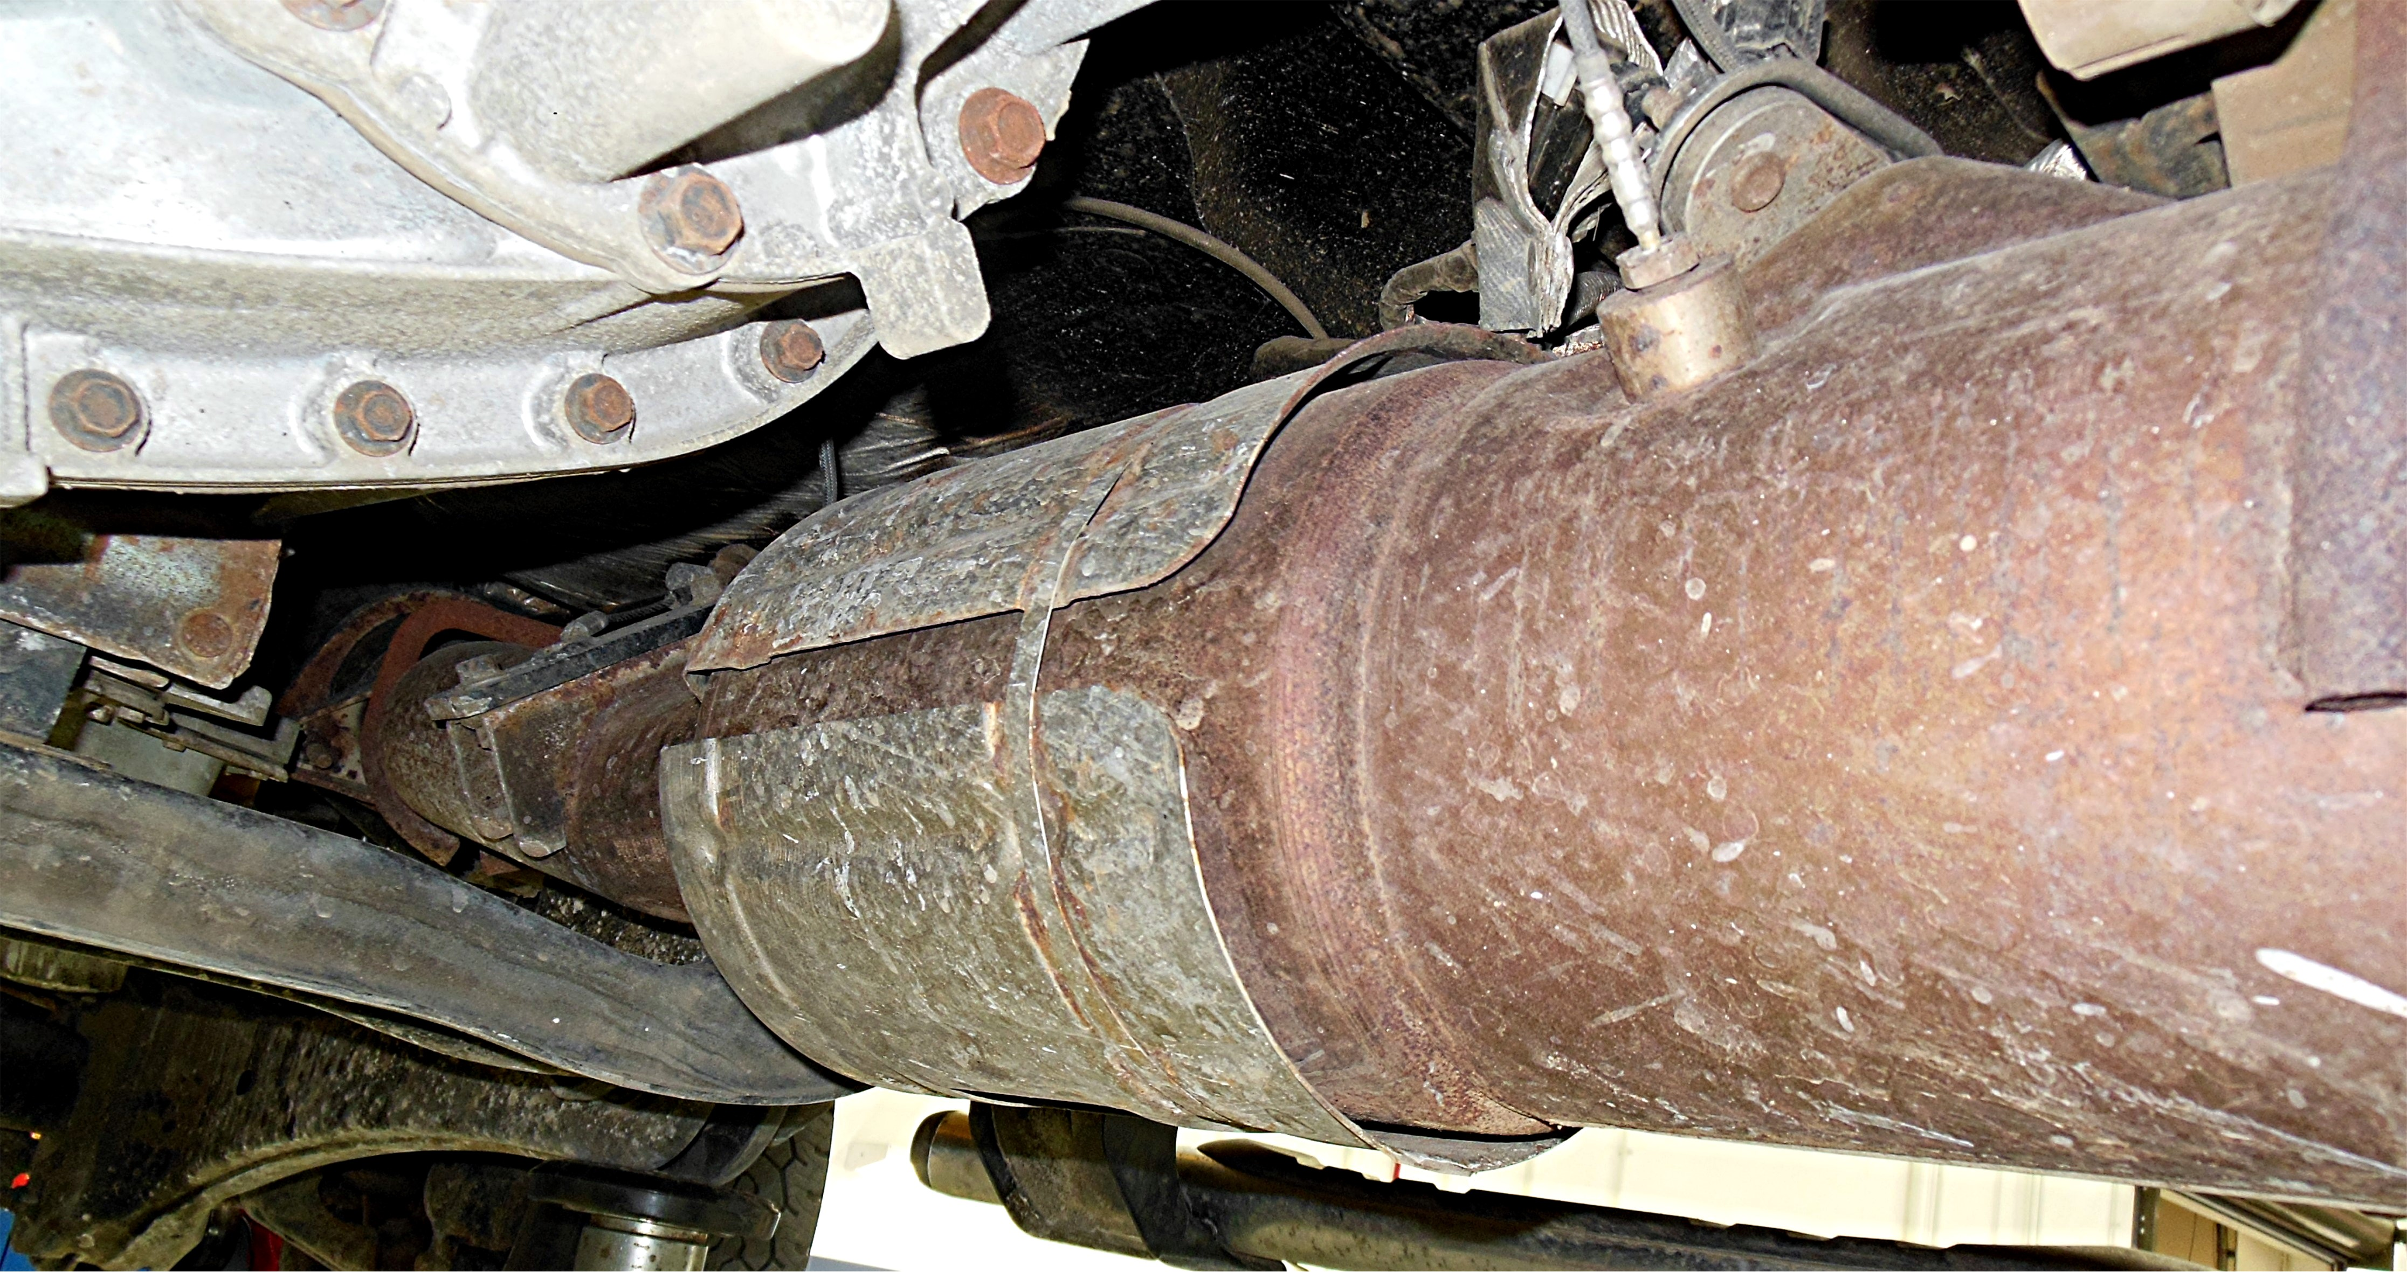

_____ 2. Check service information for the specified procedure to follow when inspecting,
testing, and replacing the diesel particulate filter (DPF), including checking the
regeneration system operation. Describe the specified procedure. _____________
__________________________________________________________________
__________________________________________________________________
_____ 3. Check service information for the specified procedure to follow when inspecting,
testing, and replacing the selective catalyst reduction (SCR) and diesel exhaust
fluid (DEF) systems. Describe the specific procedure. ______________________



