EGR System Inspection

Meets ASE Task: (A9-E-9) Inspect, test, service, and replace the EGR system components.

Name _______________________________ Date ___________ Time on Task __________

Make/Model/Year _________________ VIN ________________ Evaluation: 4 3 2 1

_____ 1. Check service information for the specified procedure to follow when inspecting the
following. Describe the specified procedure for the following:
EGR valve(s) - _________________________________________________
EGR cooler bypass valve(s) _______________________________________
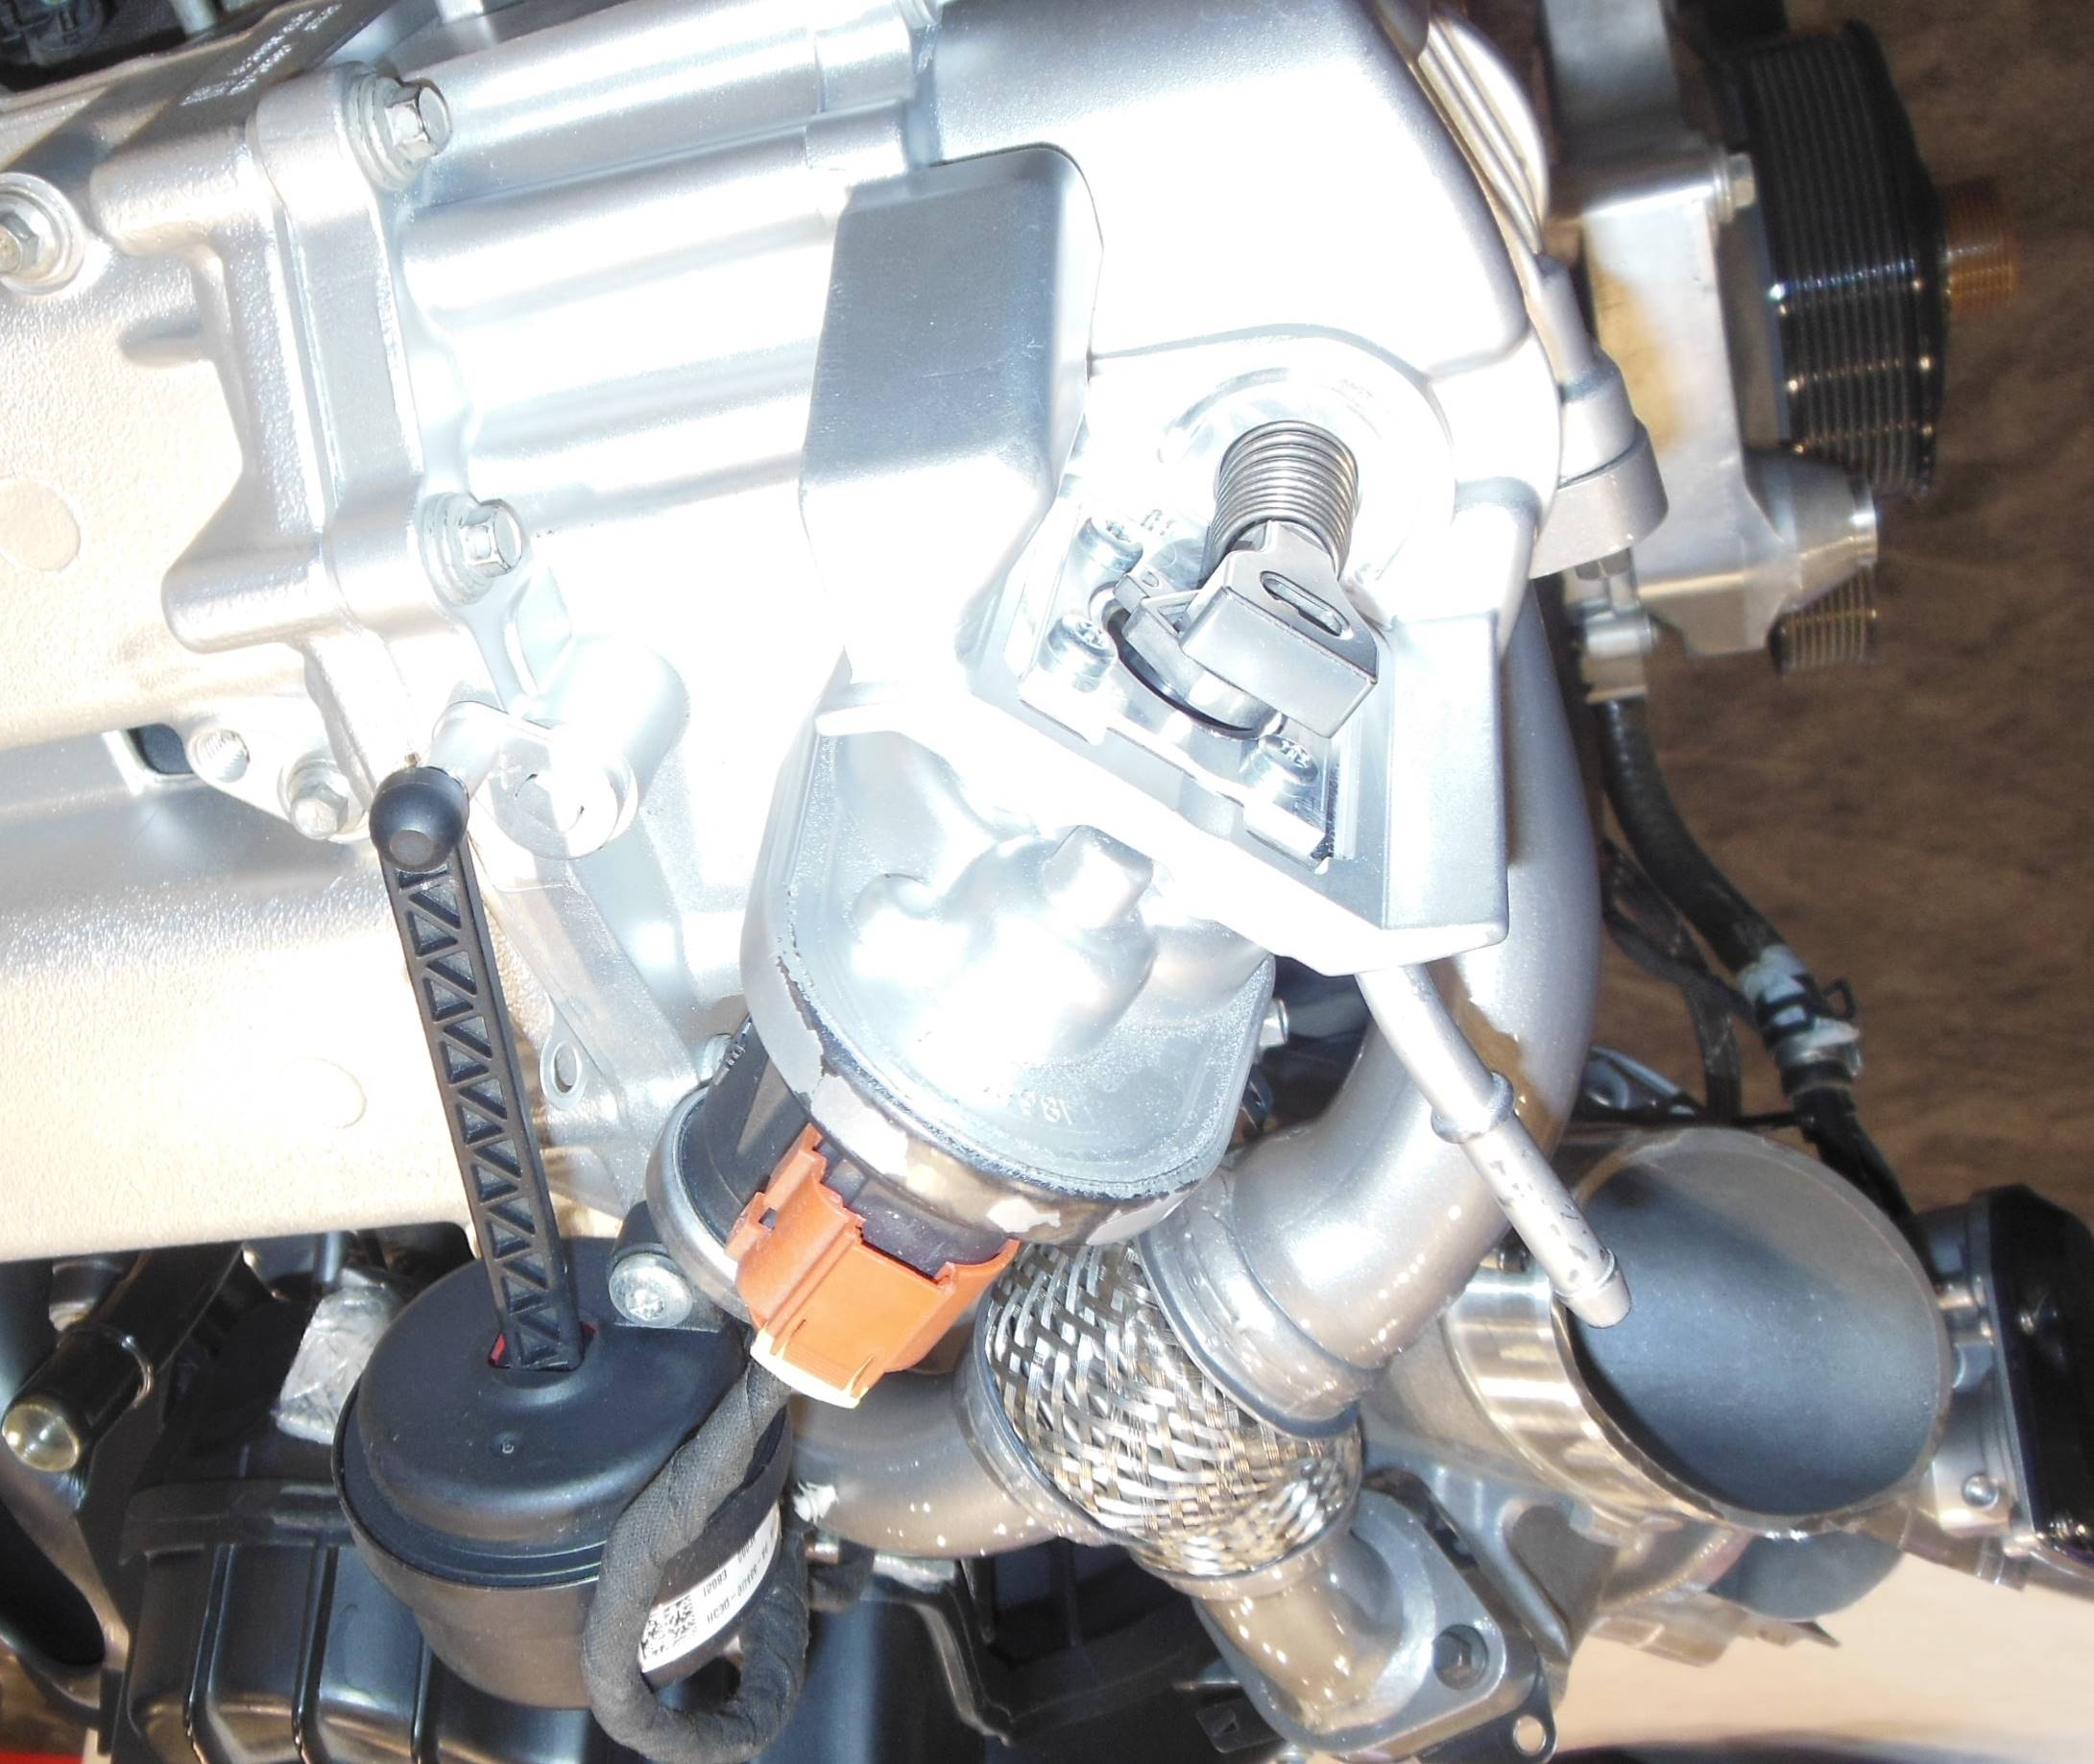

EGR cooler(s) __________________________________________________
EGR electronic sensors, actuator, controls, and wiring __________________
________________________________________________________
________________________________________________________

