Oil and Filter Change

Meets ASE Task: (A9-D-6) Chance engine oil and filter using the specified oil.

Name _______________________________ Date ___________ Time on Task __________

Make/Model/Year _________________ VIN ________________ Evaluation: 4 3 2 1

_____ 1. Check service information for the specified oil to be used.
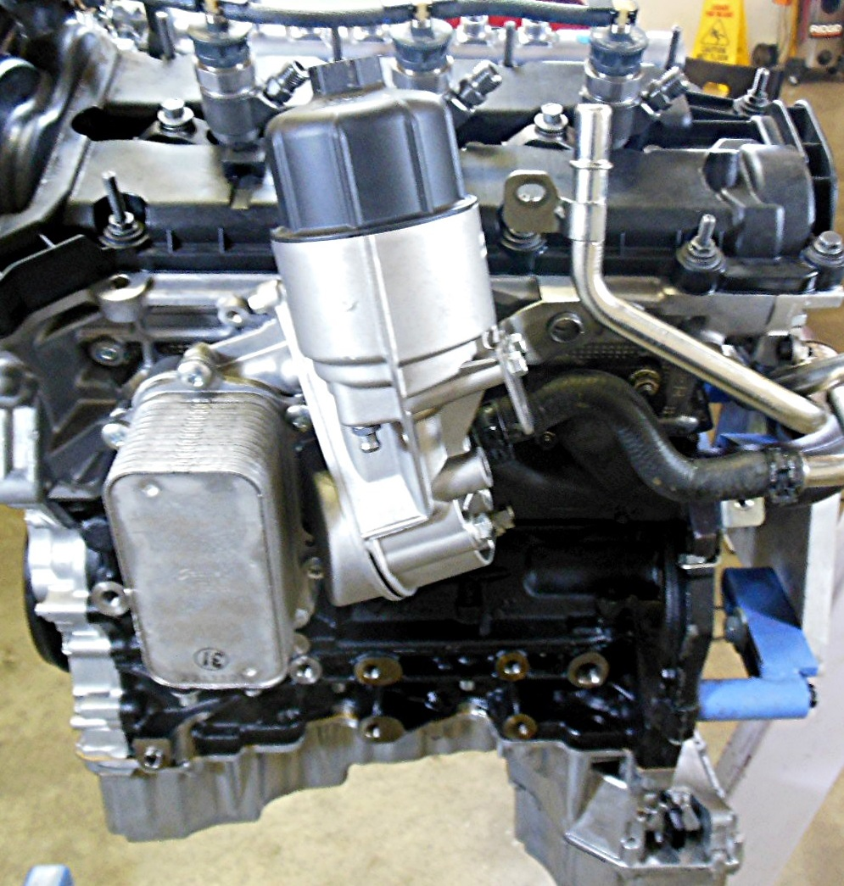
Viscosity _____________________
Oil rating (API) ________________
Number of quarts/liters __________
Part number of the oil filter _______
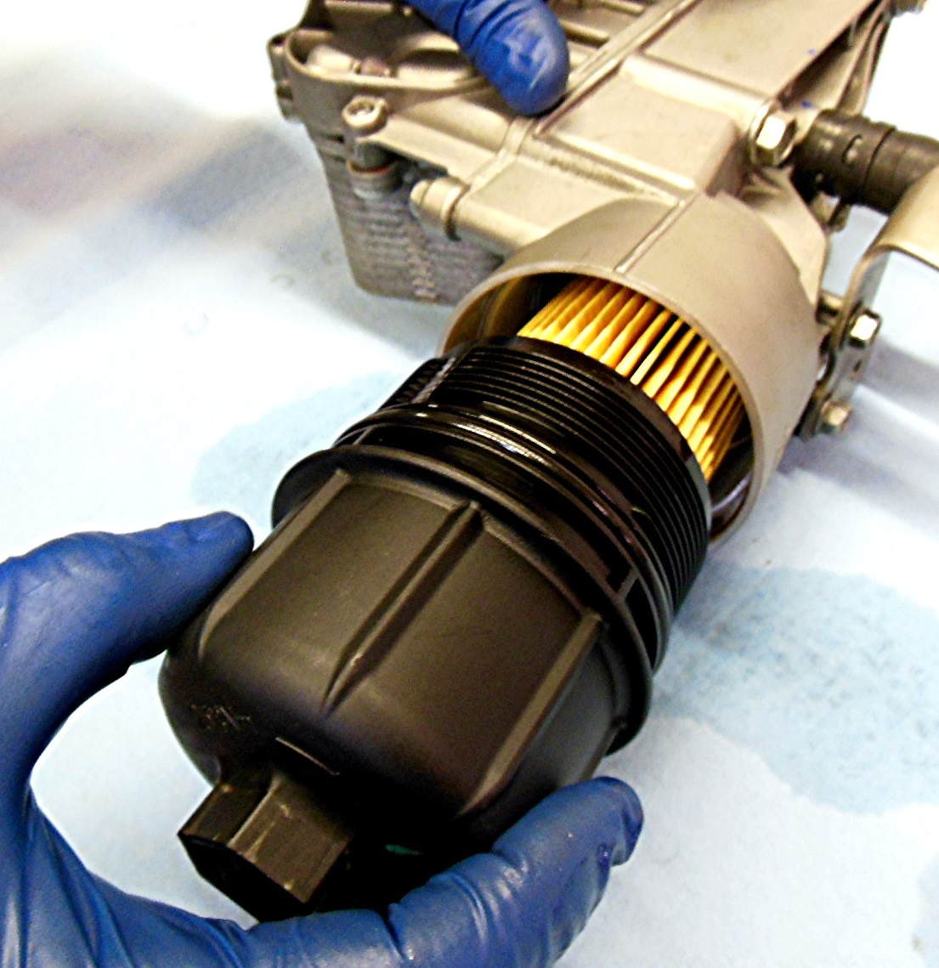

_____ 2. Drain the oil and change the filter. Torque the drain plug to ________ and fill with oil
to the proper level. _____OK _____NOT OK

