Engine Wiring Harness Inspection
Meets ASE Task: (A9-A-7) Inspect engine compartment wiring harness; determine the needed repairs.

Name _______________________________ Date ___________ Time on Task __________

Make/Model/Year _________________ VIN ________________ Evaluation: 4 3 2 1

_____ 1. Perform a thorough visual inspection of the engine compartment wiring harness,
connectors, seals, and locks. Describe the results of the inspection. ___________
__________________________________________________________________
__________________________________________________________________
__________________________________________________________________
__________________________________________________________________
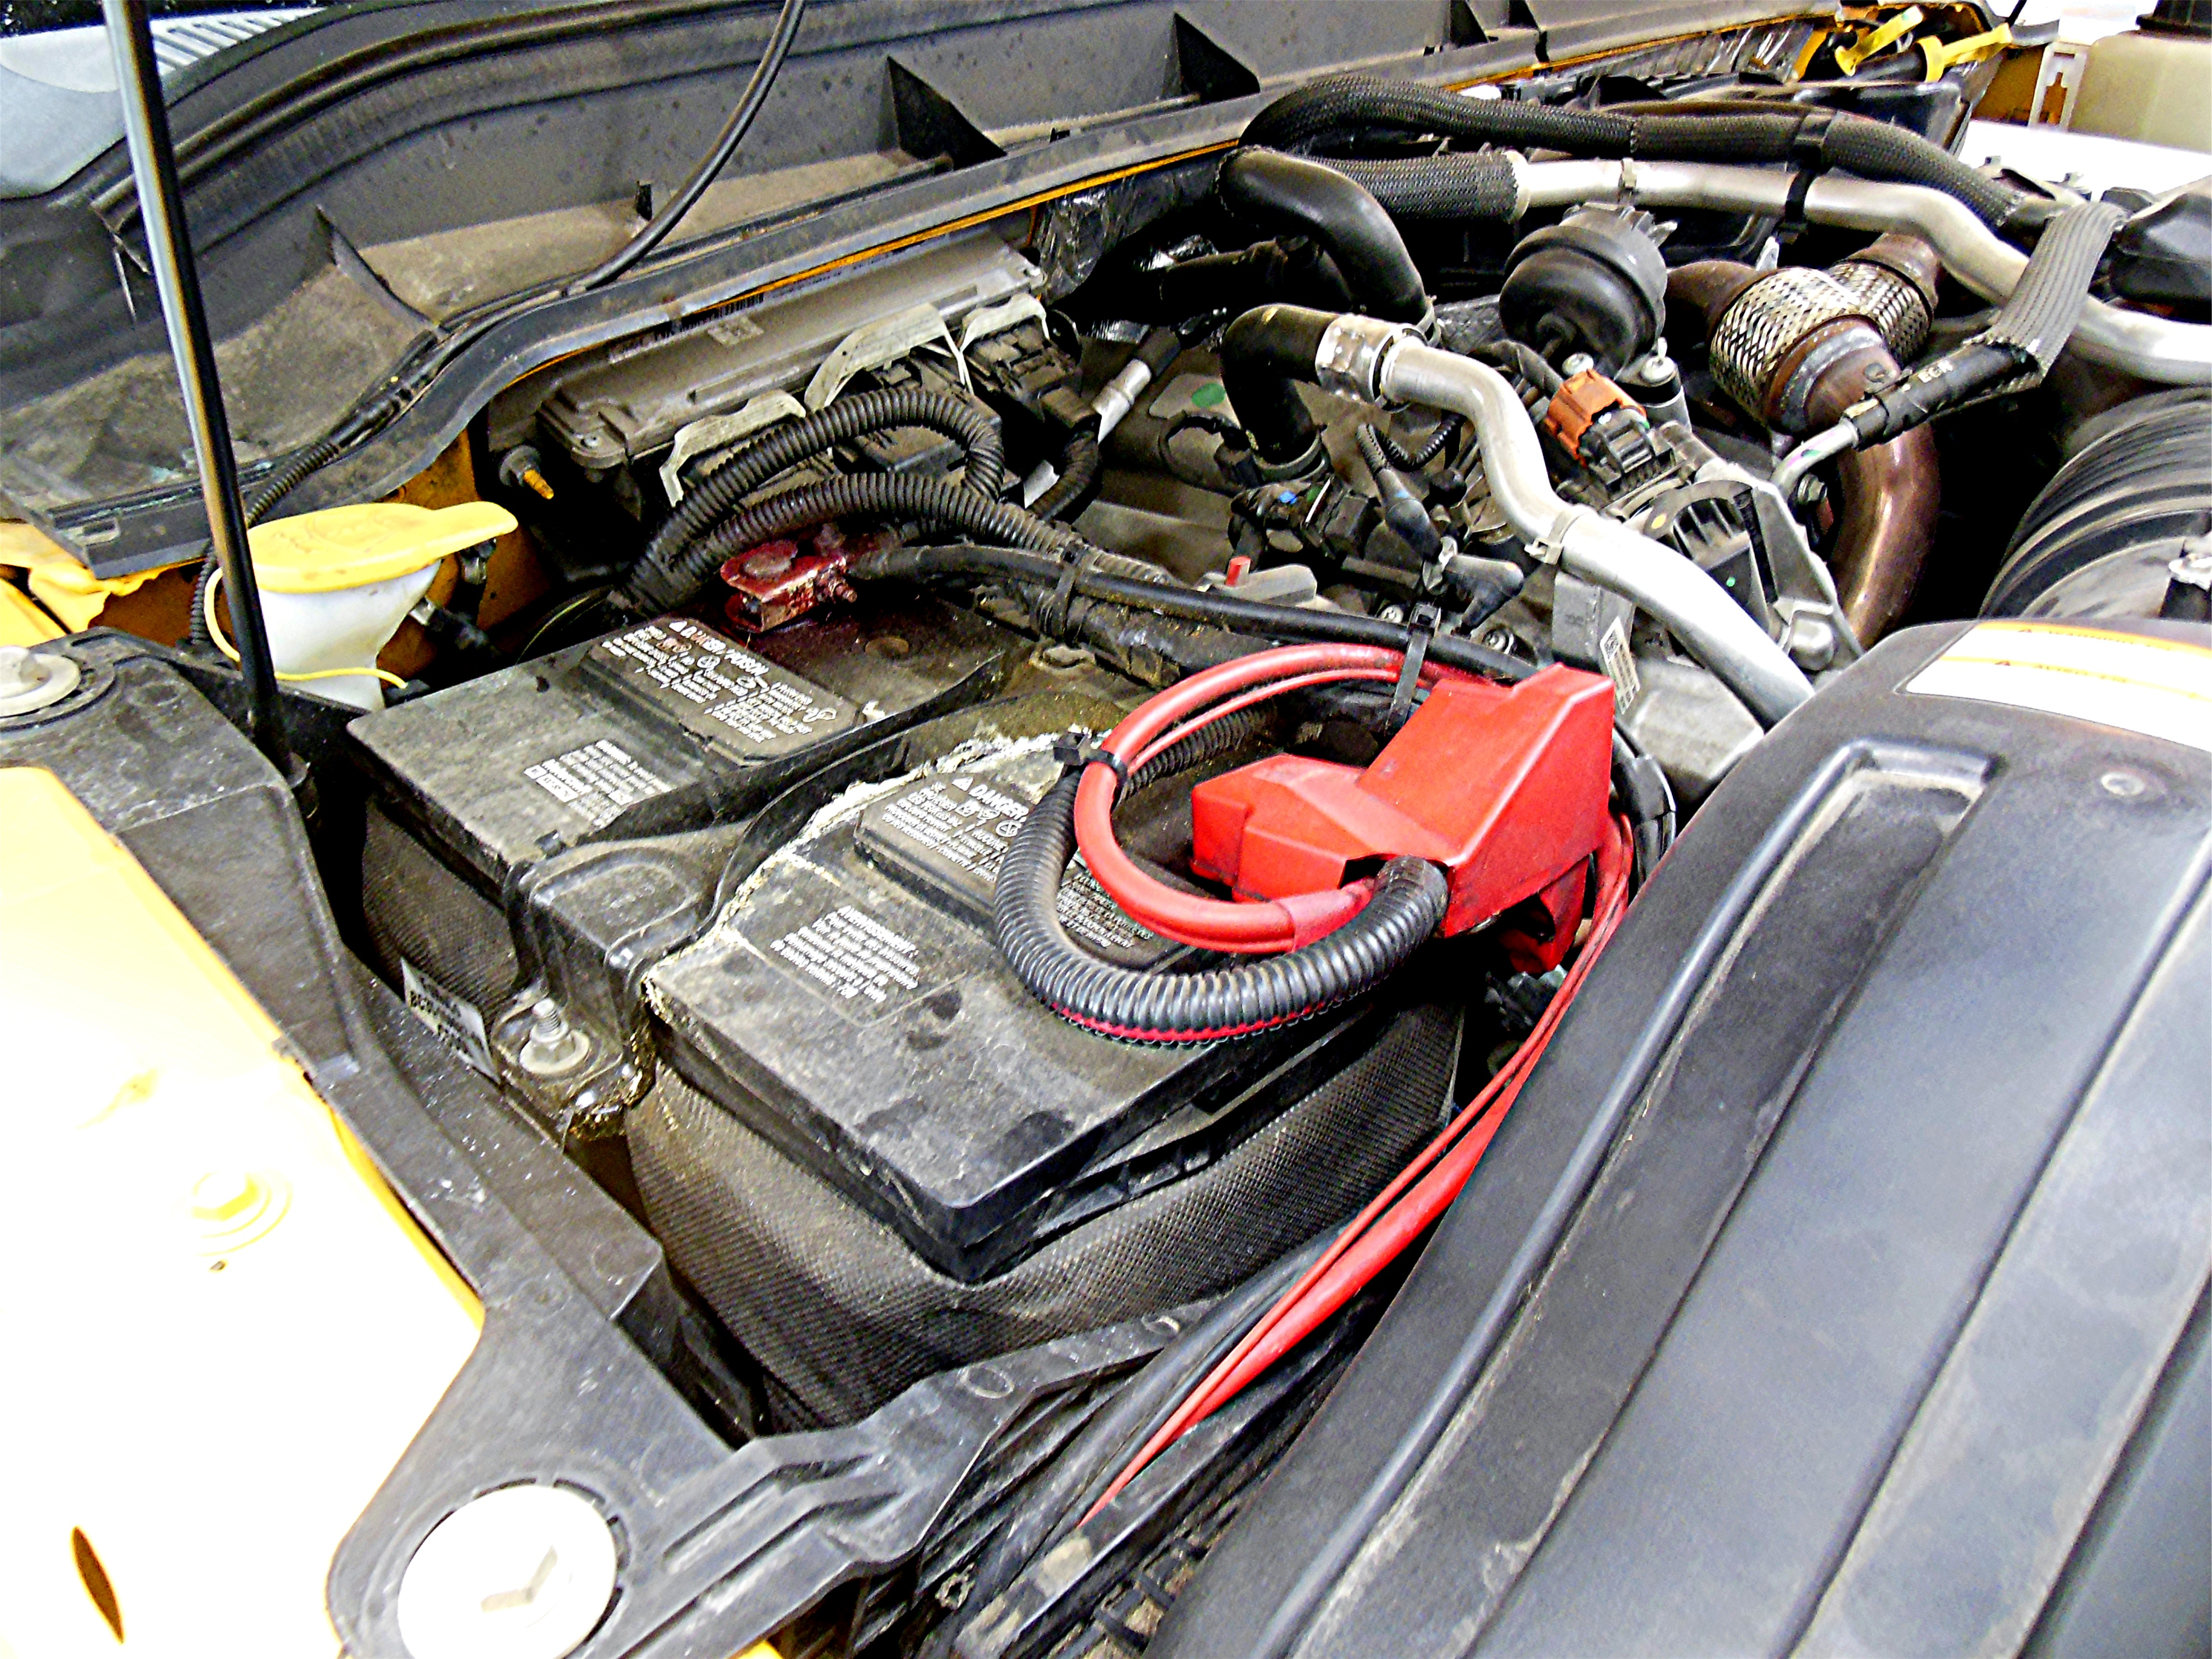

_____ 2. Based on the results of the visual inspection, what repairs are needed? _____________
__________________________________________________________________
__________________________________________________________________
__________________________________________________________________
__________________________________________________________________

