Scan Tool Check

Meets ASE Task: (A9-A-3) Perform scan tool check and do a visual inspection.

Name _______________________________ Date ___________ Time on Task __________

Make/Model/Year _________________ VIN ________________ Evaluation: 4 3 2 1

_____ 1. What scan tool was used to check for DTCs and faults? ________________________
_________________________________________________________________
_____ 2. What faults were found using the scan tool? _________________________________
_________________________________________________________________
_____ 3. Perform a thorough visual inspection for physical damage, missing, modified, or
tampered with components.
_____ 4. Describe the result of the visual inspection: __________________________________
__________________________________________________________________
__________________________________________________________________
__________________________________________________________________
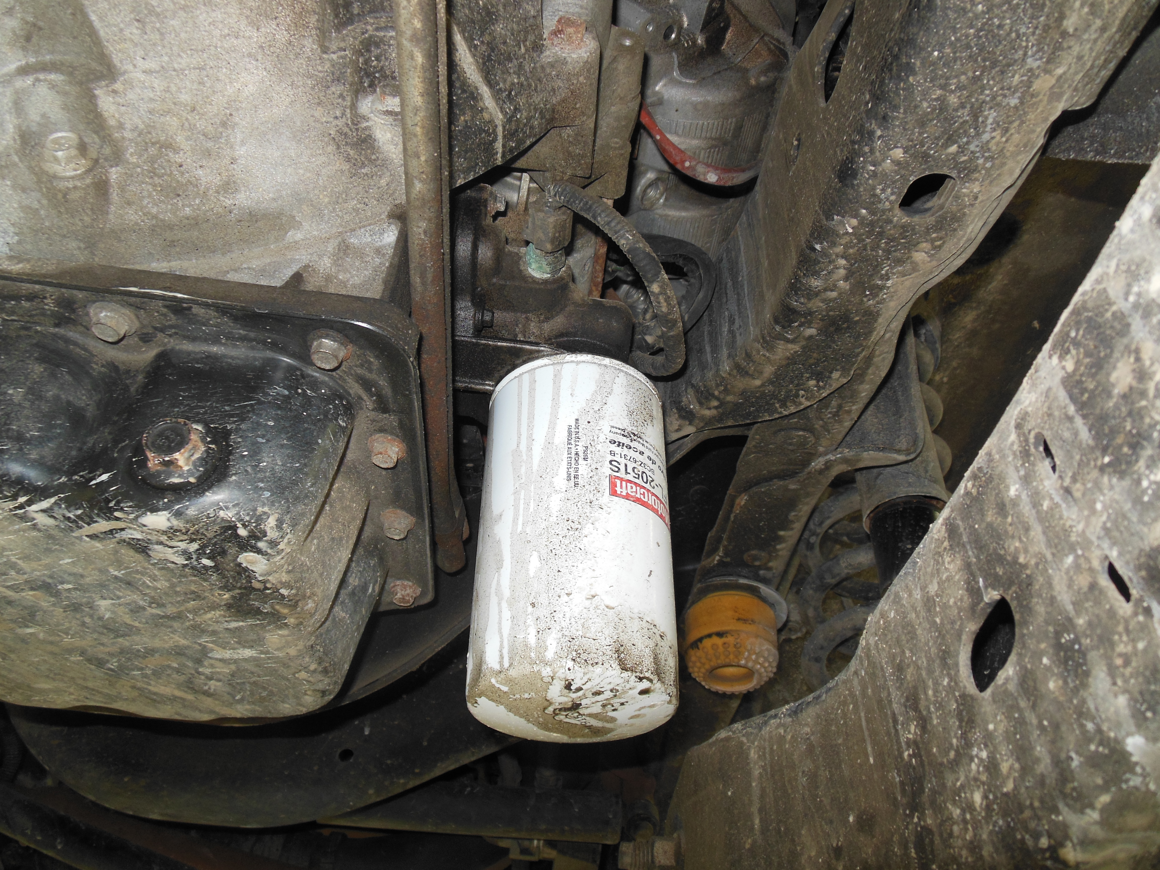

_____ 5. Based on the scan tool check and the visual inspection, what is the needed action?
__________________________________________________________________
__________________________________________________________________
__________________________________________________________________
__________________________________________________________________

