Diagnostic Trouble Code Retrieval

Meets ASE Task: (A9-A-4 Check for DTCs and freeze frame data.

Name _______________________________ Date ___________ Time on Task __________

Make/Model/Year _________________ VIN ________________ Evaluation: 4 3 2 1

_____ 1. Using a scan tool, check for any stored diagnostic trouble codes (DTCs). List and
describe all that were retrieved. _______________________________________
_________________________________________________________________
_________________________________________________________________
_________________________________________________________________
_____ 2. Checking freeze frame data, under what condition was the DTC set? _____________
_________________________________________________________________
_____ 3. Monitor the scan tool data. What, if anything, was found to be wrong? ___________
_________________________________________________________________
_________________________________________________________________
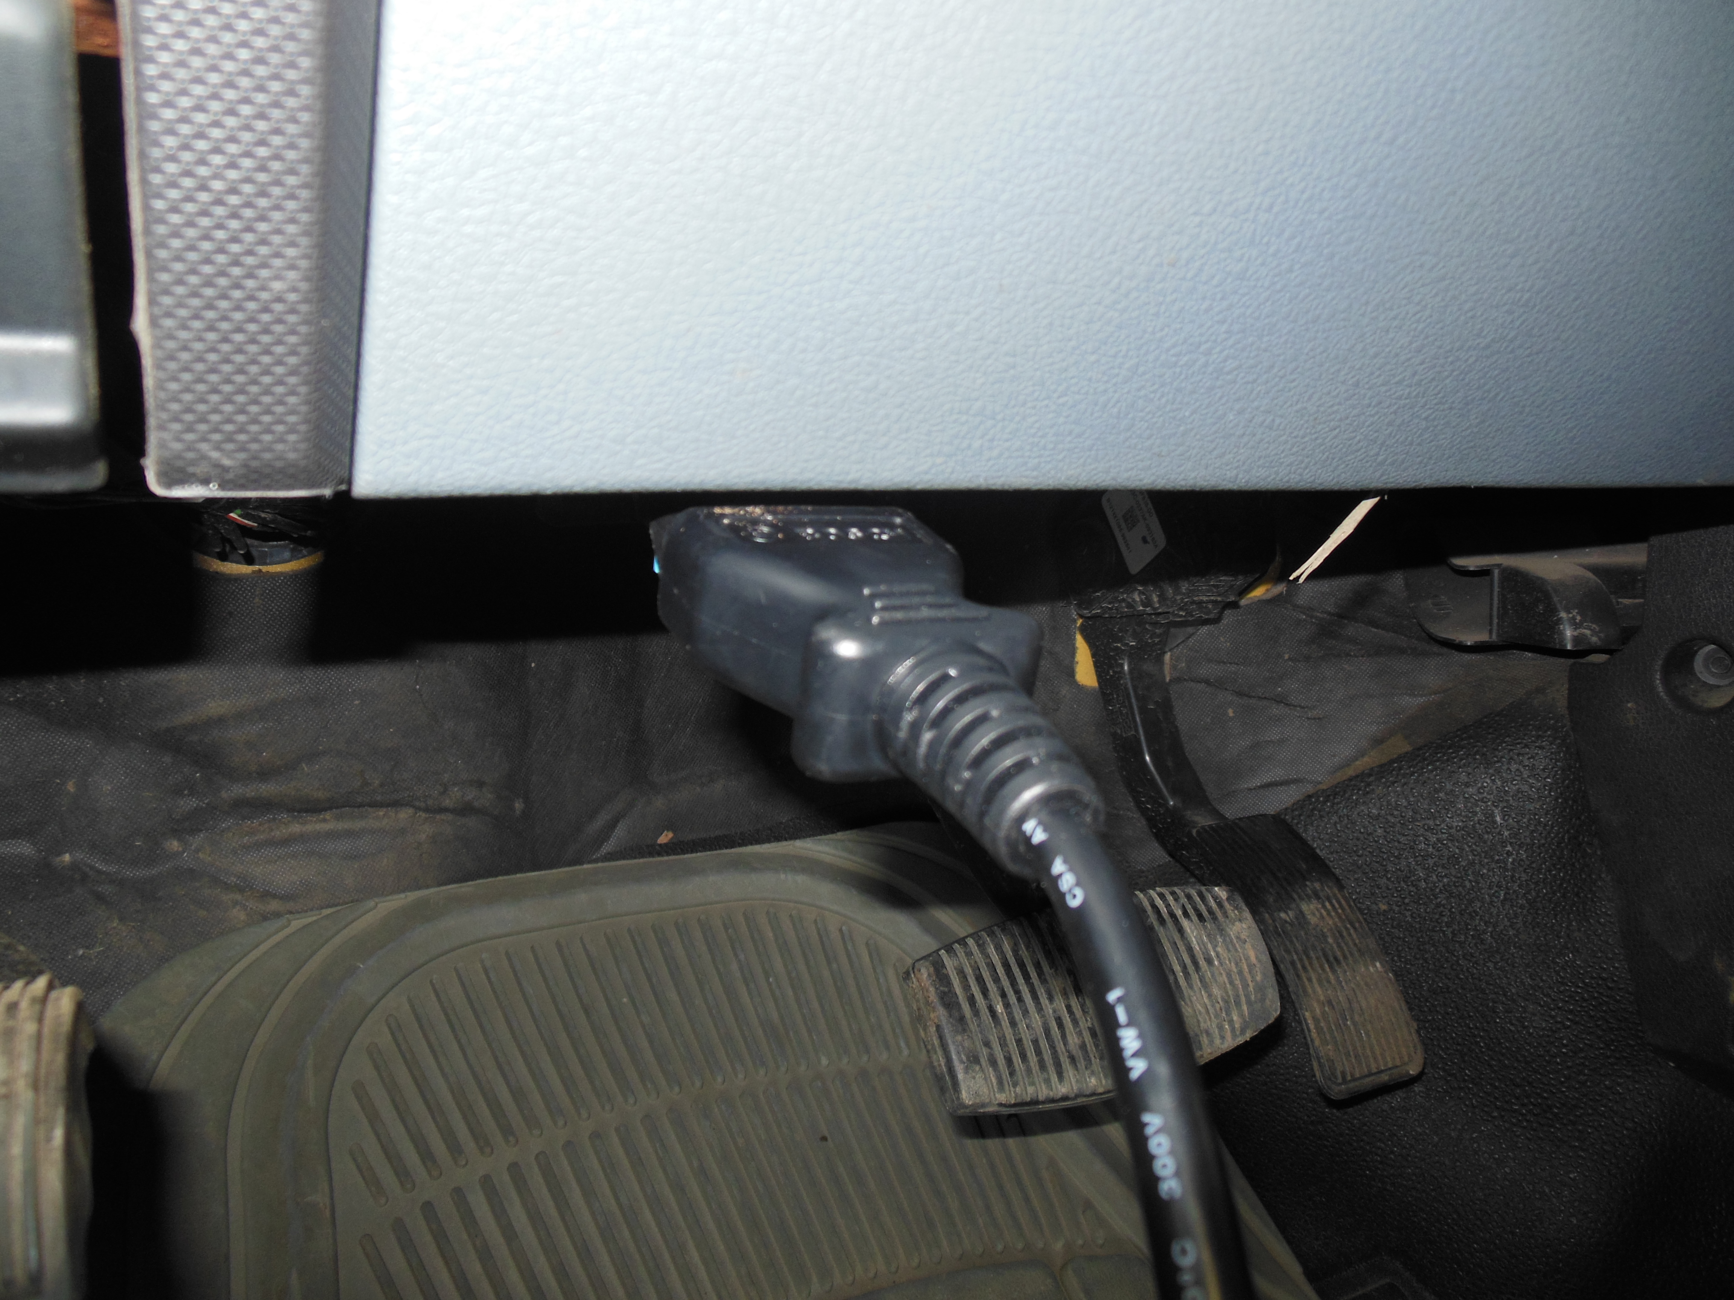

_____ 4. Based on the stored DTC and the scan tool data, what further diagnosis is needed?
__________________________________________________________________
__________________________________________________________________
__________________________________________________________________

