Clear DTCs and Verify the Repair

Meets ASE Task: (A9-A-5) Clear the DTCs and verify the repair.

Name _______________________________ Date ___________ Time on Task __________

Make/Model/Year _________________ VIN ________________ Evaluation: 4 3 2 1

_____ 1. List the stored diagnostic trouble codes (DTCs). ______________________________
__________________________________________________________________
__________________________________________________________________
_____ 2. What action/repair was needed to correct the stored diagnostic trouble codes? _______
__________________________________________________________________
__________________________________________________________________
__________________________________________________________________

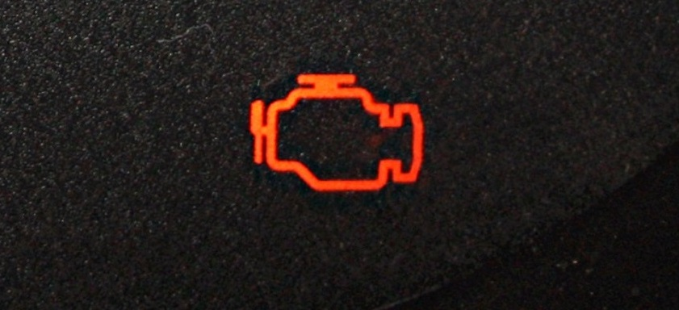

_____ 3. Describe the operating conditions under which the vehicle needed to be driven to
achieve similar conditions to rectify the repair. ___________________________
_________________________________________________________________
_________________________________________________________________

