Cummins Diesel Engine

Meets ASE Task: (None specified for this topic.)

Name _______________________________ Date ___________ Time on Task __________

Make/Model/Year _________________ VIN ________________ Evaluation: 4 3 2 1

_____ 1. Check service information to determine the following service-related information.
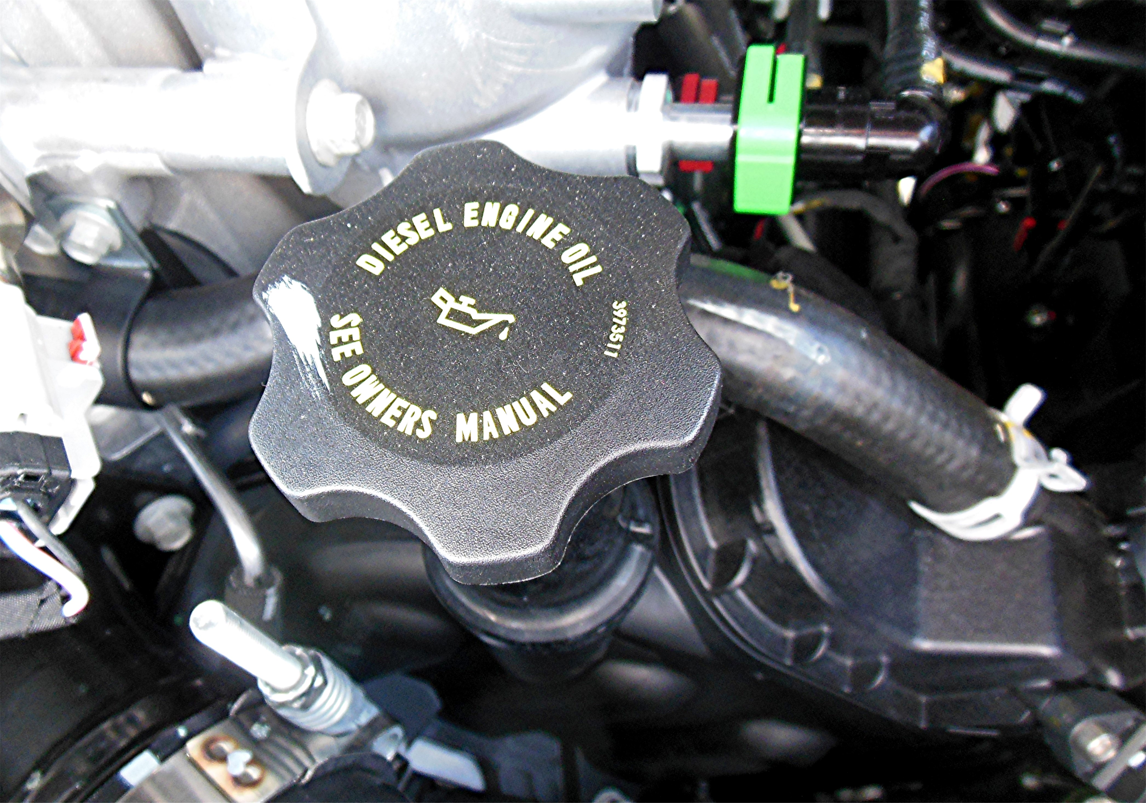
a. Recommended oil change interval ______________________________
b. Number of quarts/liters of oil needed ___________________________
c. Viscosity and API rating of the engine oil _______________________
d. Oil filter part number _______________________________________
e. Air Filter part number _______________________________________
f. Fuel filter part number _______________________________________

