Fiat/Chrysler Diesel Engine

Meets ASE Task: (None specified for this task.)

Name _______________________________ Date ___________ Time on Task __________

Make/Model/Year _________________ VIN ________________ Evaluation: 4 3 2 1

_____ 1. Check service information to determine the following service-related information.
a. Recommended oil change interval _______________________________
b. Number of quarts/liters of oil needed ____________________________
c. Viscosity and API rating of the engine oil _________________________
d. Oil filter part number _________________________________________
e. Air filter part number _________________________________________
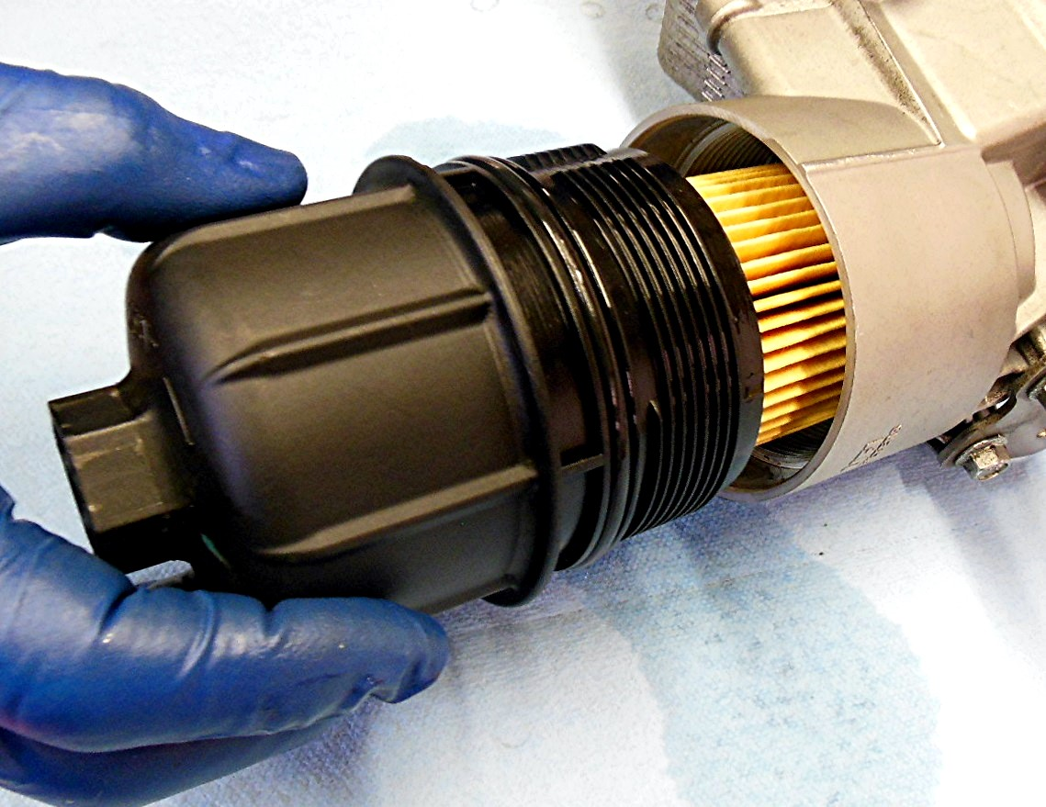
f. Fuel filter part number ________________________________________

