Inspect and Replace Main Bearings

Meets ASE Task: (A9-C-8) Inspect and replace main bearings; check and correct end play.

Name _______________________________ Date ___________ Time on Task __________

Make/Model/Year _________________ VIN ________________ Evaluation: 4 3 2 1

_____ 1. Check service information for the specified procedure to follow when installing main
engine bearings. Describe the specified procedure. ________________________
__________________________________________________________________
__________________________________________________________________
__________________________________________________________________
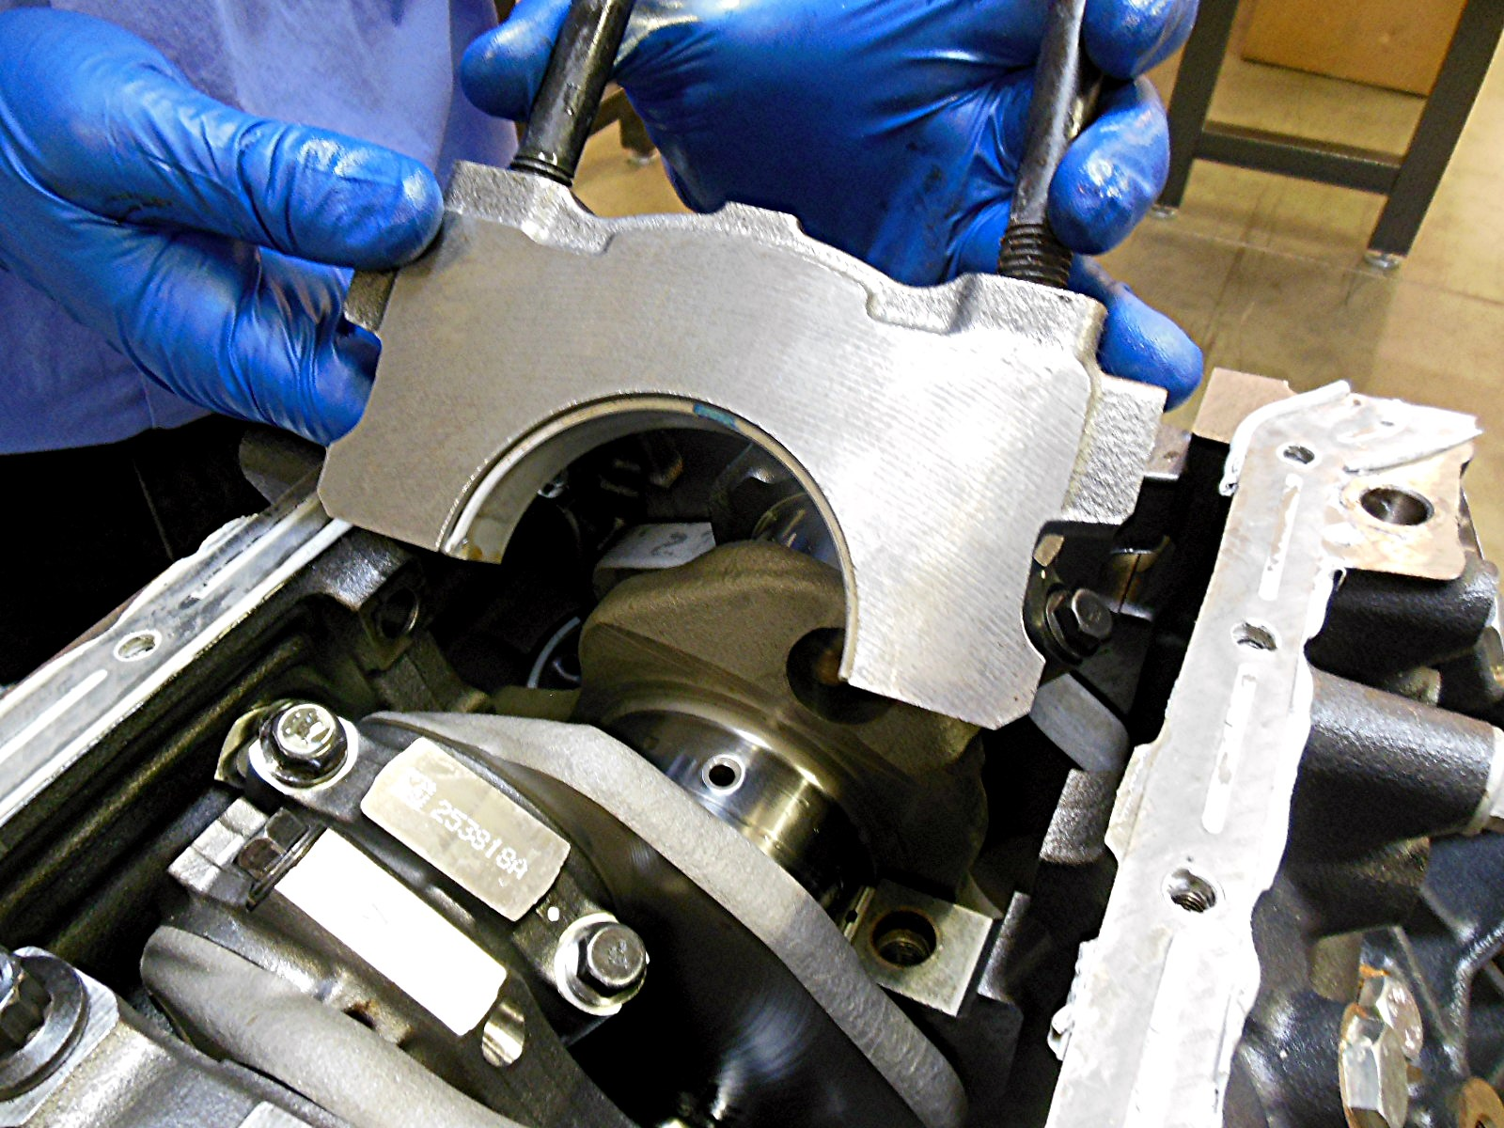

_____ 2. Check service information for the specific crankshaft end play.
Specified end play = _______________________
Measured end play = _______________________

